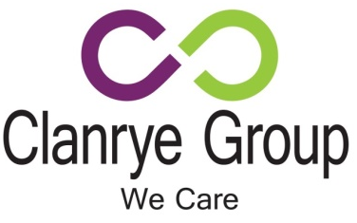
JOB DESCRIPTION

Job Title: | Employability Officer | Reports To: | DSS Co-ordinator

Programme : | Disability Support Services | Location: | Various throughout NI

Job Purpose: | To provide a work placement support service to young people who require support whilst participating on the Training for Success or Apprenticeships NI Programme as agreed with the Disability Support Services Co-ordinator.  This role may involve the post holder to work outside normal working hours to include weekends and evenings.

Working Relationships: | Reports to DSS Co-ordinator  Works closely with participants & staff, training organisations support agencies and key stakeholders

Hours of Work: | TBC

Holidays: | TBC (depending on support hours)

Key Job Duties
- Organise work placements and support students in the work placement process.
- Prepare students for interviews/introductory meetings with potential new employers and accompany them to these.
- Prepare student for their first day on placement to ensure they know what is expected of them and what they can do to make the right start.
- Organise and attend placement visits to monitor the progress of students, and deal effectively with any issues/concerns that arise.
- Assist the DSS Co-ordinator with the monitoring and evidencing of progress against Performance Targets set.
- Provide monthly updates to the DSS Co-ordinator on the young persons’ progress.
- Maintain a confidential and effective system for processing and maintaining all internal documentation.
The key job duties listed above give a broad outline of the functions of the role. However, these duties must be approached in a flexible manner. The job holder will be expected to adapt to changing circumstances and undertake other duties as allocated by your Manager. The outline of the job duties may change from time to time.

General Duties
- Carry out job duties in compliance with Clanrye Group’s policies and procedures to include equal opportunities and health and safety legislation.
- Adhere to existing work practices, procedures and undertake relevant training and development activities and to respond positively to new and alternative systems.
- Keep up to date with new resources in line with industry demand and currency ensuring participants are trained using the most up to date and current resources.
- Act in compliance with all course examination, assessment and validation requirements.
- Ensure quality of provision at all times.
- Demonstrate commitment to Clanrye Group through the completion of all tasks allocated to you and by attending staff and development opportunities to ensure that professional competency is maintained.

Qualifications Required
- 5 G.C.S.E’s at Grade C or equivalent to include English and Maths.

Experience Required
- At least 1 year experience in a similar role.
- Experience of working in an education environment.
- High level of organisational and planning skills.

Essential Knowledge / Skills Required
- Ability to actively listen and relate to children, young people and adults in an empathetic manner, valuing their views, experience and recognise their strengths.
- Ability to develop a good rapport with young people and use effective interpersonal skills.
- Support students with confidence and/or anxiety issues in a one-to-one setting.
- Excellent interpersonal skills particularly communication and presentation skills.
- Excellent organisational skills with a good ability to navigate the MS Office Suite.
- Excellent numeracy/literacy skills.
- Respect for diversity as you will be working with young people from a range of backgrounds.
- Access to own car is essential.

