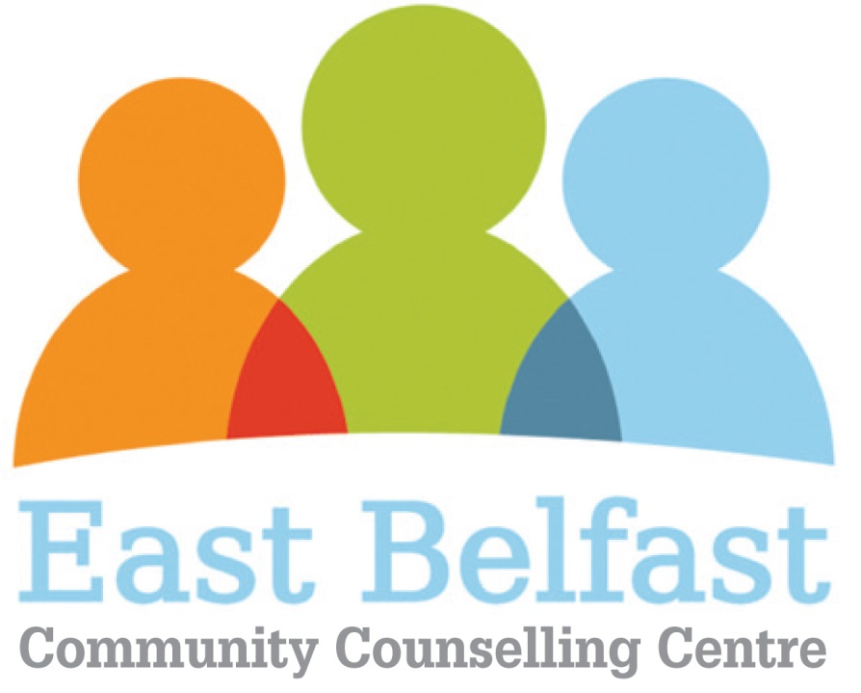

Art Therapist

East Belfast Community Counselling Centre was established to provide a locally based resource for adults experiencing emotional and mental health difficulties. The organisation offers a range of talking therapies and wellbeing services to children, teenagers , adults and couples.

EBCCC is currently seeking to appoint HCPC a registered art therapist to our panel of counsellors/psychotherapists to deliver creative therapy on a sessional basis to children. We require individual service providers whom have a specific child focused- skill set, knowledge base and considerable experience working therapeutically with children and young people.

As a sessional creative therapist, you will provide weekly therapeutic sessions to children and young people aged 5 - 18 years of age displaying symptoms of trauma, emotional distress or other behavioural difficulties which are having a detrimental impact on their wellbeing, mental health and education.

Please note that appointment to the panel will be by way of written agreement and is not a guarantee of work.

We require individual service providers who can

- conduct assessments of need and design and deliver high quality creative therapy interventions to individual children, groups of children and through parent /child sessions.

- maintain records for all work undertaken

- provide written reports and completion of outcome tools for the CEO/Board demonstrating impact and making recommendations

- attend team / contractor meetings

Maintain a high level of skill and competency by accessing appropriate CPD opportunities

Professional responsibilities include :

- Attendance at clinical supervision
- Ensuring adequate professional insurance cover
- Membership of relevant professional body
- Ability to evaluate impact critically to improve effectiveness by adopting reflective practice
- Compliance with EBCCC policies and procedures

- Establishment of effective working relationships setting a good example through presentation and personal and professional conduct

Interested individuals should forward :

- A copy of their most up to date CV
- A brief outlining their therapeutic approach to include the value base from which they work and the range of client issues ( including number of hours) they have been working over the past year
- Copies of qualifications/accreditation/ professional membership, HCPC membership and insurance
- A quote outlining their sessional rate, bearing in mind that one of the key assessment criteria will be value for money. This rate should include any anticipated travel costs. Service providers should be aware that they will also be responsible for the cost of attendance at clinical supervision in line with contractual obligations.
- The name and address of two referees whom have supervisory /managerial experience of you one of which should be your current clinical supervisor

Copies of documentation should be addressed to :

Roberta Richmond
East Belfast Community Counselling Centre
East Belfast Network Centre
55 Templemore Avenue
Belfast
BT5 4FP

