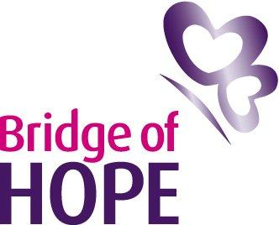

Invitation to Tender for Personal Development & Stress Management Training

Bridge of Hope, a department of Ashton Community Trust is inviting tender applications, from competent, experienced and appropriately qualified individuals to deliver Personal Development and Stress Management Training.

Bridge of Hope Overview:

Bridge of Hope is a department of the award winning regeneration charity Ashton Community Trust. It is based in North Belfast and delivers services regionally. It is a wellbeing service that supports individuals affected by the conflict and poor physical and emotional health. This includes those affected by suicide and self-harm. Since we opened in 2001 nearly 22,000 people have benefitted from Bridge of Hope support. Services are person-centred and recognise that people need different levels of support at different times in their lives.

Wellbeing services include: complementary therapies; life coaching; psychological therapies; health & wellbeing caseworker support; accredited training and personal development courses. We also encourage people to explore ‘dealing with the past’ issues through conflict legacy facilitated programmes.

Using a holistic approach we enhance positive wellbeing by supporting individuals to adopt better coping skills, develop self-care strategies and to make positive life changes.

Further information about us can be accessed on our websites:

www.ashtoncentre.com and www.thebridgeofhope.org

Bridge of Hope, Ashton Community Trust, delivers a range of personal development and stress management programmes to victims and survivors including:

- Love Yourself, Heal Your Life (based on philosophy of Louise L Hay)
- A bespoke meditation programme
- Understanding Stress for Personal Growth
- S.W.A.N (Strengths, Weaknesses, Ambitions & Needs)
- Empower Me programme
- Confidence & Communication Workshop
- Take 5 training programme
- Reducing Stress for Women
- Resilience Programme
- Mindfulness programmes

Role description

We see this role to have a range of priorities:

- To interact with individuals on a one to one and group basis.
- To deliver a range of personal development programmes to victims and survivors of the conflict.
- To act as a liaison for other Bridge of Hope staff.
- To travel to any outreach location to deliver Bridge of Hope personal development training.
- To inform individuals about the range of support services offered by Bridge of Hope to encourage a holistic approach.
- To work closely with identified Bridge of Hope staff to ensure that all appropriate procedures and processes are followed.
- Attend a meeting with Head of Victims & Mental Health Services and/or other relevant Bridge of Hope, Ashton Community Trust staff periodically throughout the year.
- Liaise with Bridge of Hope Head of Victims & Mental Health Services immediately should a problem arise, relating to the well-being of Victims and Survivors and/or if identified that an individual requires any other support or referral pathway.
- Ensure all relevant paperwork is fully and accurately completed and returned to the Operations Manager at Bridge of Hope on time.
- Attend regular one to one meetings with the Head of Victims & Mental Health Services.
- To promote the personal development programmes to individual victims and survivors who may benefit.
- Be prepared to deliver a flexible service for Bridge of Hope to enable us to meet the needs of our client base.

The tender format is as follows:

- Applicants must demonstrate and provide evidence where appropriate how they meet all elements of the essential criteria. Please note it is important to address each criteria listed above in your application. Failure to do so will result in your tender application being deemed ineligible.
- Applicants must state clearly how they will approach training within the bridge of Hope.
- Breakdown of costs for delivery of courses demonstrating value for money. Applicants must be able to demonstrate value for money. A cost per hour inclusive of travel, subsistence and VAT should be provided up to a maximum of £20 per hour.
- Applicants must be able to demonstrate a flexible approach to service delivery.
- Applicants must include a full and up to date CV including recent examples of similar work with victims/survivors.
- Applicants must include a copy of all relevant certificates.
- Applicants must include evidence of Professional Liability Insurance to a minimum of £5 million.
- Applicants must outline what days and times they would be available to deliver services on behalf of Bridge of Hope. Please be aware Bridge of Hope delivers personal development training both during the day and some evenings as well as weekends.
- Tender applications must include a completed Declaration of Employment Status forms.

Copies of tender proposals should be forwarded in a plain envelope clearly marked “Personal Development Training” to:

Lindsay Whitten
Operations Manager
Bridge of Hope
Ashton Community Trust
5 Churchill Street
Belfast
BT15 2BP

Any tender applications not including all information above will be discounted as incomplete and will not move to scoring. All tenders must be received no later than 12.00 pm on Friday 27th April 2018. No late tenders, faxed tenders or e-mails will be accepted.

Bridge of Hope will use the information supplied to score all tender applications. Please take note of weighting criteria as this will be used to total scores and only applicants who score over 80 will be added to our Approved Sub Contractors List. Although a score of 80 or more will allow enable an applicant’s details to be added to our Approved Sub Contractors List this does not constitute any guarantee of hours. Please note any successful tender will only be valid for a period of 12 months from 1st April 2018 to 31st March 2019.

Award Criteria | Score out of 100
Work with Victims and Survivors | 15
Demonstration of value for money/breakdown of costs | 10
Flexible approach to working | 5
Evidence of insurance | 5
Demonstration of qualifications | 10
CV included | 5
Experience in delivering personal development and stress management programmes | 25
Mental Health First Aid Qualification | 5
Emergency First Aid at Work Qualification | 5
Keeping Adults Safe or Safeguarding Adults Training Qualification | 5
Keeping Children Safe Training Qualification | 5
Trauma Training | 5

Contact Details: If you require further information, wish to clarify any points or have difficulty relating to the tender documentation before submission of your proposal the contact point is Lindsay Whitten (Operations Manager).

Email: Lindsay.whitten@ashtoncentre.com Tel: 028 9022 1022.

START AND COMPLETION DATES
It is anticipated that funding for this service delivery will run from 1st April 2018 to 31st March 2019.

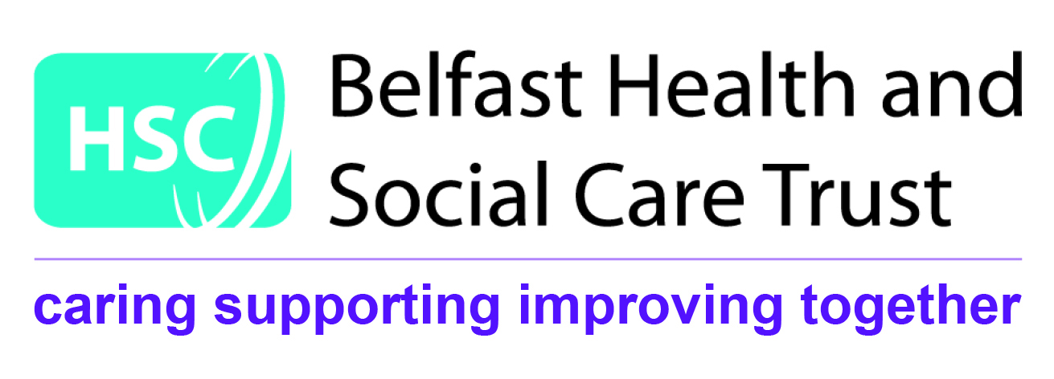

NAME: _________________________ TELEPHONE: __________________

EMAIL: _______________________________________________

SERVICE TENDERED FOR: ______________________________
Essential Criteria
1. Please demonstrate experience in delivering personal development and stress management programmes in a community setting through relevant recent examples.

2. Please demonstrate how you are committed to continuous personal development.

3. Please demonstrate all experience of working with individuals who have experienced significant conflict related trauma.

4. Have you completed or committed to completing Mental Health First Aid (or equivalent) Training within 2 months of the tender deadline?

5. Have you completed or committed to completing First Aid at Work Training within 2 months of the tender deadline?

6. Have you completed or committed to completing Trauma Training within 2 months of the tender deadline?

Essential Criteria contd.
7. Have you completed or committed to completing Keeping Children Safe Training within 2 months of the tender deadline?

8. Have you completed Keeping Adults Safe Training within the last 2 years or committed to completing the new updated Safeguarding Adults training within 2 months of the tender deadline?

9. Please state your cost per hour inclusive of travel, subsistence and VAT

10. Outline days and times available for delivery of sessions and detail how you have a flexible approach to delivery.

Check List for Applicants

Check List for Applicants
Work with Victims and Survivors
Demonstration of value for money/breakdown of costs
CV included
Mental Health First Aid Certificate
Emergency First Aid at Work certificate
Keeping Adults Safe or Safeguarding Adults Training Certificate
Keeping Children Safe Training Certificate
Trauma Training Certificate
Certificates

