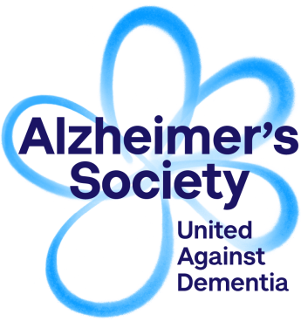
Role details
Volunteer
Registration Form
Role you are applying for:
How did you hear about this role?

Personal details
Title: |  |  |  |  |  | First name:
Surname: |  |  |  |  |  | Known as:
Address:
Postcode:
Home phone number: |  |  |  |  |  | Mobile phone number:
Email:
Are you currently an Alzheimer’s Society volunteer or employee? |  |  |  |  |  |  |  | Yes |  | No
Are you a Dementia Friend? |  |  |  | Yes | No | Are you a Dementia Friends Champion? |  |  |  |  | Yes | No

Your Skills and Experience
Please tell us why you would like to become a volunteer with Alzheimer’s Society
and what you hope to get out of the role:
Please tell us about the skills and experience you have that are relevant to the role
you are applying for (max 200 words):
Do you speak any languages other than English? | Welsh | Other, please specify below

Emergency Contact Details
Name: |  |  | Relationship to you:
Home phone number: |  |  | Mobile phone number:

Communication preferences
How would you prefer to receive communications relating to your volunteer role?
Email only | Post only | Post or Email | Opt out

References
If the role you are applying for requires references, please provide the details of two people who can provide a reference for you. They shouldn’t be related to you and should ideally be people who know you in a professional capacity, e.g. a tutor or colleague. They will only be contacted if you are offered the role.
Title: |  |  |  |  |  | Title:
First name: |  |  |  |  |  | First name:
Surname: |  |  |  |  |  | Surname:
Phone number: |  |  |  |  |  | Phone number:
Email: |  |  |  |  |  | Email:
Relationship to you: |  |  |  |  |  | Relationship to you:

Criminal Convictions
Please note that criminal convictions do not automatically prevent you from volunteering.
Do you have any unspent criminal convictions? | Yes | No
If yes, please give brief details

Marketing preferences
Alzheimer's Society would like to contact you about our activities, including fundraising, campaigning and services. Please indicate your communication preferences by selecting the appropriate option below. We will not share your information with any third party.
I am happy to be contacted by email | I would prefer not to receive information about fundraising, campaigning and services for people affected by dementia

Declaration
I confirm the details given in this form are correct and I am over the minimum age for the role I am applying for. I agree to abide by the Society’s policies, procedures and values and understand this agreement to volunteer for Alzheimer’s Society is binding in honour only and is not intended to be a contract of employment.
Alzheimer’s Society has permission to contact the referee I have provided (if applicable) and my volunteering with Alzheimer’s Society is subject to the references and any other checks being satisfactory.
Signed:
Print name:
Date:

