|  |  |  |  |  |
| --- | --- | --- | --- | --- |
| **Date** | 12-2pm | 2-4pm | 4-6pm | 6-8pm |
| **Friday 8th** |  |  |  |  |
| **Saturday 9th** |  |  |  |  |
| **Sunday 10th** |  |  |  |  |
| **Friday 15th** |  |  |  |  |
| **Saturday 16th** |  |  |  |  |
| **Sunday 17th** |  |  |  |  |
| **Thursday 21st** |  |  |  |  |
| **Friday 22nd** |  |  |  |  |
| **Saturday 23rd** |  |  |  |  |
| **Sunday 24th** |  |  |  |  |

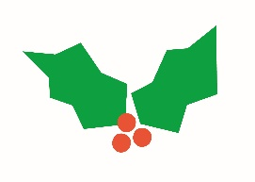

**NSPCC - Victoria Square Wrapping Schedule**

