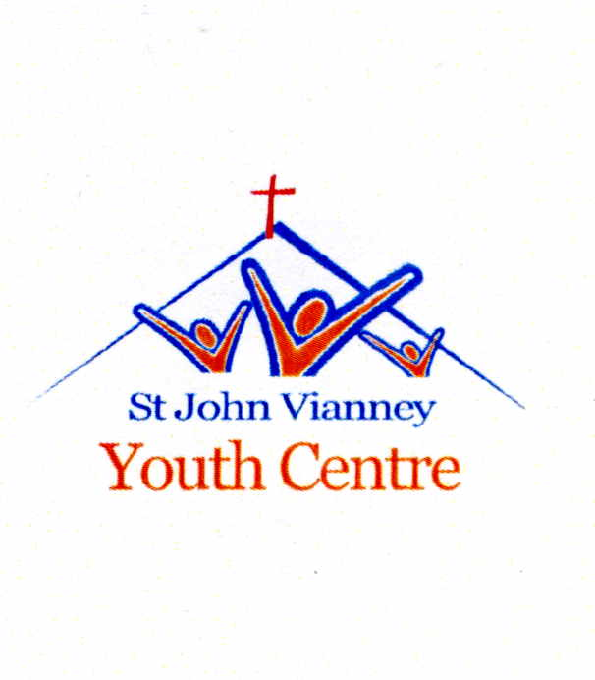

13 River Terrace, Ormeau Road, Belfast, BT7 2EN
Tel: (028) 90247118 E-mail: stjvyc@yahoo.ie
www.facebook.com/stjohn.vianney.1
Registered Charity No. – XR30019

EA Professional Youth Work Studentship Scheme

Role Description

Title: Youth Work Student (Fixed-term contract for a period of 3 years)

Location: St John Vianney Youth Centre

Hours per week: 36 hpw which will include working a minimum of 4 nights per week and 7 face to face sessions with young people. Students will work with young people of post primary school age for a minimum of 60%-70% of their weekly schedule.
Occasional weekend and residential work will also be a key feature of this studentship. Students will attend the BSc (Hons) Community Youth Work at the Ulster University 1 - 2 days per week (subject to requirements) to study.

Responsible to: Youth Worker-In-Charge

Bursary: The student will receive a bursary of £15,000 per annum towards their maintenance and subsistence costs.

Studentship purpose:
Students will be expected to work directly with young people to develop their social education by providing programmes of activities. The student will normally be expected to undertake key duties under the direction of a Professional Youth Worker. These may include;
- Assist with the planning and implementation of programmes, related to ‘A Model for Effective Practice’.
- Ensure that young people play an active role in the youth group and work towards a model of youth participation.
- Communicate effectively and develop a rapport with young people.
- Assist in the development of relationships with the wider community and external agencies.
- Assist young people to express and realise their goals.
- Provide information and support to young people.
- Support young people in evaluating youth work activities and the impact of youth work on their development.
- Implement the unit’s Child Protection Policy and work with young people to safeguard their welfare and the welfare of others.
- Assist with administrative duties as directed by the organisation.
- To carry out such duties, as may be assigned by the Line Manager, within the Studentship Placement Provider.

The Student will also be responsible for:
- Working diligently in pursuance of the professional youth work qualification;
- Attending all university classes and associated activities;
- Submitting assignments on time;
- Passing all modules in line with course requirements.
- All students must progress at each stage of the BSc course. If they do not progress, the bursary to the studentship placement provider will be terminated.
- In exceptional circumstances, where students face unforeseen circumstances, EA will consider whether alternative support can be provided. The student must be in good academic standing to be considered for exceptional support.

Person Specification

Essential Criteria

RESIDENTIAL STATUS

Applicants must be a permanent resident in NI.

EXPERIENCE

Applicants must by the closing date for receipt of completed applications:

- Have a minimum of 6 months experience in a paid or voluntary capacity of working with children or young people within the last 5 years.
- Be at least 18 years of age;

QUALIFICATIONS

- Have a minimum of one A’ Level qualification or equivalent or higher;
- Have a minimum of 3 GCSE’s (Grades A – C) to include English and Maths (or equivalent or higher);

KNOWLEDGE

Essential

- Demonstrate knowledge of issues affecting young people.

SKILLS

Essential

- Demonstrate ability to build and maintain relationships with young people;
- Effective communication skills;
- Problem solving skills;
- Organisational skills;
- Ability to work as part of a team.
- Empathy with young people.

PERSONAL QUALITIES

Essential

- Motivated;
- Enthusiastic;
- Ability to use own initiative;
- Reliable;
- Positive attitude;
- Flexible;
- Ability to accept constructive feedback;

OTHER REQUIREMENTS

Essential

- Attendance at all modules of the course including those organised over the summer months;
- To undertake an alternative placement in an EA locally registered voluntary youth work organisation.

Pre-placement checks

Any recommendation for an studentship will be subject to the following:-

- Proof of NI residency;
- Issue of a satisfactory Enhanced Disclosure Certificate;
- Receipt of original documentary evidence of qualifications (this will be required to register as a student at Ulster University 13/04/2017;
- Receipt of satisfactory references. At least one reference should be able to comment on the candidate’s suitability to work with children/young people in a youth work setting and their professional ability.

