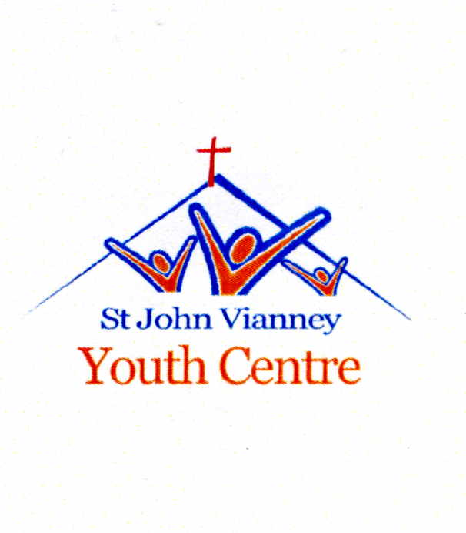

13 River Terrace, Ormeau Road, Belfast, BT7 2EN
Tel: (028) 90247118 E-mail: stjvyc@yahoo.ie
www.facebook.com/stjohn.vianney.1
Registered Charity No. – XR30019
EA Professional Youth Work Studentship Scheme
Student Information

Introduction

The Education Authority is pleased to announce an exciting new initiative to support the professional formation of youth workers in the Northern Ireland Voluntary Youth Work sector. Working in collaboration with the voluntary youth work sector and Ulster University (UU), the Education Authority has developed the EA Professional Youth Work Studentship Scheme. This is a very important development for the youth service in Northern Ireland and is built on the very successful practice developed by both YCNI and the previous Education and Library Boards.

Under this scheme EA have provided funding to 15 locally registered voluntary youth work sector organisations from across Northern Ireland to recruit and support a student youth worker to achieve a professionally recognised youth work degree at the Ulster University.

The funding available from EA will enable St John Vianney Youth Centre to pay a monthly maintenance, subsistence and travel costs (to and from university) to the student and the payment of university fees to Ulster University for a period of 3 years, ending 2020.

The Education Authority believes that by providing opportunities through the EA Professional Youth Work Studentships Scheme it will transform the way in which organisations acquire and develop the skills they need to operate in the contemporary world of youth work. This response will ensure that the Regional Assessment of Need and the Regional Youth Development Plan are embedded into EA funded front line youth work practice.

The Education Authority wants to ensure that opportunities are available to enable motivated individuals to progress into higher level learning and acquire the accreditation and recognition that professional skills can give. This approach is vital for the youth sector to attract new talent and for young people and adults to see Studentships as a route to professional status. This will also contribute to the provision of quality youth work services for young people.

For prospective students, the EA Professional Youth Work Studentship Scheme gives unique access to future employment opportunities in the youth work sector and the chance to develop valuable high level professional skills.

The successful student will be recruited by St John Vianney Youth Centre for the duration of their studentship. The organisation will receive a bursary from EA to pay the student maintenance and subsistence costs. EA will pay the fees for each of the 15 students directly to the Ulster University.

What is this Scheme?

This Studentships is a work-based training programme that enables individuals to benefit from ongoing training in a professional youth work setting, learn professional skills and gain a nationally recognised professional youth work qualification (BSc (Hons) Community Youth Work) while receiving a financial bursary to support them with maintenance and subsistence costs.

Benefits of the EA Professional Youth Work Studentship Scheme

The EA Professional Youth Work Studentship Scheme provides an alternative entrance route to starting a career in professional youth work.

Employability - You will gain lots of valuable knowledge, practical skills and work experience as well as an nationally recognised university degree – just the combination that can help increase your future employability, boost your CV, help you progress into management roles and open new career opportunities for you. This programme will provide you with an immediate 3-year fixed-term placement working and training in St John Vianney Youth Centre as well as attending Ulster University on a weekly basis. Professional youth work degrees are highly valued by a wide range of employers. Achieving the degree in youth work will therefore significantly increase your chances of getting a job in a multitude of settings.

A Stepping Stone to Professional Youth Work - You will gain a nationally recognised qualification – BSc (Hons) Community Youth Work which is NSETS/JNC recognised. This qualification will enable you to gain employment in Scotland, England, Wales, Northern Ireland and Ireland.

Bursary While You Learn - You will be provided with financial assistance (£15,000 per year) in the form of a bursary towards your maintenance and subsistence costs while you gain valuable professional youth work experience as well as gaining a recognised professional qualification.

Debt-free - The EA Professional Youth Work Studentship Scheme will allow you to start your highly-skilled career without the student debt that other university graduates will have accumulated during their degree course.

Course Details

- All Students will undertake the BSc (Hons) Community Youth Work degree at the Ulster University which is
NSETS endorsed/JNC recognised.
- This is a fast-tracked part-time course that will be completed in approximately 3 years.
- Some modules will be organised over the summer months. All Students must attend these.
- Course to begin May 2017.
- Students will be released approximately 1 - 2 days per week (subject to requirements) from their workplace to study the BSc (Hons) Community Youth Work at the Ulster University.
- All placements will be supervised by a professional youth work line manager.
- Students will be required to undertake one placement in an alternative organisational setting for a set period.

In light of recent ETI inspection reports and the changing face of contemporary youth work, assignment rubrics and assessment of competence will pay particular attention to the following key professional skills:

- Professional Identity – understanding of youth workers as educators – where youth work fits in on the continuum of education;
- Group Work – Students will be highly skilled group workers – group work will be a constant theme on the course;
- Curriculum Design – Students will be able to design a curriculum based on the age-specific needs of young people that provides variety and promotes their personal and social development;
- Individual Work – Students will be highly competent in helping skills;
- Leadership and Management – Students will develop core skills of leadership and management i.e. beyond theory;
- Networking/Partnership Working- Students will be competent in networking and working in partnership with other agencies;
- Assessment of Need/ Area-based Planning – Students will be competent in assessing the needs of young people in local communities;
- Quality Assurance – Students will be able to systematically apply a QA framework to underpin and continuously improve their work;
- Report Writing- Students will be competent in how to structure and write reports to professional standards;
- Outcomes–based Youth Work/Reporting – Students will have a clear understanding of outcomes based youth work and how to report the learning of young people;
- Financial Accountability/Budgeting – Students will be competent in financial systems and how to develop budgets;
- Teaching/Training – given the range of youth workers currently working in schools students will be competent in the delivery of teaching/training skills;

- The above list is not exhaustive and may be subject to further development;
- EA will expect the highest professional standards to be imparted to students through this scheme.

How does the EA Professional Youth Work Studentship Scheme work?

EA has appointed St John Vianney Youth Centre to recruit, manage, supervise and mentor one of the student youth workers for a fixed term period of 3 years. EA has awarded financial assistance to St John Vianney Youth Centre for administration costs and to pay a bursary to their student.

Students will receive an annual bursary of £15,000 towards their maintenance and subsistence costs.

Students will work a 36 hour week in a front line youth work position during which time they will be released approximately 1-2 days per week (subject to requirements) to study the BSC (Hons) Community Youth Work at the Ulster University.

Applying

You may apply to as many of the available positions, across the Voluntary Youth Sector, as you wish.

Following submission of your application, you will go through a formal recruitment process.

Students will have undertaken A-Levels or other suitable Level 3 qualifications and have some experience of working with young people. All applicants must be Access NI checked prior to being employed.

All Applicants must be able to demonstrate that they have the academic ability to cope with the demands of a university degree course.

Interested?

All enquiries about the EA Professional Youth Work Studentship Scheme through St John Vianney Youth Centre should be addressed to:
Stevie Mulholland
Youth Worker- In- Charge
Tel: 028 90247118
Email: stjvyc@yahoo.ie

