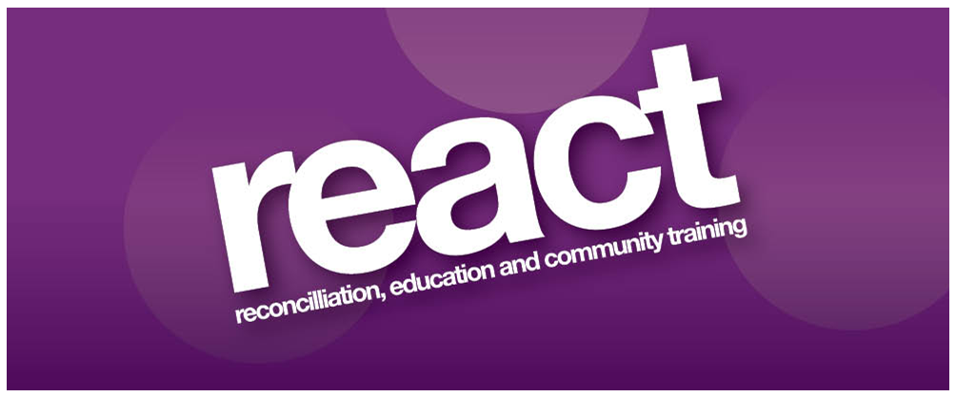

Invitation to Tender

Sessional Yoga and Pilates
Instructors

May 2017

Introduction
REACT is seeking to recruit reputable, experienced and qualified sessional Yoga and Pilates instructors to deliver Yoga and Pilates classes to members of the REACT Victims and Survivors Project.

Background
REACT Victims and Survivors Project offers health and well being and social support services to individuals directly affected by the NI Conflict, their families, and carers in the Armagh area.

Programme delivery will include:
- Yoga and Pilates classes for individuals with a history of trauma and associated ailments
- Relaxation training for individuals with a history of trauma and associated ailments

Personal Specification
Sessional Instructors must meet all the personal specification criteria:
- A recognised qualification in Yoga, Pilates or relevant area of work (Minimum Diploma Level)
- 3 years paid experience working as an instructor
- Valid Public Liability and Professional Indemnity
- Member of a relevant recognised professional body
- Experience of working with older clients with a range of health issues

Duration of contract
The contract expires on the 31st March 2020 but may be concluded or extended dependent on funding.

Pricing
£60 per one hour session to include delivery and supplying exercise mats for 8 participants.
Price quoted is inclusive of VAT and cannot be subject to increase during the term of the contract.

Format of Tenders
Tenders must include a copy of a CV, all relevant qualifications, current professional insurance and current membership of relevant professional bodies. Failure to comply will render the tender proposal invalid.

Proposals
The tender proposal and relevant documents should be submitted in hard copy to:
Sessional Yoga and Pilates Instructor Tender
REACT
2 Mallview Terrace
Armagh
BT61 9AN

To arrive no later than 3pm on Wednesday 24th May 2017. Emailed copies will not be accepted. Proposals that are received late will not be considered.

Termination of Contract
REACT reserves the right to terminate the contract at any time following one month’s notice to do so. However, any breaches of contract may result in immediate termination. The contract may be cancelled by the successful tenderer provided one months’ notice in writing has been given.

Contractually binding information
All information supplied by tenderers will be treated as contractually binding. However, REACT reserves the right to seek clarification or verification of any such information.

Conflicts of Interest
Any conflicts of interest involving a tenderer must be fully disclosed to REACT, particularly where there is a conflict of interest in relation to the aims of the project.

Insurance Requirements
Tenderers must produce all Insurance for Employers and Public Liability and Professional Indemnity and any other required insurances. The successful tenderer will be required to produce valid certificates for the duration of the contract.
Queries relating to this document and any of the requirements stated herein should be directed in writing or email to,

REACT
2 Mallview Terrace
Armagh
BT61 9AN
Tel: 028 37526869
Email: info@reactni.org

REACT promotes equal opportunities.

Registered Charity Number: XR 33610

The above project is funded under the Victims Support Programme for Groups Working with Victims and Survivors, which is administered by the Victims and Survivors Service on behalf of the Northern Ireland Executive Office.

