
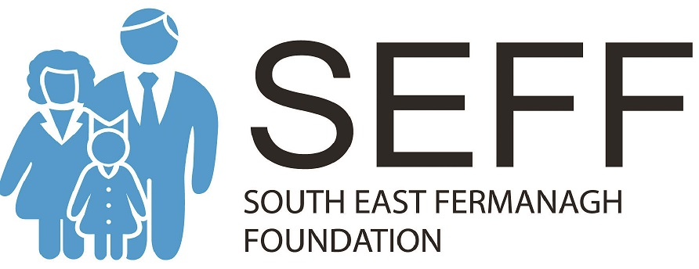
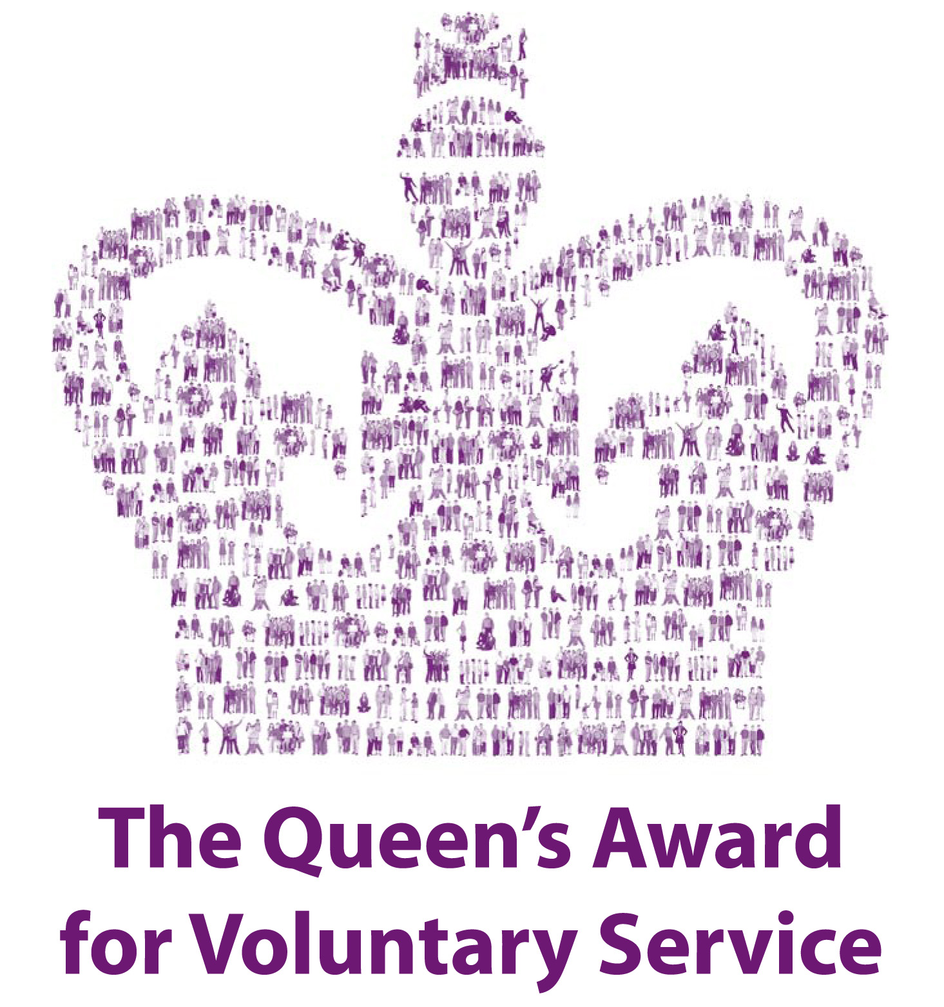
Job Description

Project Co-Ordinator

Job Title: Project Co-Ordinator - ‘Celebrating South Fermanagh’s Cultural Diversity’ Project
Employer: South East Fermanagh Foundation (SEFF)
Responsible to: SEFF’s Director of Services and Management Board
Based at: 1 Manderwood Park, 1 Nutfield Road, Lisnaskea. County Fermanagh. BT92 0FP
Job Purpose: To deliver a programme of activities as part of the ‘Celebrating South Fermanagh’s Cultural Diversity’ Project
Salary: £6,920.24 (based on 8 month contract at 15 hours per week) plus 6% pension contribution
Period of post: Up to 31st March 2018
Hours of work: 15 hours per week
Some duties will entail evening and weekend work. A system for taking time in lieu of hours worked outside the normal working day is in place.

Purpose of Job

- Planning of all activities and events as part of the project (both older people’s and younger people’s elements) including monitoring and evaluation of the same.
- Project publicity and promotion.
- Development and maintenance of a monitoring and evaluation system.
- Financial and budget management in association with other staff and management board.
- Network and liaise with other relevant organisations in facilitation and delivery of project.
- Maintaining SEFF's activities and operations in line with organisational policies and procedures.

Other responsibilities

- Keep accurate and up to date records.
- Report to the Director and Management Board on a regular basis.
- Development of Social media and Facebook page.
- Other tasks as required commensurate with post.

Person Specification

Essential

- 1 years’ paid or voluntary experience within this field of work ie. community / voluntary sector, project management / co-ordination.
- 5 GCSE’s (A-C) or equivalent and be able to demonstrate competency in use of IT.
- Excellent organisational abilities and work priorities.
- Be competent in sourcing grant-aid, completing funding applications and of spending and evaluation of Project activities.
- Experience in working with and supporting Older people.
- Experience in Youth Work.
- Have experience of various art forms including; drama, storytelling etc.
- Ability to work without direct supervision and self-manage.
- A welcoming manner and a willingness to work flexibly as part of a team
- A good standard of education, with excellent numeracy.
- Networking and negotiating skills.
- Commitment to secure funding to further develop and sustain the project.
- Have initiative and self-motivation.
- Ability to be resourceful and visionary.
- Good written and oral communication and presentation skills
- Administrative experience.
- Computer literate in word processing, spreadsheets, databases and internet use.
- Hold a full driving licence and/or have access to transport.

Desirable

- Fundraising experience.
- Be trained in first aid.

