Person Specification | Mentoring Coach | 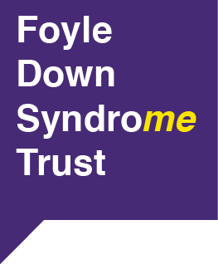  Fostering a Culture  of Inclusion

Criteria | Essential
Education | Educated to degree level or equivalent in related field
Experience | Experience of developing and coordinating projects with and for children or young people with a learning disability  Experience planning and prioritising work activities  Experience reporting on and evaluating projects
Abilities /  Skills /  Knowledge | Ability to consult children and young people with a learning disability to ensure their voice is heard and that they are empowered in the project’s work.  The ability to motivate and encourage both volunteers and children and young people with a learning disability  Excellent interpersonal, organisational and communication skills including the ability to communicate clearly and concisely  An understanding of health and safety requirements in providing support to children with a learning disability  The ability to be calm and resilient whilst under pressure and to remain optimistic and persistent  Understanding of Safeguarding Vulnerable Children and Adult Protection  Reliable, approachable and non-judgemental  Evidence of the ability to work as a team member, understanding the importance of seeking guidance and support when required  Understanding the importance of providing appropriate timely updates to members, stakeholders and management  Evidence of ability to plan and prioritise work activities  The ability to use own initiative and work independently

