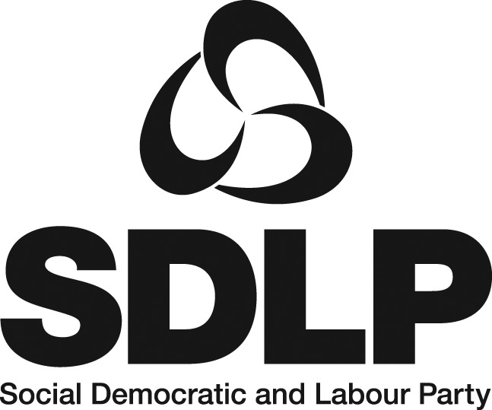
Head of Campaigns

ESSENTIAL CRITERIA

Qualifications

- A degree in, for example, social policy, politics, history, law, or equivalent qualification, and at least 5 years’ experience in either the professional communications or policy development fields.
- OR a minimum of 8 years’ experience in either the professional communications or policy development fields.

Experience

- Developing and promoting a wide range of policy initiatives.
- Presenting public affairs across all media platforms.
- Developing and implementing media/social media strategies.
- Capacity to develop a close professional relationship with the media.
- Planning work effectively to meet deadlines and goals in a pressurised environment.
- Strong analytical and research skills.
- Excellent organisational and administrative skills.

Knowledge and Skills

- Knowledge of public policy issues and policy formulation, and familiarity with relevant policy networks and NGOs.
- Ability to understand, interpret and advise on draft legislation.
- A thorough knowledge of modern publicity and communications techniques, throughout all media.
- Excellent oral and written communication skills.
- Ability to write and analyse reports and produce succinct and focussed summaries.
- Proven people/team management skills.

Personal

- Excellent interpersonal skills and the ability to operate with impact at a senior level.
- Approachable, calm under pressure and able to lead with integrity.
- A strong personality with the ability to communicate effectively to achieve results.
- The successful applicant must demonstrate how s/he meets the mobility requirements of the post.

