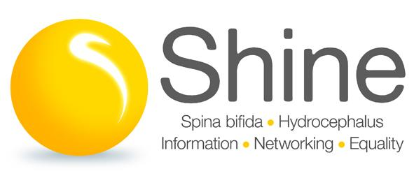
Part-time Support and Development Worker – Northern Health and Social Care Trust area

If you want to work in a job where you can really make a difference to people’s lives, this may be the role for you. An exciting opportunity is open for a part time Support and Development Worker based in the Northern Health and Social Care Trust area. You will support, advise and empower people affected by spina bifida and/or hydrocephalus, through a variety of means.

Relevant experience in social work, nursing, an allied health profession, or teaching is preferable but not essential, and previous work with people with physical disabilities or learning difficulties will be an advantage. Shine places high value on enthusiasm and commitment to the cause, and for the right person this role will be extremely fulfilling. The abilities to work effectively from home and travel throughout NI are essential.

Hours: Part time – 17.5 hours per week

Duration: Permanent

Salary: £24,000 - £25,170 pro rata (dependent on experience)

Closing date for applications: 12 noon on Wednesday 29th March

Interviews will be held during week beginning 10th April

For a full job description and application form please click the documents below

Please return your completed applications, specifying which position you are applying for, to recruitment@shinecharity.org.uk

Shine welcomes applications irrespective of disability, creed, age, ethnic origin, gender or sexuality; and the successful applicant will be subject to an enhanced Access NI check. Shine is committed to protecting and safeguarding children and vulnerable adults.

