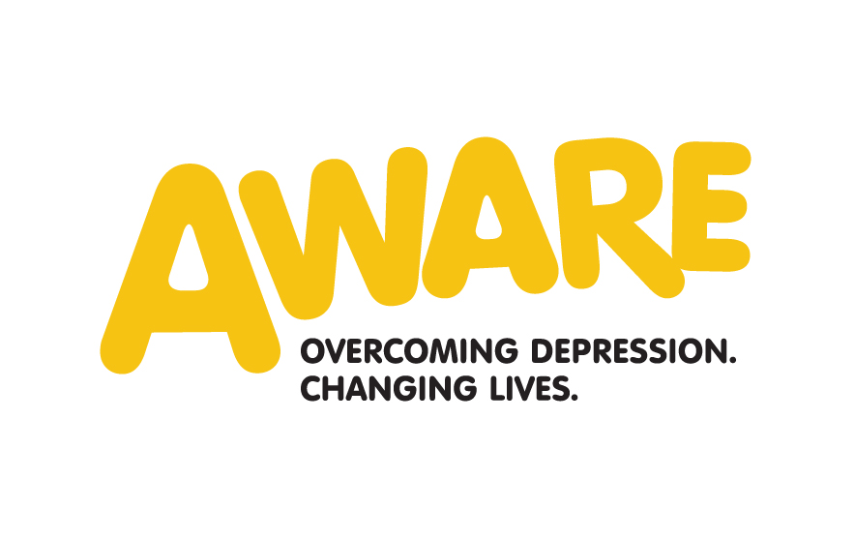

Job Description
Community and Events Fundraising Officer

Location | Belfast Office of AWARE but with a regional remit
Reports to | Director of Fundraising and Communications
Hours | 36 hours per week
Salary | £24,459.48
Key Internal relationships | CEO, Senior Management Team and staff, volunteers, members and sessional trainers
Key External Relationships | The local community, business, public and private sector and community / voluntary groups
Duration of contract | A permanent contract will be offered to the successful candidate pending successful completion of a 9 month probationary period

Purpose of Post

To increase unrestricted income by organising community and events fundraising activities. To develop a fundraising strategy that will allow us diversify our activities to in order to maximise net income.

Key Responsibilities

General Responsibilities

- Liaise with the Director of Fundraising and Communications in order to agree and develop a fundraising strategy that will raise an agreed annual target of unrestricted income.
- To ensure that all activities are carried out in accordance with the values of the charity.

Events Fundraising Responsibilities

- To organise and deliver profitable AWARE events
- To organise a calendar of events throughout the year and recruit adequate volunteers, supporters and work with the Communications Officer to utilise social media, website and other media coverage before and after the events.
- To develop new and imaginative fundraising activities, which are community and events based, in consultation with colleagues, Senior Managers and Director of Fundraising and Communications.
- Actively market and promote events including the use of social media.
- Manage the fundraising budget to ensure events are within specified income and expenditure limits.
- Ensure all participants including online and offline fundraising are thanked for all fundraising activity in line with the donor strategy.
- Ensure all income is banked within the company time limits.
Community Fundraising Responsibilities
- To recruit key fundraising volunteers and establish a volunteer database with at least 50 volunteers
- Work with schools, colleges and universities where AWARE has a close relationship to generate fundraising income through creative fundraising activities and promote the importance of mental wellbeing.
- Provide them with support to establish a fundraising committee in Belfast with other key areas as agreed by Director of Fundraising and Communications.
- To work with other key staff to develop links with community organisations in key towns across the region and with our support group facilitators to develop local knowledge, presence and profile within communities
- To liaise with the Communications Officer to raise the profile of the organisation to assist in the recruitment of fundraising volunteers in order to maximise voluntary income opportunities.
- To organise traditional fundraising activities such as flag days, bag packs, sponsored walks, fashion shows, and recruit teams and individuals for marathons challenge events and recruit adequate volunteers for these activities
- To build and maintain long-term fundraising relationships with all our fundraising volunteers and ensure that all volunteers receive ongoing supervision, support, training and recognition in accordance with appropriate policies and procedures.
Other Responsibilities
- To work with the Director of Fundraising and Communications to research and develop a strategy for individual giving and in memoriam donations and legacy marketing.
- To keep the donor database up to date with all contacts and to develop a personalised “thanking process” that is efficient and professional
- To continue to promote E-Giving as a way for people to donate to the Charity and to people who are raising money for us
- To take responsibility for all income and prepare monthly report for Director of Fundraising and Communications and quarterly reports to the Board of Trustees.
- To promote the take up of Gift Aid on donations and draw down all Gift Aid associated with Fundraising activity

Person Specification
Community and Events Fundraising Officer

1. Qualifications

Essential | Degree level education or equivalent ( 5 years community and events fundraising experience)
Desirable | Relevant management or post graduate or professional qualification

2. Experience

Essential | At least 3 years successful community and events fundraising in a full time paid capacity.
 | Experience of securing significant funds through community and events fundraising techniques
 | Experience in using a range of computer packages including MS Office, particularly Word, PowerPoint and Excel
 | Experience in the successful recruitment, support and retention of volunteers specifically for fundraising activity
 | Experience in establishing fundraising committees
 | Experience of working within a team with different functional roles and developing relationships with internal stakeholders
 | Experience of working on own initiative in developing fundraising activities, motivating people to work with us and working with sectoral interests in the area
 | Experience of developing new fundraising initiatives
 | Demonstrable experience in managing fundraising events and challenge events.
Desirable | Experience of voluntary or public sector organisations
 | Good understanding of other fundraising disciplines

3. Skills, knowledge and abilities

Essential | Excellent interpersonal skills and the ability to communicate well with a broad range of people
 | Excellent written and oral communication skills and confidence to represent the organisation publicly
 | Demonstrable knowledge of community and events fundraising methodologies and an in depth knowledge of current community, events, corporate fundraising trends and techniques
 | Ability to develop and maintain networks and build relationships with potential supporters, volunteers and others in the community, voluntary and private sector
 | Financially AWARE with strong knowledge of donor databases, Gift Aid and E-Giving
 | Ability to communicate with people at all levels, using a range of medium to ensure that a consistent organisational message is communicated.
 | Ability to work with the Communications Officer to publicise events using all possible media
 | Ability to prioritise, manage a busy workload and meet deadlines
 | Ability to monitor income and produce reports to the CEO in a timely manner
Desirable | Strong knowledge of the community and voluntary sector in NI

4. Personal Style and behaviour

Essential | Able to sign up to and promote the values of the organisation
 | Willingness to undertake relevant on the job and external training as required
 | Willing to sign up to the organisations standards of conduct
 | Willingness to abide by the organisations policies and procedures
 | Committed to the work of the organisation
 | Be open minded, non judgemental and have a willingness to question own attitudes
 | Ability to empathise with service users regardless of race, gender, age, religion, nationality, marital status, sexual orientation or disability
 | High level of drive and personal motivation to achieve results
 | A team worker who is friendly, approachable and enthusiastic
 | Enthusiasm and flexibility to adapt to changing circumstances and capitalise on new opportunities
 | Well developed negotiating, influencing and persuading skills

5. Other

Essential | Willingness to work flexibly including evening and weekend work
 | Willingness to travel across the region and further afield including ROI, and UK if the post requires it.
 | Access to a car or other means of transport to fulfil the travel requirements of the role

