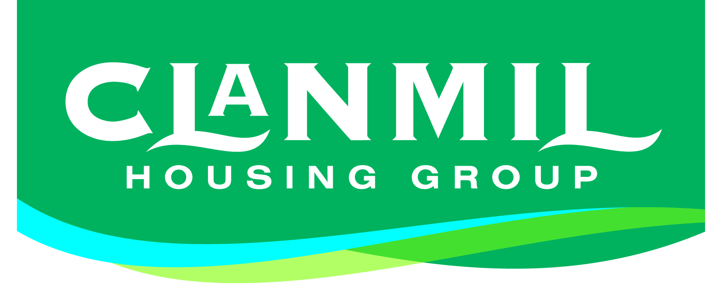
RECRUITMENT MONITORING FORM

Please read the Guidance Notes provided before completing this form.

Clanmil Housing Association is committed to equal opportunities and fair employment. Our aim is to ensure that all applicants are given equal opportunities regardless of age, disability, ethnic or national origin, gender, marital status, political opinion, race or colour, religion or sexual orientation. This sheet is detached from the remainder of your application and does not form any part in the selection process.

Please return it in the envelope provided.

Under Data Protection Regulations, this form will be held securely and only accessed by the Monitoring Officer in order to provide statutory statistics to the Equality Commission in Northern Ireland.

The following section is compulsory and failure to complete will mean that we cannot consider your application.

You are required under Fair Employment Law to provide this information.
Reference No.

Date of Birth:

Gender |  | Male Female Transgendered
Community Background | Protestant |  | Roman Catholic | Neither Roman Catholic nor  Protestant
Please state the name of primary school attended in Northern Ireland:

The following section will help Clanmil to monitor applications for employment to help promote equality of opportunity.
This section is voluntary and will not prevent your application being considered.

DISABILITY
The Disability Discrimination Act 1995 defines disability as “A physical or mental impairment which has a long-term affect on a person’s ability to carry out normal day-to-day activities.”
Do you consider yourself to be disabled? | Yes No
If yes please tell us about your disability:

RACE/ETHNIC ORIGIN
To which of these ethnic groups do you consider you belong:
WHITE UK/IRISH |  |  |  | WHITE OTHER Please specify
BLACK AFRICAN |  |  | BLACK CARIBBEAN |  |  |  | BLACK OTHER Please specify
INDIAN | PAKISTANI |  |  |  | BANGLADESHI |  | MIXED ETHNIC GROUP Please specify
CHINESE |  | IRISH TRAVELLER |  |  |  | ANY OTHER GROUP Please specify

MARITAL STATUS

SINGLE

MARRIED/IN A CIVIL PARTNERSHIP
DIVORCED/FORMERLY IN A CIVIL PARTNERSHIP WHICH IS NOW LEGALLY DISSOLVED
WIDOWED FROM A MARRIAGE/CIVIL PARTNERSHIP
SEPERATED, BUT STILL LEGALLY MARRIED/IN A CIVIL PARTNERSHIP

DEPENDANTS
Do you have personal responsibility for the care of___________? (Tick each box that applies to your circumstances)

A CHILD OR CHILDREN

A PERSON WITH A DISABILITY
A DEPENDANT OLDER PERSON
NONE OF THE ABOVE

POLITICAL OPINION

UNIONIST

NATIONALIST
NEITHER

SEXUAL ORIENTATION
My sexual orientation is towards someone:

OF THE SAME SEX (this covers gay men and lesbians)

A DIFFERENT SEX (this covers heterosexual men and women)
OF THE SAME SEX AND OF THE OPPOSITE SEX (this covers bisexual men and women)

