Making an ‘Impact’ on Autism Accessibility

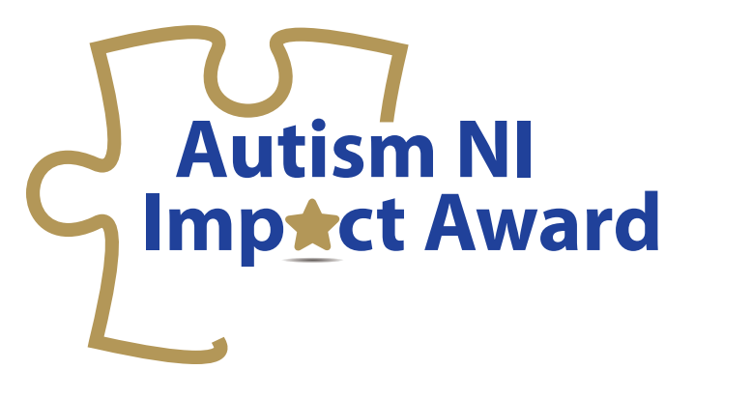
Date: 25th October 2017
Time: 11-1pm (lunch provided)
Venue: Stormont Hotel
Barnett suite
Upper Newtownards Road
Belfast
BT4 3LP

As part of the Impact Award initiative, Autism NI are hosting a free event for businesses and organisations across Northern Ireland to find out more about what Autism Accessibility means for their organisation.
The event will explore more about Equality legislation surrounding Autism Accessibility and the steps an organisation can take to become more Autism friendly for the 30,000 individuals affected by Autism in Northern Ireland.
The event will explore:
- What does it mean to become Autism Accessible?
- The steps needed to become more accessible in your organisation
- The Impact of Autism Accessibility
- A range of ‘Gold Standard’ good practice case studies

Who should attend: Public and private sector organisations, Council Equality Officers, Customer Service Managers.

All delegates attending this event will receive an exclusive discount code for the Autism Impact Award Scheme.
Places on this event are strictly limited and early booking is recommended. To book a place on this event, please complete the booking form overleaf and return it to christine@autismni.org.

Booking Form

Making an ‘Impact’ on Autism Accessibility
25th October 2017 (11-1pm)

Name
Organisation
Full Postal Address
Email
Telephone Number
Special Requirements (e.g. Access/ Dietary/ Support/ Other) | Yes No  Please Specify:

Please complete and return booking form to Christine Quail, Autism NI, Donard, Knockbracken Healthcare Park, Saintfield Road, Belfast BT8 8BH or email christine@autismni.org
Confirmations will be sent by email only.

