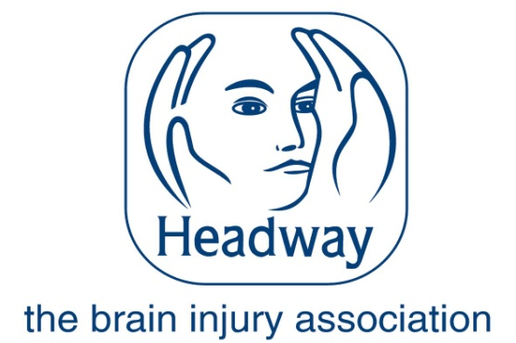
Dear Applicant,
Re: ABI Services Coordinator Western HSCT Vacancy
Please find the attached documents relating to the post:
- Application form
- Job description
- Personnel specification
- Equal opportunities monitoring form
- Guidance notes
Please refer to these documents for the purpose of your application.
Your completed application must be returned to us by 5.00pm on Thursday 29th June 2017. If posting, please use a separate sealed envelope for the completed monitoring form marked for the attention of the Monitoring Officer.
Hard copy: Electronic copy:
Headway the brain injury association Johny.Turnbull@headway.org.uk
C/O Regional Acquired Brain Injury Unit
Musgrave Park Hospital
Stockman’s Lane
Belfast
BT9 7JB

May I take this opportunity to thank you for your interest in Headway the brain injury association, we look forward to receiving your application.
Yours faithfully
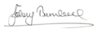
Johny Turnbull
Network Support Manager Northern Ireland

