

**Membership Support Officer**

**(Northern Ireland)**

**Job Information Pack**

**October 2017**

4th January 2016

**Membership Support Officer (Northern Ireland)**

**Part Time, 12 months fixed-term contract**

Dear Applicant,

Thank you for expressing an interest in the role of Membership Support Officer (Northern Ireland).

Sported is a free membership organisation that offers organisational development and support to groups and organisations in the community and voluntary sport sectors in the UK. We recognise that many of the organisations which are great at delivering sport and activity to young people would benefit from support on the business side of their activity, and we want to provide that, to ensure they are operating to the maximum of their potential and to enable them to do what they do best – change the lives of young people.

We are also working to demonstrate the value of “sport for development” and its ability to change young people’s lives – our work moving forward will focus on demonstrating impact as well as on continuing to deliver our services. Those services include online resources around business development, bespoke consultancy and grant funding.

For more information about Sported and our programmes please see [www.Sported.org.uk](http://www.Sported.org.uk)

We are currently seeking to appoint a Membership Support Officer for Northern Ireland to maintain and build on the strong relationships that have been forged with our member groups and volunteers across Northern Ireland. The successful candidate will also be tasked with supporting the Northern Ireland team in the development and delivery of new projects and initiatives.

Yours faithfully

**Brenda Kelly**

National Manager, Northern Ireland

**Background Information:**

Sported was established by Sir Keith Mills, who was inspired by the commitment made in Britain’s Olympic bid to use the London 2012 Olympic Games to improve the lives of disadvantaged young people in the UK.

Sportedsupports community and voluntary sector organisations that use sport as a vehicle for personal and community development, rather than those which promote particular sports or look for elite players. These projects do not form part of the school or club structure and range from third sector organisations to community based groups and inspirational individuals.

Sported aims to bring together as many members as possible under the ‘sport for change’ umbrella, giving community sports organisations the opportunity to be part of something national, recognisable and credible.

Through capacity building services, a volunteer mentor programme, project funding and other be-spoke member services, Sportedprovides operational and financial resources to their members, helping them to build their business expertise and sustainability.

Sported has 12 offices around the UK’s nations and regions, and is a UK registered charity governed by a Board of 10 Trustees.

**Overview of Role:**

|  |  |  |
| --- | --- | --- |
| **Job Title** | **Membership Support Officer (Northern Ireland)** | |
| **Reports to** | Development and Delivery Manager, Northern Ireland | |
| **Role** | To support the delivery of Sported services and projects in Northern Ireland | |
| **Hours** | 22.5 hours (3 days) per week.  Sported operates a core work hours system, meaning employees can structure their work around the core hours of 10am and 4pm.  There will be an expectation to work some evenings and weekends. However, time off in lieu, in accordance with the Sported policy, will be offered for anti-social hours. | |
| **Contract** | 12 months (with a possible extension) | |
| **Location** | Belfast | |
| **Salary** | £21,000.00 per annum, pro rata. | |
| **Holiday** | 25 days holiday per annum (pro rata) in addition to statutory bank holidays. | |
| **Main Relationships** | **Internal:**   * Development and Delivery Manager- Northern Ireland * National Manager, Northern Ireland * Head of Member Services * Volunteer Services Team * Evidence and Learning Team | **External:**   * Sported Members * Sported Volunteers * Sported Partners |

**Main Duties & Responsibilities**

**To provide administrative support for Sported’s services in Northern Ireland**

* Build strong relationships with the Sported Northern Ireland Membership
* Work closely with Sported’s Volunteers and setting up of placements with member groups.
* Volunteer recruitment – working with Sported’s Operations Manager Northern Ireland and Volunteer Services team to, prepare adverts, organise training and networking events
* Support the ongoing delivery of member services
* Co-ordinate, administer and support the delivery of meetings, workshops and events, including member capacity-building workshops
* Collate statistics and other information, and use the data to produce reports or summaries.
* Keep the membership administration and database up to date
* To respond to member queries and questions regarding Sported services
* Collect information for new web stories, newsletters and press releases
* Work in co-operation and partnership with Sported Central team on new initiatives as appropriate
* Liaise and work with Sported’s Central Team including Member Services, Evidence and Learning, Marketing and PR
* Attend events as appropriate to help promote Sported to relevant groups
* Attend and contribute to regular Sported Team Meetings
* Any other duties as appropriate

**Person Specification:**

**Part 1: Knowledge and Experience**

*Essential*

* 2 years’ experience (either in paid or voluntary role) in the voluntary, community or sports sectors
* An understanding of the needs of groups and organisations offering community sport to disadvantaged young people
* Experience of a client facing or membership support role
* Experience of an administrative role, ideally in a relevant sector
* Experience of database management, including Microsoft Office
* Experience of the administration of events
* Experience of recruiting and supporting volunteers

*Desirable*

* Experience of delivering presentations

**Part 2: Skills and Attributes**

*Essential*

* Ability to manage own workload
* Strong verbal communication skills – the ability to build rapport with members via a range of communication methods
* Strong organisational and prioritisation skills
* Excellent administrative and IT skills
* Commitment to the aims of Sported

**Part 3: Competencies**

*Essential*

* Adaptability: Maintaining effectiveness when experiencing major changes in work tasks or the work environment; adjusting effectively to work within new work structures, processes, requirements or cultures.
* Planning and Organising: Establishing courses of action for self and others to ensure that work is completed efficiently.
* Communication: Clearly conveying information and ideas through a variety of media to individuals or groups in a manner that engages the audience and helps them understand and retain the message.
* Continuous Improvement: Originating action to improve existing conditions and processes; using appropriate methods to identify opportunities, implement solutions and measure impact.

**Part 4: Personal Circumstances**

*Essential*

* Commitment to the aims of Sported
* Able and willing to work outside of office hours as required
* Willing to travel to regional and national meetings
* A current driving licence and access to a car (or able to make suitable transport arrangements) that will enable the applicant to fulfil the duties of the role in a timely manner across Northern Ireland

**Recruitment Timetable:**

|  |  |
| --- | --- |
| **Stage** | **Date** |
| **Closing date for applications** | Friday 20th October 2017 5pm |
| **Applicants to be notified if successful for interview by** | By 5pm on Wednesday 25th October 2017 |
| **Interviews** | Tuesday 31 October 2017 |
| **Role commences** | ASAP |

If you have any questions about the role please contact **Judith McComb on j.mccomb@sported.org.uk**

To apply for this role please complete the application form and equality monitoring form and send it to [recruitment@sported.org.uk](mailto:recruitment@sported.org.uk)

**Please note:**

We are a small organisation with limited resources; therefore only successful applicants invited to interview will be contacted. Please assume that if you have not heard from us by 2nd November 2017 that you have not been successful for interview.

We would like to thank all applicants for your interest in Sported and the time taken to apply for this position.

**ADDITIONAL INFORMATION:**

**Mentor Supported project case study - The Running Charity**

The Running Charity is a unique new charity that provides running and fitness-based initiatives to homeless and disadvantaged young people aged 16-24, using the great value of sport as a catalyst for proactive and productive social change.

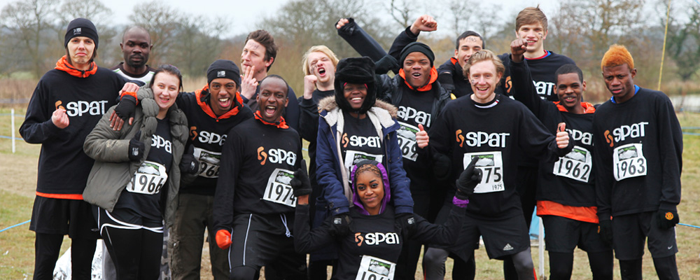

**Sported mentors:** Anas Hassan and Jessica Anstee

**Professional expertise:** Strategy consulting, business planning and marketing

**Sported mentor period:** September 2013 – April 2014

**Mentor investment:** One day’s consultancy a month per mentor

**Then…**

When Sported mentors Anas Hassan and Jessica Anstee first started working with The Running Charity (formerly known as SPAT), they were immediately impressed by the organisation’s innovative concept and the enthusiasm and drive of the founders - James Gilley, James Butler and Alex Eagle. All that was missing was some business experience and a roadmap to guide the organisation’s plans and priorities.

Using their collective strategic and marketing expertise, Anas and Jess helped the founders channel their obvious energy and creativity into developing a sustainable business plan, laying the foundations for The Running Charity’s future growth.

**And now…**

The Running Charity has become a registered charity with the infrastructure and resources in place to support many more young people. What started as a small group of runners in North London is on the verge of turning into a national movement, helping young people all over the UK.

**The Running Charity’s key achievements:**

* Thanks to The Running Charity’s work, society saved £4,427,008*
* Secured £9,982 grant from Sported following mentor support
* Gained official charity status by Charity Commission
* Announced Olympic gold medallist Colin Jackson CBE as the charity’s patron
* Rebranded from SPAT to The Running Charity
* Established a Board of Trustees

* *Source: Sported’s Sportworks data, Sept 2012 – Oct 2013*

*“The Sported team in London and our mentors started helping us at the perfect time, we had to establish an organisational structure and a programme structure quickly and make sure both were flexible when we would finally become a charity. Sported were essential for building the correct foundations for us to flourish on.”* **James Gilley, Founder of The Running Charity**

**The mentor’s story - Anas Hassan**

*“When I first met James Gilley, I was instantly struck by his passion for using running to improve young people’s lives, and the energy and tenacity with which he pursued his aspirations for The Running Charity. My concern was that he might find it hard to juggle all the many competing priorities involved in starting up a new charity. That’s where Jess and I came in.*

*I feel we were able to support James and his colleagues in two main ways.*

*First, we provided some practical support and guidance around strategic and business planning, budgeting, fundraising, marketing and governance. Second, we acted as a sympathetic, yet objective, sounding board – setting up a charity can sometimes be a lonely and difficult process.*

*The Running Charity has developed in leaps and bounds during the project. Jess and I really enjoyed being part of that, and are very much looking forward to the next exciting chapter of The Running Charity’s story.”*

**The young person’s story – Claude (23)**

•     *“I first joined The Running Charity as a member on the fitness programme roughly a year ago, James came to the youth centre I was attending to tell us about his great idea and to have our help to design the programme. His passion shone through and that won a lot of us over. Two years later, I'm now an instructor and mentor to new members.*

*As a group we meet up every week and run around the streets of London. The best thing about The Running Charity when I was homeless was that it was an escape for me. When you are homeless your entire world revolves around being homeless and The Running Charity was an escape and somewhere I could just be myself. With running and with life, you only get what you put in, and once you have achieved something great, your confidence shoots up.*

*This programme taught me goal-setting to get physical benefits, but the team helped me take this approach into my everyday life which now helps me on a daily basis to keep striving for the things I love. I'm also very confident in my abilities and love to give back by volunteering at The Running Charity.”*

•