Job Description | Mentoring Coach | 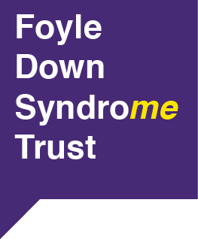  Fostering a Culture  of Inclusion
Status of Post  Full time  (30 hours per week) | Post Role  To work as part of a team to motivate, engage and support young people with Down syndrome to participate in and enjoy a mentoring support project | Responsible to  Manager

PRINCIPAL DUTIES AND TASKS

Responsible for the development of a mentoring programme for young people with Down syndrome, aged 8 to 25 through the identification, recruitment, support and development of volunteer mentors

Develop, co-ordinate and delivery of mentoring sessions

Production of mentor recruitment materials

Development of Induction process in conjunction with Manager

Together with Manager, interview and select new volunteer mentors

Match volunteer mentors with young people with Down syndrome and monitor the relationship

Initiate action plan in relation to health and well being of each project participant

Maintain monitoring and evaluation records against required outcomes and relay same in a timely manner to Manager

Build positive relationships with project participants

Assess and establish the reasons behind health and well being barriers

Develop suitable programmes to help improve health and well being of project participants

Ensure that all volunteers are made feel an integral part of Foyle Down Syndrome Trust

Support project participants in one-to-one and group sessions as part of a structured programme of mentoring

Assign appropriate task and duties to volunteers

This role will involve organising residentials and working Saturdays

