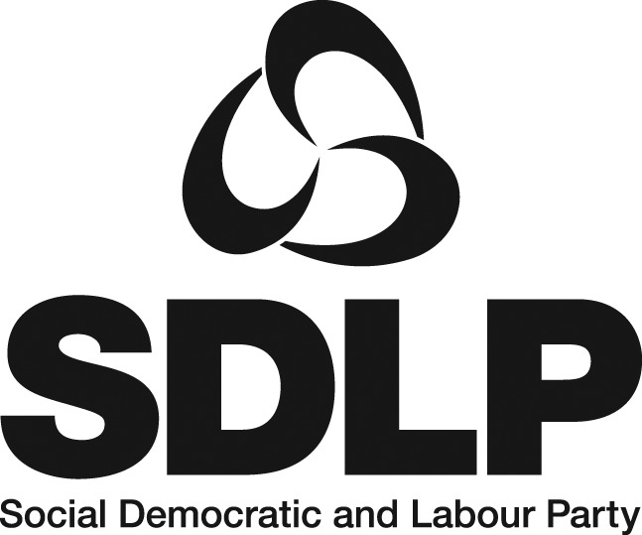

JOB DESCRIPTION

Job title: Head of Campaigns

Reports to: Party Manager

Responsible for: Policy and communications staff (Campaigns Unit)

Locations: SDLP HQ and Parliament Buildings, Stormont

Key purpose:
- Build a dynamic SDLP policy platform;
- Develop a coherent strategy for communicating this policy offering to the public; and
- Mobilise effective campaigns in the Assembly, Parliament, local councils and at grassroots level to help fulfil the SDLP’s political objectives.

Main responsibilities:

- Co-operate with the SDLP leadership, the Senior Management Team, colleagues, elected representatives and staff on all aspects of policy development and communication.

- Manage the new Campaigns Unit (comprising policy and press support staff), ensuring cohesive policy formulation, campaign planning and communication.

- Provide policy and PR support for SDLP MLAs, MPs and councillors.

- Co-ordinate Party policy motions, amendments, questions and Private Members’ Bills, as appropriate, in the Assembly, in Parliament and/or in local councils.

- Work with relevant spokespersons to develop and maintain effective and extensive policy research materials, including policy papers and election manifestos.

- Identify opportunities for policy development and communication through Party conferences, seminars and workshops.

- Lead on policy engagement with external stakeholders; including NGOs, social partners, statutory bodies, business groups, trade unions, churches and other organisations as appropriate.

- Ensure prompt response to all policy consultations.

- Prepare an annual policy development programme of work for submission to the Electoral Commission and an end-of-year audit on all work carried out.

- Develop and deliver an integrated media and public relations strategy for the Party.

- Lead on day-to-day press co-ordination on behalf of the Party, including on the drafting and issuing of press statements and speeches.

- Develop a media training programme for all SDLP elected representatives and prospective election candidates.

- Build strong media profiles for key Party figures, primarily senior elected representatives.

- Maximise and professionalise the Party’s social media presence at all levels.

- Ensure the Party has a strong professional working relationship with the print, broadcast and online media locally, regionally, nationally and internationally.

- Provide coherent policy and political briefings to journalists.

- Ensure maintenance of an up-to-date media contacts database.

- Deliver professional media events, press conferences and photo opportunities on behalf of the Party.

- Build an effective internal communications strategy to ensure SDLP members are fully involved in policy formulation and informed of policy and political development.

- Ensure the Campaigns Unit works effectively with all other organs of the Party.

- Attend Party meetings, as required, to ensure information sharing, cohesive planning and team building.

22. Undertake any other duties as may from time to time be reasonably required.

This is a senior post which will require commitment, initiative, leadership and drive. Flexibility will be required, particularly in relation to evening and weekend work which occur regularly. The position may involve travel throughout Northern Ireland and the successful applicant must demonstrate how s/he meets the mobility requirements of the job.
The post will be offered initially for one year, subject to a six-month probationary period. Salary scale £29,000 to £32,000 per annum depending on qualifications and experience. Candidates will generally be appointed at the lower end of the scale.

