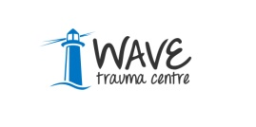
Job and Person Profile

Job Title: Welfare Rights Officer (Part-time)

Job Reference No.: WRO/ARM/MAR/17/

WAVE Trauma Centre’s Mission and Values:

Mission: WAVE’s Mission is to:-

- Serve people directly affected by the conflict in Northern Ireland

- Empower individuals, communities and wider society through trauma education programmes.

Values: WAVE is committed to:-

- Empowerment of those bereaved, traumatised or injured by the conflict in Northern Ireland.
- Inclusivity in all of work.
- Working to promote the non reoccurrence of violence.
- Equality and good relations as the foundation for our work.
- Continuous improvement through ongoing review of the provision of high quality, innovative evidence based services.
- Responding to change and shaping delivery within the victim/survivor sector.
- Helping to build a shared and cohesive future to address the legacy of the past.
- Accountability to clients and to funders for the services and programmes delivered with the effective financial processes.
- Partnership with other agencies to achieve better outcomes for clients.
- Continued development and recognition of our staff and volunteer team.

