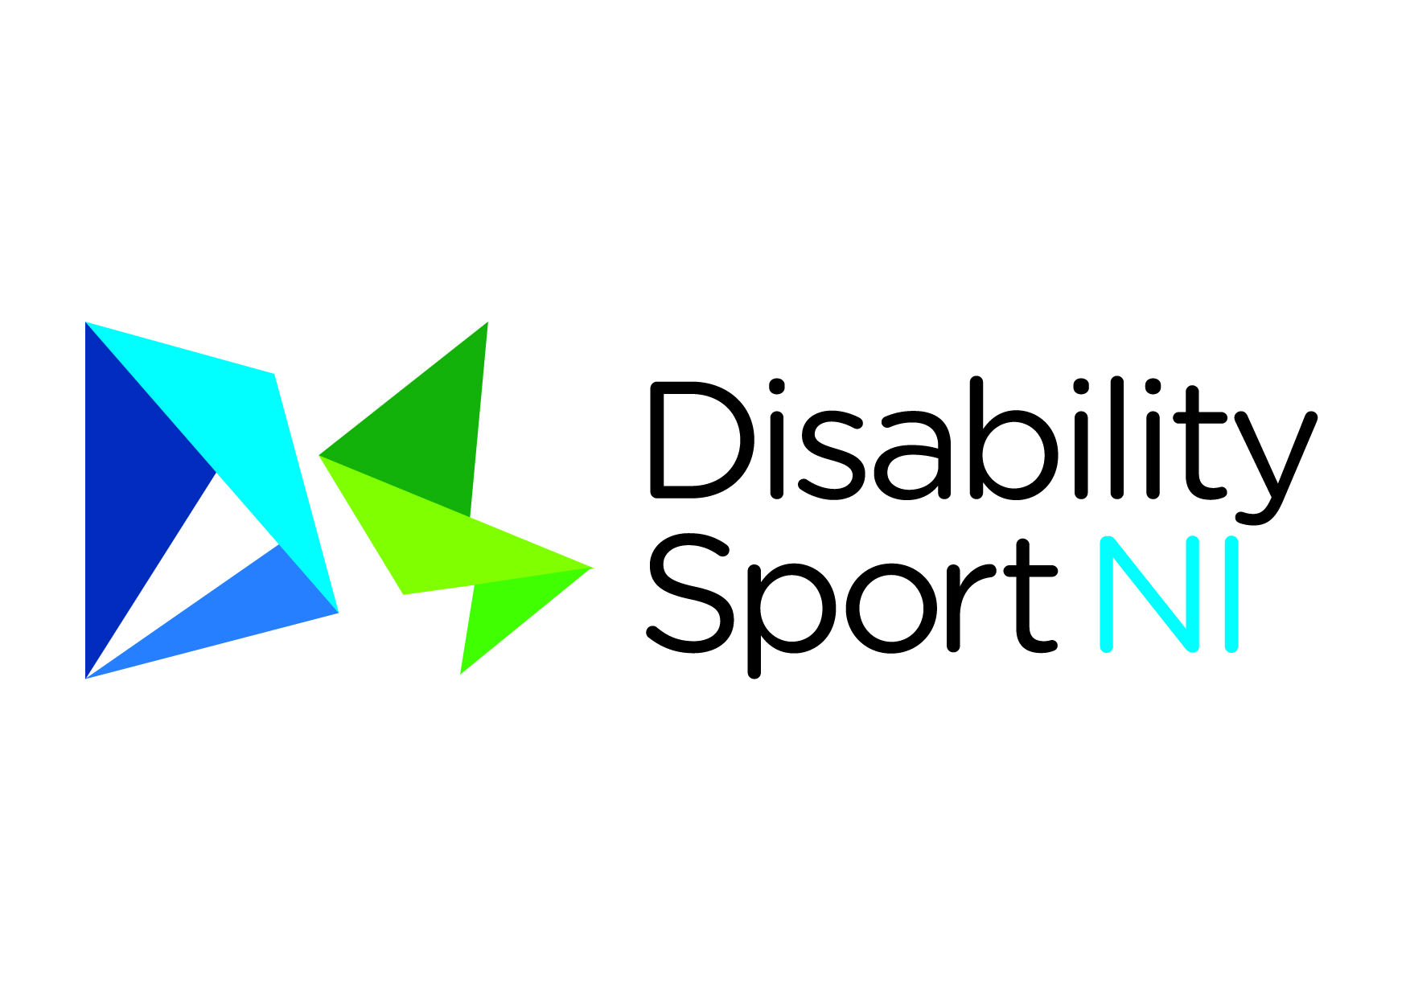

INFORMATION FOR APPLICANTS

ABOUT DISABILITY SPORT NI
Disability Sport NI is the main disability sports charity in Northern Ireland working to improve the health and wellbeing of children and adults with disabilities through sport and active recreation.

We work with people with physical, sensory and learning disabilities of ages, and with schools, disability groups, sporting organisations and clubs to ensure that everyone can benefit from sport and active recreation.

We believe that every person with a disability has the right to participate in all aspects of life and are committed to building a more inclusive society where people with disabilities have an equal opportunity to lead a full, active and healthy lifestyle through sport and active recreation.

We also work closely with Sport Northern Ireland and Governing Bodies of Sport to ensure that talented disabled sports people have the same opportunity as their non disabled peers to train, compete and excel in their chosen sport on the world stage.

At the heart of who we are is the belief that participation in sport and active recreations at any level is a positive and transformational experience.

We understand the positive impact of sport and active recreation because every day we see how our work changes the lives of people with disabilities for the better.

Last year our programme benefitted over 10,000 children, young people and adults across Northern Ireland, but looking to the future we know we can do more.

Disability Sport NI is a limited company with charitable status.

Further information on the work of Disability Sport NI is available at www.dsni.co.uk.

Equality of Opportunity
Disability Sport NI is committed to the principles of genuine equality of opportunity for all employees and potential employees.

Disability Sport NI recognises the organisation’s legal and moral obligations to protect all individuals from unfair discrimination and harassment and where necessary it will take positive steps to ensure that equality of opportunity is afforded to all regardless of disability, gender (including gender reassignment), and marital / Civil partnership status, sexual orientation, religious belief, political opinion, race or cultural origin, domestic or caring responsibility, trade union membership, or age.

Benefits

Working for Disability Sport NI offers a wide range of benefits including:

- 25 days annual leave
- 11 customary holidays
- Occupational sick pay – one week for every full year worked.
- An occupational pension scheme. Employer contribution rate is currently 6%.

- Enhanced maternity/adoption rights – 52 weeks leave (18 weeks at full pay).

- Flexible hours, part-time working and job sharing can be requested.
- Educational support and time off for study and exams.
- Option to join our childcare voucher scheme.
- Travel and subsistence payments for all work related travel.
- Option to purchase a bike through our cycle scheme, benefiting from tax relief.

GUIDANCE NOTES WHEN COMPLETING YOUR APPLICATION FORM

Please read these notes carefully. Your application form plays an important part in our selection process.

Please ensure you tell us everything that you think is relevant to your application. Disability Sport NI will not make assumptions from the title of your posts as to the skills and experience gained. It is vital that you highlight your specific role and contribution by using actual examples to illustrate your experience against the criteria.

It is not sufficient to simply list your duties and responsibilities.

SELECTION PROCESS

To ensure equality of opportunity for all applicants:

- The space available on the application form is the same for all applicants and must not be altered or re-formatted;
- We will not accept CVs or any other supplementary material in addition to the completed application form;
- We will not accept any applications which are received after the closing date and time;
- Make sure your application form is well presented – illegible or incorrect forms will not be accepted.
- Use a black ballpoint pen or lowercase type, black always shows up best when photocopied.

If hand delivering the application form please make sure you request a receipt as proof of delivery.

Please ensure you complete the monitoring form and the disclosure of criminal convictions form. This information will remain confidential and will be separated from the application form by the Monitoring Officer and will not be seen at any point by the selection panel.

All unsuccessful applicants will be informed after an appointment to the post has been made.

All applications should be returned to the address shown on the application form or alternatively can be emailed to email@dsni.co.uk.

Shortlisting

A shortlist of candidates for interview will be prepared on the basis of the information contained in the application. It is therefore essential that all applicants demonstrate through their application how, and to what extent, they satisfy each of the criteria specified in the application form. Specific dates of employment in each position held should be included. It is not appropriate to simply list various posts that an applicant has held.

The essential and desirable criteria listed in the application form will be assessed at shortlisting.

Only those candidates, who from the information supplied on the application form, match the essential, and when necessary the desirable, criteria for the post will be shortlisted.

Application forms which do not provide the necessary detailed information in relation to the qualifications, experience and skills required will not be shortlisted.

Interview and Assessment

Part of the selection process may include a skills-based assessment and/or presentation. These may be used as another stage in the shortlisting process or as part of the interview.

All selection processes will include an interview for those shortlisted candidates in order to establish the most suitable candidate for the position.

All applicants who meet and exceed the pass mark for interview will be deemed suited for employment and will be held on a reserve list.

Interviews will focus on the applicant’s experience and competencies for the role. You should therefore come to the interview prepared to discuss in detail a range of examples which best illustrate your experience, skills and abilities. You may draw examples from any area of your work/life experiences.

All appointments are subject to receipt of satisfactory employment references, personal identification verifying an individual’s right to work in the UK and copies of all examination documents. Specified positions may also be subject to the completion of Access NI police checks.

