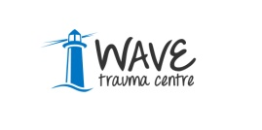
For the care and care of those bereaved, traumatised or injured as a result of the ‘Troubles’

Applicant Information Pack

Health and Wellbeing Caseworker

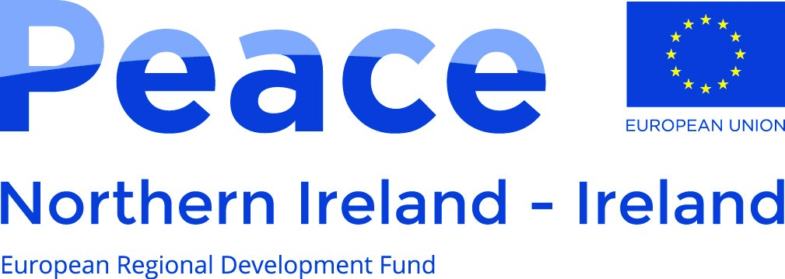
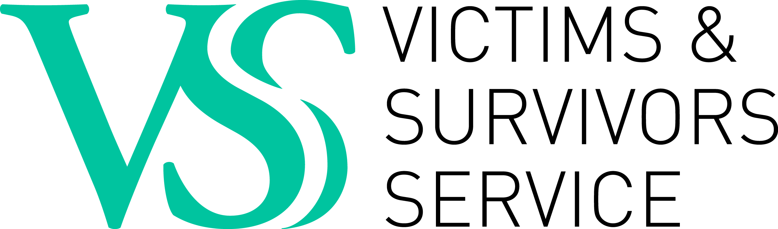
:

A project supported by the European Union’s PEACE IV Programme,
managed by the Special EU
Programmes Body (SEUPB).
This post is funded by the Victims and Survivors Service through the Victims and Survivors Programme administered on behalf of the Executive Office.

Dear Applicant,

Post: Health and Wellbeing Case Worker

Thank you for your interest in the above post.

Short listing will be completed on the basis of the information you provide on the application form, therefore please ensure you complete all relevant sections to help us make our decision. Please note that we do not accept CV’s.

Please find enclosed the following: -

- Our Mission and Values
- Job Description
- Personnel Specification
- Outline of Terms and Conditions
- Guidance Notes
- Employment Application Form and Monitoring Form (for completion).

We request that you complete and return this for statistical monitoring purposes.

For information on WAVE, please visit our website www.wavetraumacentre.org.

If you intend to complete and return the Application Form, please also complete and return the enclosed MONITORING QUESTIONNAIRE and place in an envelope. This will be treated in confidence. We request this information to help WAVE promote equality of opportunity in employment. Our recruitment policy operates on the merit principle i.e. we select the best person for the job, regardless of religious affiliation, political opinion, belief, age, race, gender, marital status, sexual orientation or disability.

We would like you to know that: -

Only the Application Form is considered by our Recruitment Panel, who shortlist and interview for vacancies. The Monitoring Questionnaire is confidential to our Monitoring Officer who uses it for compiling statistical information and is not seen by the Recruitment Panel.

If you have any questions regarding the information enclosed, please do not hesitate to contact us.

I look forward to hearing from you.

Yours faithfully

Tracey Shirlow
HR Manager

PLEASE NOTE: CLOSING DATE: Tuesday 23rd May 2017 at 4.30 pm
Hard Copy Completed forms should be returned to:
HR Manager, WAVE Trauma Centre,
5 Chichester Park South, Belfast, BT15 5DW.

WAVE: Who we are?

WAVE, established in 1991, is a voluntary, cross community charitable organisation which offers care and support to anyone bereaved, traumatised or injured as a result of the Troubles/Conflict. The philosophy and ethos of the organisation is one of inclusiveness, providing care for anyone irrespective of religious, cultural or political belief. WAVE promotes a respect for life and an understanding of difference that is seen as enhancing rather than threatening. WAVE continually seeks creative ways of working through issues that have the potential to divide.
Over the years the violence in Northern Ireland has led directly to the deaths of over 3,600 people and resulted in over 40,000 serious injuries. The Cost of the Troubles Study (1997) estimated that, “At the very least 6,800 people have the experience of one of their immediate family - parent or sibling - being killed in a troubles-related incident.” The true cost however, is much higher as the relatives of those killed and maimed have also suffered ill health, disruption of family relationships, impaired functioning, and substance abuse and in some cases when their grief became intolerable, suicide.
Over the last twenty five years the level of calls and referrals to WAVE has increased year on year. Referrals are received from those affected by violence more recently in addition to those injured, traumatised or bereaved across the last four decades. This indicates the necessity of providing the services offered by WAVE on a long-term basis.
To date WAVE has offered care and support to over 10,000 people, a cross section of adults, young people and children. WAVE works to utilise the benefit of every pound received in funding or donations for the benefit of clients. The organisation’s management cost is extremely low at 8%, well below the recommended national level of 15%. WAVE offers exceptional value for funders and strong professional services for clients.
WAVE has extensive community based Trauma Education Programmes. These programmes have been refined and developed over 18 years and offer students a range of options to meet their learning needs. Trauma Training includes:-

- Short Trauma Courses accredited by the School of Education at Queen’s University Belfast under their Open Learning Programme.
- A BSc. (Hons) in Psychological Trauma Studies is delivered in partnership with the School of Nursing and Midwifery at Queen’s University. It remains the only undergraduate trauma programme available in the United Kingdom and Ireland.
- A Postgraduate Pathway in Trauma Studies is currently being developed in partnership with University College, Cork. It is scheduled for delivery in the 2017/2018 academic year.
- Professional Development in trauma awareness and trauma informed practice for social work and nursing students is delivered in partnership with the Schools of Social Work and Nursing and Midwifery at Queen’s University.

WAVE has an extensive network of delivery processes across Northern Ireland. The organisation operates from five Outreach Centres in: Belfast, Armagh, Omagh, Ballymoney and Derry Londonderry and services such as Outreach/Befriending, Health and Wellbeing, Psychotherapy/Counselling, Advice/Welfare, Trauma Training, Personal Development, Training Opportunities and Complementary Therapies are available from all its Centre’s. In addition the organisation has a number of satellite projects operating across a range of venues in response to local need.

Organisation Profile

Job Title: Health and Wellbeing Caseworker

Job Reference No.: H&WB/May/17/

WAVE Trauma Centre’s Mission and Values:

Mission: WAVE’s Mission is to:-

- Serve people directly affected by the Troubles/Conflict in Northern Ireland.

- Empower individuals, communities and wider society through trauma education programmes.

Values: WAVE is committed to:-

- Empowerment of those bereaved, traumatised or injured by the Troubles/Conflict in Northern Ireland.
- Inclusivity in all its work.
- Working to promote the non recurrence of violence.
- Equality and good relations as the foundation for our work.
- Continuous improvement through ongoing review of the provision of high quality, innovative evidence based services.
- Responding to change and shaping delivery within the victim/survivor sector.
- Helping to build a shared and cohesive future to address the legacy of the past.
- Accountability to clients and to funders for the services and programmes delivered within effective financial processes.
- Partnership with other agencies to achieve better outcomes for clients.
- Continued development and recognition of our staff and volunteer team.

Job Description

Job Title: Health and Wellbeing Caseworker

Job Reference No.: H&WB/May/17/

Reports to: Lead Health and Wellbeing Caseworker / Project Manager / Regional Manager

(Line Manager depends on where the Health and Wellbeing Caseworker will be based).

Post(s): There are six Health and Wellbeing Caseworker posts. One post to be based at each of WAVE’s outreach centres:- Armagh, Omagh, Ballymoney and Derry Londonderry and two posts based at WAVE Belfast.

Key working relationships:

Internal contacts:

- Management and staff
- Individuals and families (Clients)
- Contractual team (Counsellors, Psychotherapists & Complementary Therapists)
- Volunteers

External contacts:

- Other community and voluntary organisations
- Statutory agencies
- VSS

Background:

This post has been developed as part of the EU PEACE IV Programme which provides investment for cross-border health and wellbeing services by increasing the quality of care in the sector for victims and survivors and their families to include collecting information on victims’ and survivors’ needs.

Job Purpose:

The Health and Wellbeing Caseworker will work directly with individual victims and survivors and their families in a pro-active and innovative way within the statutory, community and voluntary sectors. This work will be underpinned by WAVE’s protocols, policies and procedures.

Co-ordination and Delivery of Health and Wellbeing Services:

- Proactively and innovatively engage with vulnerable and marginalised individuals.

- Keep up to date with relevant statutory, community and voluntary sector services available to victims and survivors and their families and work to ensure pathways are seamless, responsive and mitigate against duplication of services.

- Identify any barriers to victims and survivors accessing the care and support they need and work with the individual and relevant agencies to remove or mitigate any adverse effect such barriers may pose.

- Undertake an assessment and design an individual and/or family health and wellbeing care plan in consultation with the individual. This care plan should address identified needs, facilitate independence and increase resilience.

- Continually review and monitor health and wellbeing care plans in conjunction with the client under the guidance of the Line Manager.

- Participate in regular client case reviews with the Line Manager and Outreach, Welfare and Therapeutic teams to ensure that the needs of the individuals are being met.

- Liaise with other agencies in a professional manner, ensuring that complex and sensitive information is communicated with empathy and reassurance and within the boundaries of data protection legislation.

- Advocate on behalf of, or if necessary accompany vulnerable individuals to services/appointments/activities where low confidence, low motivation and diminished trust may have left them isolated and marginalised.

- Facilitate the process for victims and survivors to access personalised support through the EU PEACE IV Resilience Programme e.g. accessing services such as one to one literacy, tutoring or a physical activity of choice.

- Introduce victims and survivors and their families to shared spaces and services.

Business Improvement and Quality Management:

- Ensure adequate and appropriate case notes/record keeping is undertaken and that relevant on line electronic databases are updated on a regular basis according to set time frames and adhere to WAVE and VSS policies and procedures.

- Record, monitor and evaluate client progress according to measurable goals described in their individual care plan.

- Ensure that all care plans, records and associated processes are maintained to the high standard required for auditing, monitoring and evaluation by WAVE and VSS.

- Manage the security/processing of sensitive and confidential client information in keeping with the requirements of the Data Protection Act.

- Ensure that all records, manual and/or computerised are held securely and all information is treated as confidential as per the WAVE’s Data Protection policy and procedures.

- Ensure that all paperwork submitted to VSS Case Work Managers is agreed and approved by the Line Manager in line with WAVE’s and VSS policies and procedures.

- Report immediately to the Line Manager any concerns regarding client service delivery, including any potential risk to clients, staff or others, or any child protection concerns or any matters impacting on victims, survivors and/or their families.

- Adhere to WAVE Risk Management procedures and protocols.

- Report immediately to the Line Manager any matter or concerns that may constitute reputational risk to WAVE.

- Actively encourage participation of victims and survivors and their families in reviewing and modernising current services and service development.

- Promote a culture of continuous service improvement through the appropriate sharing of constructive feedback, case studies or testimonies and work with relevant statutory, community and voluntary sector organisations to implement improvements.

- Ensure that all information regarding funding, resources, service delivery and training promoted by VSS Case Managers is communicated to the Line Manager in a timely manner to facilitate maximum benefit to individuals and families.

Training:

- Deliver in-house six week WAVE resiliency programmes, designed to help individuals understand the importance of self-care and resiliency after trauma.

- Support participants by identifying a range of models which promote resiliency and encourage them to apply practical tools such as visualisation, meditation, mindfulness, exercise, or relaxation techniques which can help to build resilience.

- Provide information and/or deliver tailored individual or group programmes.

Personal Development, Performance and Professionalism:
- Maintain high standards of personal accountability and ethical practice which are aligned with WAVE’s values, ethos and policy and procedural frameworks.
- Ensure that the ethos of WAVE is promoted and that you act as an Ambassador for the organisation at all times.

- Facilitate liaison with professional and senior management within stakeholder organisations.
- Maintain annual renewal of Northern Ireland Social Care Council (NISCC) registration.
- Maintain and record continuous professional development in accordance with the conditions associated with NISCC (to include recording any training undertaken, participation on forums or any personal reading i.e. journals, articles, books etc) that is required in order fulfil the obligations of NISCC.
Other:

- Undertake training as required by the Lead Health and Wellbeing Caseworker/Project Manager or organisation.

- Undertake as required any work identified by the Line Manager.

- Attend WAVE staff, service delivery and other meetings as required.

- Any other reasonable duties requested by the Chief Executive Officer or Management Board.

This job description outlines the core role of the Health and Wellbeing Caseworker as it is currently. Additional elements within grade and competence may be added as appropriate to meet the needs of victims and survivors and their families as the service develops.

Person Specification

Job Title: Health and Wellbeing Caseworker

Selection Criteria | Essential | Desirable | Method of Assessment
- Qualification/Education  (i). Possess a (Level 5) University Degree or Professional Qualification or equivalent Qualification in a relevant area i.e.  Health and Social Care, Social Work, Social Science, Nursing or equivalent.  OR  5 GCSE’s grades A – C, including English language AND have 2 years voluntary/paid experience equivalent to 16 hours per week in a community/voluntary/statutory environment working with individuals with mental health and/or physical health issues.  OR  NVQ Level 3 or equivalent AND have 1 year’s voluntary/paid experience equivalent to 16 hours per week in a community/voluntary/statutory environment working with individuals with mental health and/or physical health issues. |  |  | A  A  A
- Experience  (i) Demonstrated experience of effectively engaging with clients in situations where they have been vulnerable and built positive relationships.  (ii) Demonstrated experience of liaising between vulnerable clients and a broad range of service providers.  (iii) Demonstrated experience of providing progress reports and management information in clear and agreed formats, in line with a reporting schedule.  (iv) Demonstrated experience of successfully prioritising and managing your own workload.  (v) Demonstrated experience of at least 1 year working with, or in the interests of victims and survivors of the Troubles/Conflict.  (vi) Demonstrated experience of using or contributing to outcomes focussed monitoring and evaluation processes.  (vii) Experience of delivering training on an individual and group basis. |  |  | A/I/T  A/I  A/I/T  A/I/T  A/I  A/I  A/I
- Skills and Abilities  (i) Ability to communicate effectively with colleagues and management.  (ii) Demonstrated evidence of undertaking assessment of need and service delivery as a regular part of the role. |  |  | A/I  A/I
- Other Requirements  (i) Currently registered with the Northern Ireland Social Care Council (NISCC)  OR  A willingness to register and be responsible for the initial registration fee and upkeep of annual renewal of registration.  (ii) *Current driving licence and access to a suitable vehicle (appropriately maintained and insured for business).  (*This criteria will be waived in the case of an applicant whose disability prohibits driving but who is able to demonstrate an appropriate alternative means of meeting the mobility requirements of the post).  (iii) Have a willingness to work unsociable hours as required and be flexible. |  |  | A/I  A/I  A/I  A/I

A = Application Form I = Interview P = Presentation T = Test
R = References

Outline – Terms and Conditions

The following information represents the key terms and conditions of this post and should not be viewed as a Contract of Employment.

Salary: £25,871 per annum

Place of work There are six Health and Wellbeing Caseworker posts. One post to be based at each of WAVE’s outreach centres:- Armagh, Omagh, Ballymoney and Derry Londonderry and two posts based at WAVE Belfast.

Hours of Work: 37.5 per week.

Travel: You will be required to undertake travel as part of your role. This will include travelling throughout the North and South of Ireland conducting home visits and between our regional centres.

Pay Periods: You will be paid on the third last working day of the month.

Probationary Period: Normally six months.

Fixed Term: March 2021.

Holidays: 23 days per annum (increasing with service) and 11 statutory days. The leave year operates from April to March.

Benefits: 8% employer pension contribution
Mileage payable at 0.40p
External Supervision
Training and Development Programme.

Smoking Policy: WAVE operates a non-smoking policy.

Pre employment Checks: The successful candidate will be required to undertake pre- employment checks which will include an Enhanced Access NI Disclosure check and satisfactory references.

