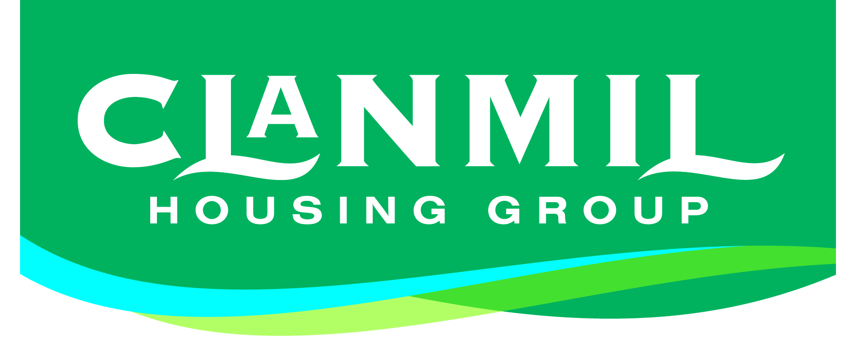
GUIDANCE NOTES FOR APPLICATION FORM
Are you ready to join the best and brightest of Northern Ireland’s Housing sector?
We’re excited to welcome you as a potential new member of our team. Our instructions below should provide you with all you need to complete your application and if you have any further queries, please contact us on our Recruitment Line 02890876011. A member of our HR team will be happy to help!
Are we the right company for you?
Clanmil’s vision is that ‘Everyone has a great home’. We are passionate about providing an excellent customer experience and exploring innovative ways to build our communities – have a look at our website to read about our values and what we do: www.clanmil.org
What’s the right job for you?
A Job Description has been issued for this post. Please read through this carefully, as it has been designed to reflect the main duties of the role. It will help you to decide if this role is the right fit for you.
What we’re looking for…
Our Person Specification will provide you with the essential and desirable criteria for this post. You’ll need to clearly demonstrate how you meet the criteria on your application. We may heighten the criteria, based on demand, so it is important that you give us as much appropriate detail as possible.
The Application form
All applications must be submitted using Clanmil’s application form – CVs will not be accepted. Your application should be typed using minimum size 11pt, or if it is handwritten, in black ink and block capitals only. We’ve provided instructions for each section on the form, so please read these carefully.
Remember, we will use our Person Specification when considering your application – when completing your application, try to match your skills and experience to the criteria set out, as best you can.

Submitting your application
Applications must be signed and dated on the last page, and must be submitted before the closing date & time stipulated on the advert. You can return applications by email to recruitment@clanmil.org.uk or by post/in person:
HR Department
Clanmil Housing
Northern Whig House
3 Waring Street
Belfast
BT1 2DX
_________________________________________________________________
Our promise to you
If you are shortlisted to attend an interview, we’ll provide you with the details at least 5 working days beforehand, and we’ll get back to everyone within a week after interviews.
Under Data Protection Regulations your application form and details will be held securely, and only accessed by those staff who are processing your application for employment, including HR staff and the Line Managers responsible for recruiting the post for which you have applied. Information will be held under the Data Protection Principles.
_________________________________________________________________
Recruitment Monitoring Form
To ensure that our Equal Opportunities and Fair Employment Policy is effective and to meet Fair Employment Monitoring requirements, all candidates are required to complete the section on monitoring. This will be treated as confidential and does not form part of the recruitment and selection process. Place this sheet in the sealed envelope provided and return it with your application form. Your application may not be considered if you fail to return the Recruitment Monitoring Form. Please refer to the Monitoring Form for details of who will access your sensitive personal data.
Equal Opportunities
Please note at Clanmil, we welcome applications from all sections within our community. If you have a disability, we will be happy to accommodate your application. Please contact the HR team who will be able to facilitate the completion of your application, discuss any special requests, and any physical requirements relating to your disability you may have.
A translation service/alternative format can also be made available on request. Please contact the HR team in the first instance, and we will make every effort to facilitate your application.

