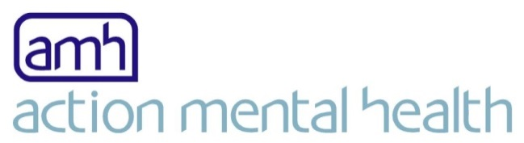

**Central Office**

27 Jubilee Road

Newtownards

Co Down

BT23 4YH

T: +44(0)28 9182 8494

www.amh.org.uk

**TO WHOM IT MAY CONCERN**

**Re: Employment Support Officer (Workable) AMH New Horizons Belfast or AMH Regional Office Antrim**

Thank you for your inquiry about the above position. Please see attached an information pack containing:

* Job Description and Personnel Specification.
* AMH Values and Behaviours
* Application form including monitoring form
* Guidance notes on filling in the application form
* Equality & Diversity Policy

In view of increasing postal costs and our constant need to make the best use of our resources, we shall not be writing to you again unless you are shortlisted for interview. It is envisaged that interviews for the above post will take place within two weeks of the closing date; if this changes for any reason, shortlisted candidates will be informed.

***If you have not heard from us by then you should assume that your application has been unsuccessful on this occasion.***

If you decide to apply for this vacancy you will need to complete the enclosed application form including monitoring form. Completed forms should be returned to HR dept by 12.00noon, Friday 18th August, 2017.

**AMH will not accept CV’s.**

We strongly recommend that you read through the enclosed guidelines before completing your application form.

Once again, thank you for your interest in the post and I look forward to receiving your application.

Yours sincerely,



MARIA MCVEIGH

HUMAN RESOURCE MANAGER