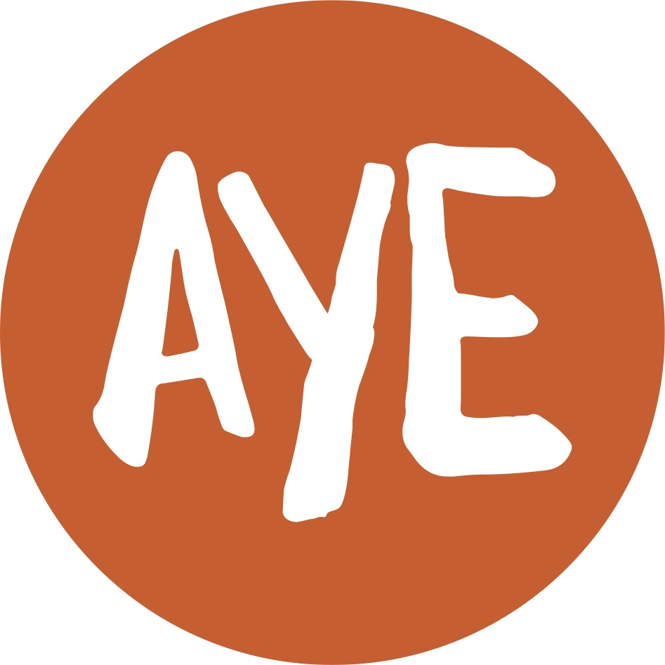

Job Description

Job Title: Communications Assistant (part-time)

Salary: £17789.2 (£23,935 pro-rata)

Hours: 27.5 hours per week, flexible hours

Holidays: 22 days per year plus statutory holidays pro-rata

Contract: Permanent post subject to future funding post September 2017

Probationary period: 6 months

Location: Old Beltex Mill, Flax Street, Belfast

Reports to: Ardoyne Youth Enterprises (AYE) Director

AYE is only able to accept applications from those individuals who are currently eligible to work in the UK. Only those applicants who appear, from the information provided, to be the most suitable in terms of the selection criteria will be called for interview.

Main Purpose
The AYE Communications Assistant will:

- Enhance the reputation of AYE and promote its work;
- Engage with key stakeholders on strategic objectives;
- Measure and evaluate all communications activities in line with best practice, legislation and funding guidelines;
- Organise events and provide organisational support;
- Undertake other reasonable duties as agreed with the director.

Summary of responsibilities and personal duties

- Enhance the reputation of AYE and promote its work:

- Develop and implement an AYE communications strategy;
- Develop and implement an AYE digital strategy;
- Liaise with IT service providers to develop the website;
- Manage and maintain AYE’s digital platforms, including social media and website;
- Build capacity among and provide appropriate support to staff so that they can effectively engage and communicate online and offline;
- Design and deliver creative marketing materials, video and online content;
- Engage with media and prepare and disseminate newsworthy copy;
- Promote a positive image of the neighbourhoods.

- Engage with key stakeholders on strategic objectives:

- Represent AYE when necessary;
- Coordinate stakeholder engagement activities with media, elected representatives, key decision-makers and others;
- Respond to the needs of project staff and members of the public on a range of issues;
- Develop and deliver presentations to key stakeholders.

- Measure and evaluate all communications activities in line with best practice, legislation and funding guidelines:

- Monitor relevant media coverage;
- Set SMART communications objectives
- Implement appropriate measurement and evaluation tools in line with guidelines and best practice;
- Deliver activities in line with stakeholder or funding requirements, including adhering to brand guidelines;
- Measure and report on impact;
- Access the ongoing communications needs of AYE and recommend and implement changes where relevant.

- Provide organisational support and organise events

- Input, maintain and reconcile all financial organisational records
- Ensure information for reports is recorded accurately and promptly;
- Raise all organisational payments.
- Organise meetings and events;

- Undertake other reasonable duties as agreed with the director:

- Work as part of a small team;
- Provide administrative support;
- Undertake other relevant duties as determined by the director and in line with the needs of AYE.

The duties outlined in the Job Description serve as a guide to the current and major responsibilities of the post. These will inevitably vary as the role develops and the Job Description will be reviewed on a regular basis. Changes will be subject to consultation with the post holder.
Person Specification AYE/CAO17
 | Essential | Desirable
Experience | - A minimum of 2 years’ experience in a dedicated communications related role to include:  - Management of a range of communication channels including using social media marketing & communications across key platforms (Facebook, Twitter and Instagram)  - Experience of drafting marketing materials, web content and news releases and liaising with media to secure coverage
Attainments/ Education | - A relevant third-level qualification in a communications and/or marketing discipline | A degree in Communications Management and Public Relations  Membership of a relevant professional membership body, e.g. CIPR
Skills | - Written communication – the ability to write clearly across different mediums  - Oral communication – the ability to convey complex information, listen and respond to requests from management and staff and to communicate with others internally and externally;  - Team member – the ability to work as a member of a team, providing organisational support to colleagues in an efficient/effective manner on a range of tasks and duties to achieve objectives;  - Customer care – the ability to identify and deal with the needs of customers  - Technological skills- an understanding of web analytics, high impact design, email marketing, web design, search engine optimisation;  - Design/creativity skills - the ability to use Photoshop and Illustrator at an advanced level for use in online and offline materials  - Good numeracy skills and ability to use spreadsheets, data input and other software packages to maintain financial records  - Excellent organisational skills and experience of working to deadlines  - Good knowledge of Microsoft Office | Proficiency in Adobe Creative Suite
Disposition | - Well presented & inspires confidence  - Self-motivated and initiative taking  - Team player
Knowledge & Values | - Commitment to Vision and Mission of AYE and a partnership approach
Circumstances | - Willingness to work flexible hours to meet the requirements of the post

