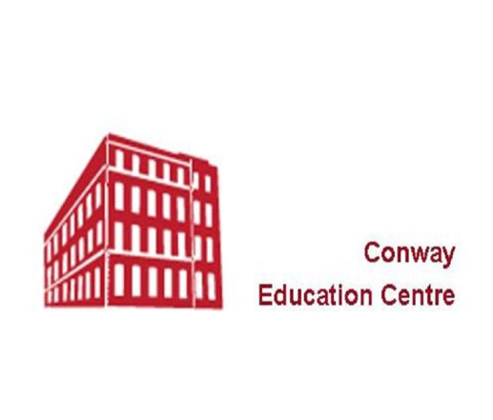
Conway Education Centre
5/7 Conway Street
Belfast BT13 2DE
Tel.: 02890 248543
Email: info@conwayeducation.org
www.conwayeducation.org

TUTOR APPLICATION FORM
Name: | E mail address:
Address | Telephone number:  Mobile number
Accredited course to be delivered:

Please tell us about your qualifications and experience relevant to the delivery of this course:

Referee 1 | Referee 2
Additional information

