**HOLYWELL – DiverseCity Community Partnership**

**Job Opportunity**

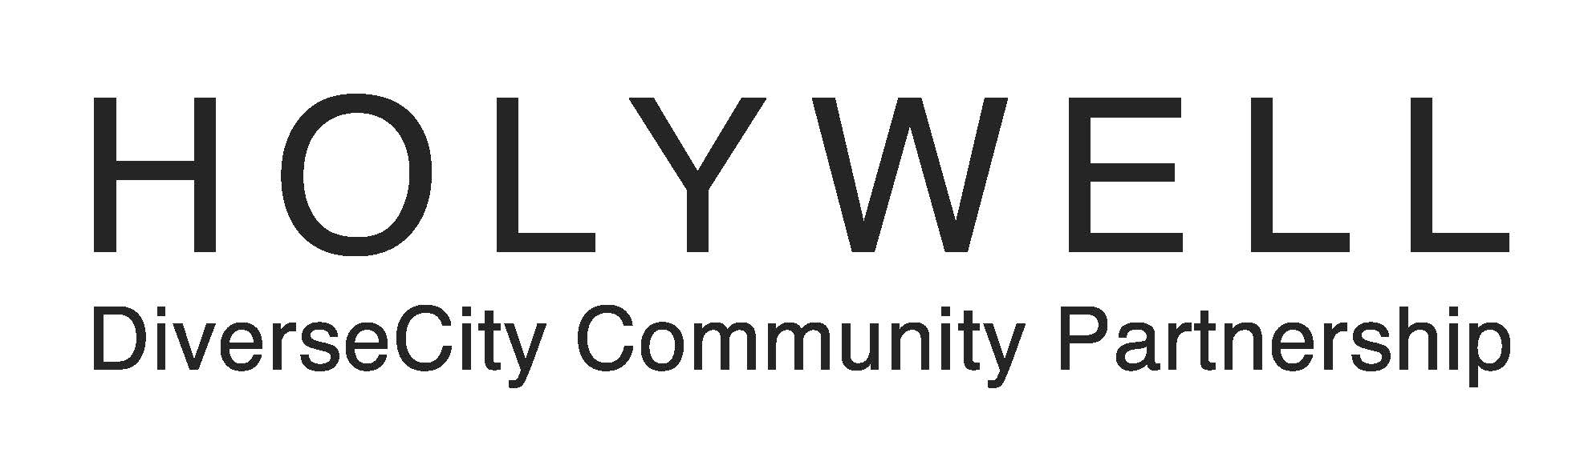

HOLYWELL – DiverseCity Community Partnership, through Holywell Trust as lead partner, welcomes applications for the post of:

* **Casual Support Staff**

For a job application pack please contact:

Lisa Clements

Holywell Trust

HOLYWELL – DiverseCity Community Partnership

8-14 Bishop Street

Derry/Londonderry,

BT48 6PW

Tel. (028) 7126 1941

Email lisa@holywelltrust.com

The deadline for completed applications is **2.00pm Wednesday 30th August 2017.**

Holywell Trust is registered with the Charity Commission for Northern Ireland - NIC105831