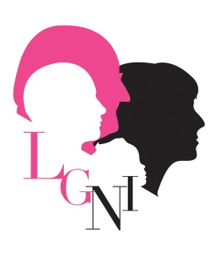
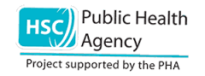
01

Application Pack – All Ages April 2017
(Electronic version)
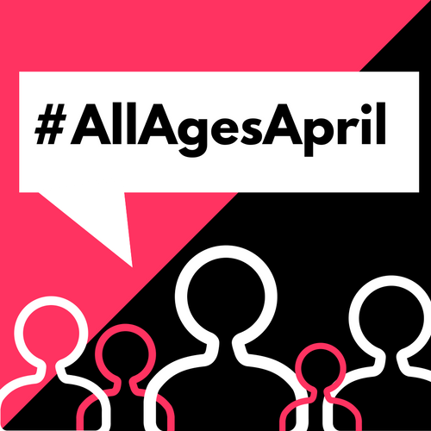
Small Grants Programme to bring generations together to build age-friendly communities and celebrate All Ages April 2017
*Please refer to guidance notes at the end of this form to help you complete the application*
Please complete this application form and return to:
lynn.johnston@bjf.org.uk
by
MONDAY 27 FEBRUARY 2017 at 5pm
Maximum grant per group: £150
Questions?
Email: lynn.johnston@bjf.org.uk or
telephone 02891 813022
LINKING GENERATIONS NORTHERN IRELAND
ALL AGES APRIL 2017
Closing date for applications: Monday 27th February 2017 at 5pm
- Contact details
Name of group/organisation: Click here to enter text.
Council Area: Click here to enter text.
Name of contact person: Click here to enter text.
Address: Click here to enter text.
Post code: Click here to enter text.
Telephone no: Click here to enter text. Mobile no: Click here to enter text.
Email address: Click here to enter text.
Does your group use social media? If yes please give Facebook / Twitter addresses below:
Facebook: Click here to enter text. Twitter: Click here to enter text.
(FYI we are Linking Generations NI on Facebook & @LinkGenNI on Twitter)

- Tell us about your group e.g. what do you do? What area do you cover?
Click here to enter text.

- Have you been involved in or are aware of the Age Friendly Movement?
If yes, please tell us of your involvement:
Click here to enter text.

- Your Project Idea:
4.1 Please tell us what you plan to do to celebrate All Ages April 2017 and why?
Click here to enter text.
4.2 Is there a title for your event / project / activity?
Click here to enter text.
4.3 Approximately how many people will be involved in your project? (there should be at least 10 of each age group)
Older people: Click here to enter text.
Younger people: Click here to enter text.

4.4 What preparation work have you done / will you do for your project e.g. how will you recruit participants?
Click here to enter text.
- Project Costs
Successful projects will receive a maximum grant of £150 in advance
(these grants are designed to support activities, not capital costs)

How much will the project cost and what will you spend the money on? (Please note we would urge you to use existing resources where available)

Item / Activity | Amount needed
Click here to enter text. | Click here to enter text.
Total  (NB maximum available is £150 per project) | £ Click here to enter text.

- Bank Details
Please give full bank account details of your organisation (please ensure these are accurate as, if you are successful, we will pay the grant directly in to this account)
Bank Name: Click here to enter text.
Branch Address: Click here to enter text.
Bank Account Name: Click here to enter text.
Sort Code: Click here to enter text. Account Number: Click here to enter text.

- Organisation Governance Checklist
Please tick to confirm your organisation has the following governance arrangements currently in place
A signed and dated constitution or governing document ☐
A bank account in the name of your organisation ☐
Our accounts are annually audited ☐
A relevant child protection policy (for groups working with children under 18) ☐
Vulnerable adults policy where appropriate ☐

- Who will be responsible for the financial claims for this project?

Please sign your name below to confirm that the information provided in this form is correct and that you will be the person responsible for the grant
(We will accept electronic / typed signatures)

Name: Click here to enter text.
Position in the group: Click here to enter text.
Signature: Click here to enter text.

If you receive a grant, all claims and receipts must be returned by
Friday 5th May 2017
What Happens Now?
Thank you for completing the application form to take part in All Ages April 2017
A panel will meet to choose the successful projects. The panel’s decision is final. Award of grants will be made through a letter of grant offer and will be conditional on applicants signing a contract.
Completed applications should be returned by 5pm on MONDAY 27 FEBRUARY 2017 either by email to:
lynn.johnston@bjf.org.uk
or posted to:
Linking Generations Northern Ireland
43-45 Frances Street
Newtownards
BT23 7DX
IMPORTANT:
If you have sent us an application and have not received an acknowledgement of receipt within 7 days, please contact us to ensure that we have received your application successfully

Guidance notes

If we receive more than 35 applications, we will apply the following criteria to score the activity you have outlined in your application:

- Activities which use the principles of intergenerational practice and our good practice guide – please refer to our website for more detail:

www.linkinggenerationsni.com
Principles of intergenerational practice summary
- Mutually beneficial to both age groups
- Participants help to plan it
- Uses existing resources
- Well planned
- Locally connected
- Strengthens community
- Challenges ageism
- Connects organisations

- Activities that connect generations in and with communities

- Activities which bring another generation in to an environment that is generally used by one generation only (eg schools, care homes, youth clubs, older people’s housing, services/organisations that usually work with just one age group)

- Activities that show good value for money

- Activities that we think will make people feel good

- Activities which engage older people who don’t get out much

- Activities from groups we have not worked with before

Additional Recommendations
This year, we particularly would like to see schools (primary and post primary) and residential care homes taking part. This might be a day in a school when older people are invited to come in, or it might be a youth group visiting a care home, or it could be a school and a care home connecting.
We have recently developed a Digital Toolkit, which is suitable to use if your project aims to support older people to develop their digital skills. You can follow a link to the toolkit on the Digital Age section of our website.
The Age-friendly movement is a World Health Organisation initiative which is developing quickly in Northern Ireland, through local councils. Improving intergenerational relations is an important part of building age-friendly environments and your project will contribute to this.
The PHA funding for #AllAgesApril is aimed at tackling social isolation and loneliness amongst older people, which is why one of the criteria is about connecting with older people who don’t get out much.
Your activity can be an Intergenerational /Age-Friendly one-off event or a project delivered over a number of sessions. We hope that by taking part you will see the value of incorporating Intergenerational/Age-Friendly values into your everyday practice.
We welcome applications from all sectors: public, private and voluntary.

Thank you and we look forward to receiving your application

If successful, you should include the LGNI, Public Health Agency and #AllAges April logos on any publicity materials.
To see what we funded last year, have a look at this short video:
http://linkinggenerationsni.com/eu-day-of-solidarity-between-generations-2016-makethelink/

This year we want to fund 35 projects across NI – you have a very high chance of being successful!

Closing date Monday 27th February 2017 @5pm

