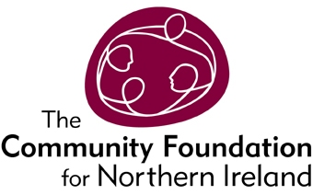

The Community Foundation exists to connect people who care to causes that matter. We help donors choose how, when and where they give, by helping them to set up funds, supporting them to make grants and to see the impact of their donations on local communities in greatest need. For 37 years, we have been making grants and working with communities to help the most vulnerable, marginalised and excluded people in our community - giving out more than £100m since we were founded.

Grants and Donor Care Officer (full-time permanent)

Salary Scale – NJC Points 29-31 (£25,694 - £27,394)

The Grants and Donor Care Officer will support the Programmes, Grants and Donor Care team to make effective grants that support the objectives of the Foundation; and to help the team build strong relationships with donors and funders that encourage them to invest more in the local community through the Community Foundation.

Application forms and further information for the above post can be downloaded from: www.communityfoundationni.org or please email Betty McNally at
bmcnally@communityfoundationni.org

Closing date for applications is 12 noon on Monday 20th February 2017.

The Community Foundation for Northern Ireland is an Equal Opportunities Employer.

