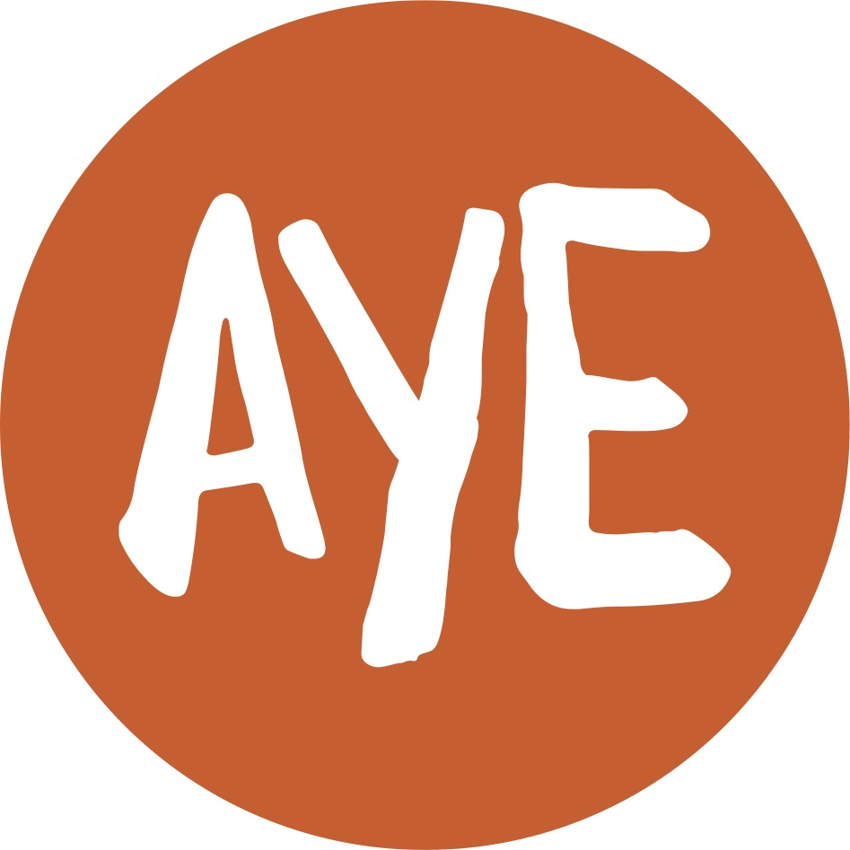

Job Description

Project: Ardoyne Youth Enterprises (AYE)

Job Title: Youth Engagement Worker

Location: Old Beltex Mill, Flax Street, Belfast.

Reports to: AYE Director and Youth Engagement Coordinator

Terms and conditions

Salary: £3,949 (8hrs post) (£18,267 pro rata – JNC pt 7)

Contract: This is a permanent post, however it is dependent on future funding, which is currently secured until March 2017. Job subject to 6 month probation period.

Holidays: tbc plus statutory

Hours of work: 8 hours per week including evenings and at weekends. Indicative work pattern – two shifts per week with rotating weekends.

AYE is only able to accept applications from those individuals who are currently eligible to work in the UK. Only those applicants who appear, from the information provided, to be the most suitable in terms of the selection criteria will be called for interview.

Main Purpose of Job
The role of the Youth Engagement Worker (YEW) will be to work directly with young people through outreach/detached work and programme delivery to develop their social education. Through needs assessment and in consultation with the local community, the person appointed will be responsible for the creation of opportunities and initiatives focussed on group work, community relations, gender work and other areas relating to the youth work curriculum, which will enhance opportunity for personal and social development of young people.

AYE provides a range of effective and timely interventions offered to vulnerable young people with priority given to those who have an offending history or who are at risk through involvement in anti-social behaviour, substance use, homelessness and mental and emotional health.

AYE is attempting to bring about closer collaboration and more effective management and co-ordination among local services through better strategic planning, deployment of people and focusing of resources to support the following outcomes:

- Improved collaboration with residents, the Education Authority, education partners, health and social services and others, in meeting the needs of young people and youth provider organisations.
- The increased participation of young people in youth activities providing opportunities for their personal and social development;
- Innovation across service to meet the changing educational, social and welfare needs of children and young people;
- Meeting the needs of socially disadvantaged and marginalised young people across the youth service age range;
- Involvement of parents and the local community;
- Ongoing development of community relations work within youth services;

As part of AYEs Project you will;

- Deliver outreach and detached youth work in order for young people to access appropriate support and advice and act as a means of developing meaningful relationships with vulnerable young people.
- Work with young people in detached settings and assist in enabling them to develop a suitable range of personal and social skills.
- Within the assigned geographical area the worker will assist in the assessment of needs, provide advice and support and liaise between local youth providers.
- Assist in the development of outreach work and programme delivery supporting local community groups, working with young people, particularly young people at risk.
- To work with other adult staff in a team, to provide a programme of activities, services and facilities to help deliver the youth service curriculum.
- Compile and complete regular work reports and measure impact and client progression as routine
- Assist young people to express and realise their goals.
- Enable young people to work effectively in groups.
- Challenge oppressive behaviour in young people.
- Provide information and support to young people.
- Encourage young people to broaden their horizons and be active citizens.
- Support young people in their understanding of risk and challenge and in taking action to address key issues in their lives.

Key Accountabilities:

Service delivery and development:

To encourage and facilitate young people’s feedback and continual input through reliable and valid means, ensuring that information captured is utilised towards direct and timely service improvement and development.

To ensure appropriate interventions are developed as part of the agreed package of support for individuals, ensuring plans are outcome focussed and progress is reviewed effectively.

To track progress for young people to ensure that progress can be monitored and measured for individuals and the service as a whole.

To work in partnership with the full range of relevant agencies to ensure that young people receive the services they need at an early stage to enable them to progress and achieve positive and lasting outcomes.

The delivery of targeted group programmes of support for identified groups including summer programmes and good-relations programmes.

Signpost and refer young people to services to increase their support network which will improve their overall outcomes.

To actively contribute to team meetings, share skills and knowledge and support colleagues across the organisation.

Partnership working:

To work in partnership with all local youth provider organisations and relevant statutory and voluntary organisations in order to ensure that the young person’s needs are being met, maximise the opportunities for young people and to ensure that organisationally we are using our knowledge to promote the needs of our young people.

To build and nurture relationships with all local providers and assist in the development and definition of AYEs service offer.

To have full knowledge and appreciation of the range of activities, courses, opportunities, organisations and individuals who could be drawn upon to provide extra support for the young people.

Adopt a professional approach that enhances AYEs reputation.

Quality and Monitoring:

To maintain accurate records, complying at all times with completion deadlines.

Health and Safety:

To ensure that all duties and responsibilities of this post are carried out in compliance with the Health & Safety at Work Act 1974, Statutory Regulations and Organisational Policies and Procedures.

To attend relevant training and access specialist advice where required in meeting the above responsibilities.

Miscellaneous:

Undertake additional tasks and responsibilities as reasonably directed by the Director/YEC

The duties outlined in the Job Description serve as a guide to the current and major responsibilities of the post. These will inevitably vary as the role develops and the Job Description will be reviewed on a regular basis. Changes will be subject to consultation with the post holder.
Person Specification AYE/YEW16

 | Essential | Desirable
Experience | - 2 years experience of working within a recognised youth project working directly with young people  - One years experience of delivering Outreach & Detached Youth Work  - Evidence of delivering, planning and organising programmes that address the expressed needs of young people. | 3 years demonstrable experience in a paid youth-work role
Attainments/ Education | - Educated to OCN Level 2 in Youth work | OCN Level 3 in Youth Work or higher  Grades A-C GCSE English
Skills | - Communication – Good communications skills including speaking, report writing and listening skills.  - Team member – the ability to work as a member of a team, providing support to colleagues in an efficient and effective manner  - Customer care – the ability to identify and deal with the needs of young people and other stakeholders  - Ability to influence and build relationships with all providers  - Proficiency of Microsoft Word, Excel and the Internet
Disposition | - Well presented & inspires confidence  - Self-motivated and initiative taking  - Team player
Knowledge & Values | - Commitment to Vision and Mission of AYE and a partnership approach  - Knowledge of the Youth Service Curriculum
Circumstances | - Willingness to work flexible hours including evenings and weekends.

