

Job Description and Personnel Specification

Health Improvement Officer

Full Time

Permanent

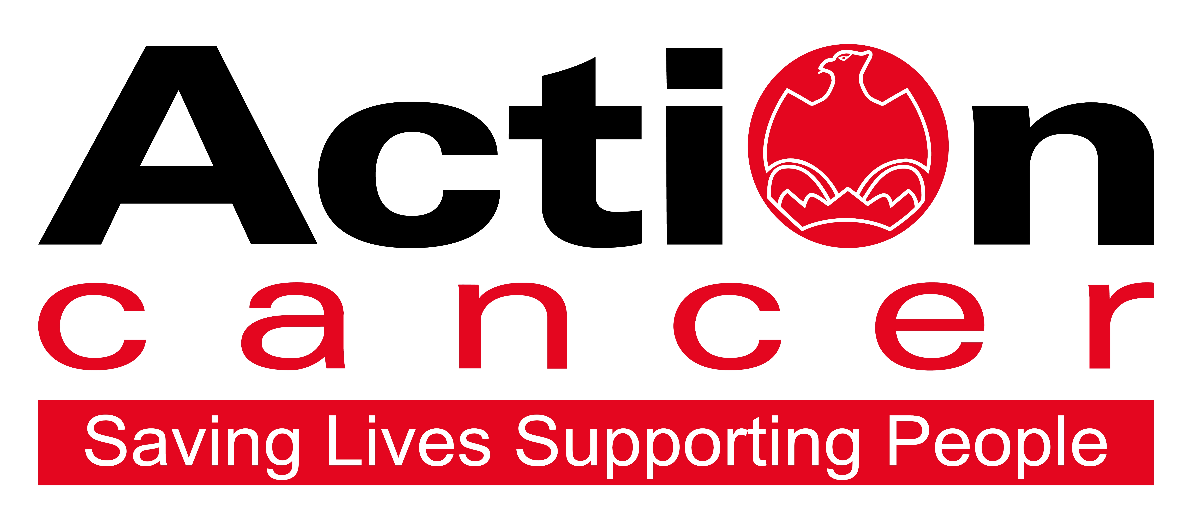

Title of Post: Health Improvement Officer

Hours: 35 hours per week

Accountable to: Head of Professional Services

Location: Based at Action Cancer House-Belfast

Salary: NJC Scale Pts 23-27- £21,268 - £24,174

In addition to a competitive salary, Action Cancer offer the Total Reward Package (enclosed), which focuses on what our staff value, and includes a flexible mix of rewards designed to meet staff needs, their lifestyle, and their stage in life, including a time-off-in-lieu accrual system, training, flexible family-friendly working arrangements, pension contributions, and excellent professional development opportunities.

Action Cancer is a local Northern Ireland charity - all our money is raised to provide services for local communities. Our dedicated team of staff and volunteers work across the whole of Northern Ireland helping to save lives and support people affected by cancer. To operate our services we must raise circa £3.4 million every year.

We provide early detection and health promotion services, and counselling and support services for cancer patients and their families, thereby making a real difference to people who are affected by or living with cancer.

Action Cancer staff - a mix of highly skilled professionals - are the most valuable asset to our charity. We offer a wide variety of training and development opportunities, and family friendly initiatives to enhance work-life balance, and to value and support individuals and family life. In recognition of this we were awarded Best Learning and Development Organisation in Ireland - Not for Profit Sector, and were winners of The Irish News ‘Best Place to Work’ Award, Employers For Childcare “Childcare Works Award”, Employers For Childcare Family Friendly Employer Award - Social Enterprise/Charity of the Year, and Employer of the Year Award by UTV Business Eye Awards.

We are also very proud to have achieved Investors in People Gold Champion status, Investors in People Health & Wellbeing Good Practice accreditation, and Investors in Volunteers accreditation. These awards are testament to our continued commitment to “have highly valued, trained, enthusiastic, focused and committed people who work together and engage with others to make a positive impact on our community”. 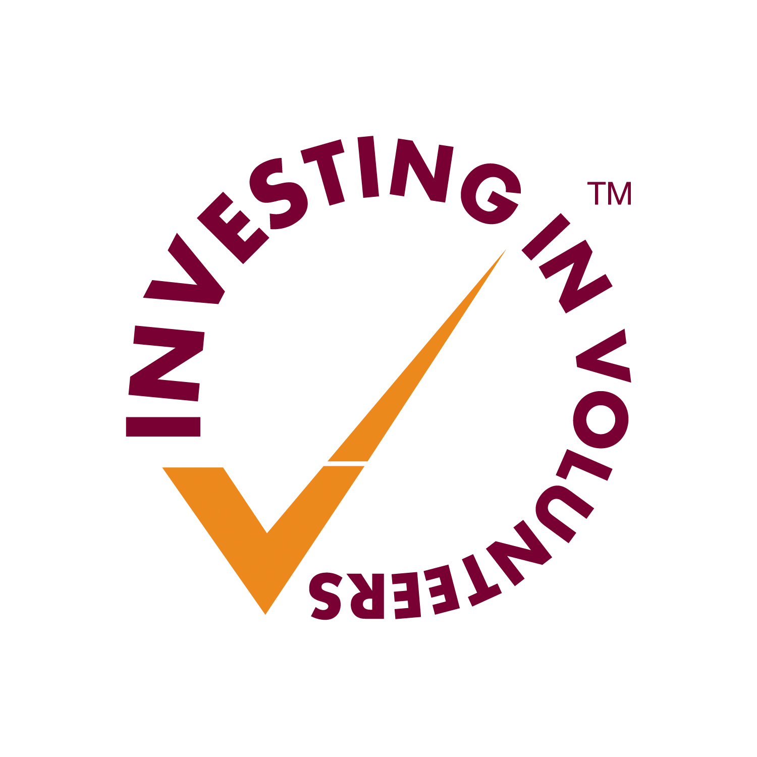

Employees of Action Cancer must support its Mission, Values and Behaviours:

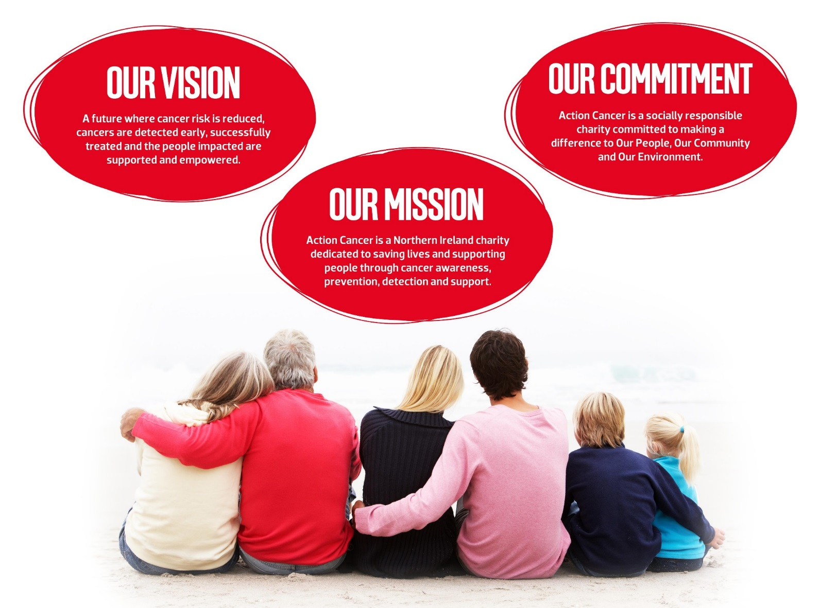

Values and Behaviours:

Our strengths are that we are a Values driven charity with people being at the very centre of everything we do. Our services are proven to make a difference, we are a Northern Ireland charity run and controlled by local people, raising money, spending money, and supporting people only here in Northern Ireland.
We have three stated Values which are supported by seven expected behaviours.

Value 1: Putting People First - People are at the centre of everything we do.

Value 2: Making a Difference - Having a positive impact on everything we do.

Value 3: Being Accountable - Clear, open and honest about everything we do.

Our Values are supported by seven Behaviours. We Will…
1. Treat people with respect, care, dignity and consideration.
2. Listen, hear and respond positively to what people say.
3. Support, develop and equip our people to reach their full potential.
4. Gain from our experience and celebrate success.
5. Work together, supporting, adding value, learning from and sharing with others.
6. Embrace and develop new ideas, ways of working and technologies.
7. Welcome scrutiny, taking ownership and responsibility collectively and individually for our actions.

Health Improvement Officer – Job Description

Overall Responsibility

With a primary focus on the delivery of health checks, health education and self-examination programmes, the overall responsibility of this role is to provide a high quality, professional and effective health education service, under the direction of the Head of Professional Services. Delivering care according to the National Institute for Clinical Excellence (NICE) and relevant National Service Framework (NSF) guidelines and evidence-based care, you will ensure we meet the protocols and clinical standards for service and programme delivery in a variety of locations across Northern Ireland.

Main Duties:

- Develop and deliver health checks, health education and self-examination programmes, ensuring adherence across the team to the NSF and NICE guidelines, and evidence-based care.

- Deliver Health Checks on board the Action Cancer Big Bus, in Action Cancer House and in Community and Workplace settings across NI.

- Deliver a range of health education and promotion programmes and activities in a variety of community and workplace settings (including to those affected by cancer).

- Support clients to adopt health promotion strategies that encourage healthy living, and apply principles of self-care.

- Assess, plan, develop, implement and evaluate programmes to promote health and well-being, and prevent adverse effects on health and well-being.

- Be responsible for the safe use and maintenance of health check equipment.

- Participate in, or lead on, health education and awareness campaigns and research projects.

Communication

- Support and advise clients requesting information relating to prevention, early detection and cancer support strategies.

- Communicate effectively with clients, recognising the need for alternative communication methods to overcome different levels of understanding, cultural background and preferred ways of communicating.

- Build relationships and partnership working with other clinical specialist teams and health professionals to enhance and improve the quality of health promotion services, responding to organisational, local and national policies and initiatives, as appropriate.

- Represent Action Cancer on external working groups, represent the charity at public functions and speak to the media in relation to health promotion messages, when appropriate.

Team Working

- Working together in the Health Promotion team, design and develop new programmes, services and materials in support of achieving the charity’s health promotion strategic aims.

- Work as an effective and responsible team member, supporting others and exploring the mechanisms to develop new ways of working.

- Delegate clearly and appropriately, adopting the principles of safe practice and assessment of competence of those taking on delegated duties.

- Accept delegation from others, prioritise own workload and ensure effective time-management strategies are embedded in own practice.

- Participate in team activities that create opportunities to improve service and programme delivery.

Quality Assurance

- Recognise and work within own competence and professional code of conduct, as regulated by the Nursing and Midwifery council (NMC).

- Take an active role in the production of monitoring, evaluation and audit processes, as required and appropriate.

- Assess effectiveness of service and programme delivery through self and peer review, benchmarking and formal evaluation.

Learning and development

- Act as a mentor to new staff, students and volunteers, assessing competence against set standards as requested and if appropriately qualified.

- Assess own learning needs and undertake learning as appropriate

- Make appropriate use of learning opportunities within and outside the workplace, evaluating their effectiveness and feeding back relevant information.

Other Duties

- Undertake administration required in support of service and programme delivery, including but not limited to, diary and rota management and the maintenance of accurate, up to date and relevant information required by the organisation for reporting and research purposes.

- Monitor work areas and practices to ensure they are safe and free from hazards and conform to health, safety and security legislation, policies, procedures and guidelines.

- Undertake work and development projects as assigned by the Head of Professional Services.

Key Essential Requirements of the role:

- The ability to travel throughout Northern Ireland - a current full driving licence and access to a car or some other form of transport to allow the post holder to carry out the duties of the post in full, is an essential criteria.

- The ability and willingness to work flexible hours, including evenings and weekends, holidays/sickness as required.

- To adhere to all of the charity’s Values, Behaviours, Policies and Procedures

- Ensure personal training and development commensurate with the role and job responsibilities.

- To participate fully in the life of the charity, contributing to its development and sustainability.

This job description will be subject to review in the light of changing circumstances and is not intended to be rigid and definitive, but should be regarded as providing guidelines within which the individual works. Other duties of a similar nature and appropriate to the grade may be assigned from time to time. It is important to note that the responsibilities of the post may change to meet the evolving needs of the services that the charity provides.

General Responsibilities

Members of staff are expected at all times to provide the appropriate service and to treat those with whom they come into contact with in a courteous and respectful manner

All staff must comply with Action Cancer’s No Smoking Policy on Action Cancer Premises and also while on duty for the charity.

All duties are carried out in compliance with Action Cancer’s Health and Safety Policy and Statutory requirements.

Action Cancer is an Equal Opportunities Employer. You are required to adhere to Action Cancer’s Equal Opportunities Policy throughout the course of employment.

All staff must comply with Action Cancer Data Protection Policy and Procedures.

To ensure the ongoing confidence of the public in the staff of Action Cancer, staff must ensure they maintain the high standards of personal accountability.

PERSONNEL SPECIFICATION

Essential Requirements

- Hold a Nursing Degree (Adult Nursing).
- Knowledge and experience of adhering to clinical standards and guidelines, within a related context.
- Knowledge of health promotion strategies.
- Experience of supporting individuals in adopting healthy lifestyles.
- Excellent communication and interpersonal skills
- An ability to work both independently and as part of a team.
- Proven ability to prioritise and work to deadlines.
- Ability to work flexibly and to work evenings and weekends.
- Experience and working knowledge of IT (Microsoft packages), including use of presentation package in a work setting.
- Be able to undertake manual lifting and handling duties to carry out the duties of the post in full.
- Current full driving licence and access to a car to enable travel throughout N Ireland or some other form of transport to allow the post holder to carry out the duties of the post in full. Action Cancer operates a staff car pool rota for staff travelling to and from the Big Bus.

Desirable Requirements

- At least one year relevant nursing work experience – specify dates and roles.
- Membership of a professional body.
- Knowledge and/or experience of Health Promotion issues in relation to cancer awareness and self-examination.
- Experience in dealing with the media.

Terms and Conditions of Employment

- 2 satisfactory references are required one which must be from a current / previous employer
- Successful applicants must evidence their right to work in the UK (under the Asylum and Immigration Act).This will be evidenced in the first instance by a passport or other forms of ID that will be outlined if no passport is available.
- 6 months probationary period
- Evidence of relevant academic and professional qualifications
- Evidence of appropriate vehicle documentation
- All potential employees may be asked to attend a pre-employment medical
- Satisfactory AccessNI /Security Check including barred list check.

Action Cancer is an Equal Opportunities employer, and are proud to have achieved Investors in Volunteers accreditation.

Appendix 1 : Action Cancer Total Reward Statement
TRAINING AND DEVELOPMENT
- Organisation Wide Training Budget
- Paid Tailored Training and Development Support
- Comprehensive In-House Training Courses and External Development Opportunities linked to Role, Strategic Plan, Individual Requests, and Competencies
- Comprehensive Induction Programme
- One to One Coaching & Mentoring
- Personal Job Plans, Development Plans, and Ongoing Supervision
- Continued Professional Development Support
- Structured Interim and Annual Performance Reviews
- Regular Teambuilding and Staff Away Days
- Cross Departmental Working Opportunities
- Overseas Challenge Opportunities

WORK LIFE BALANCE
- Standard 35 hour working week
- Staggered start times
- Up to 30 days annual leave and 12 annual statutory days
- Flexible working (home working, compressed and reduced working hours)
- Fixed Christmas closure
- Time Off In Lieu (TOIL) in compensation of additional hours worked
- Career breaks
- Discretionary leave
- Family Friendly Policies
- People Friendly Policies
- Christmas Family Party

SOCIAL, PHYSICAL AND MENTAL HEALTH WELLBEING
- Therapeutic Supports - Counselling, Complementary Therapy, Acupuncture
- External Staff Care and Support Services
- External Occupational Health Service
- Health Checks, Screening and Flu Vaccinations
- Regular Staff Health and Wellbeing Surveys
- WPA - NHS Cash Back Plan
- Financial Workshops
- Mediation Services
- Subsidised Christmas Departmental Celebrations
- Staff Pool Car

FINANCIAL REWARD AND RECOGNITION
- Sector Competitive Salaries
- Annual Increments to Top of Scale and Cost of Living Increase
- Enhanced Sick, Maternity, Paternity and Adoption Pay
- 6% Contributory Pension Scheme
- Work Related Professional Membership Fees Paid
- Salary Sacrifice for Pension, Childcare, Bus Travel, and Bike to Work Schemes
- Celebration of Individual and Team Success
- Mileage Allowance at the Prevailing HMRC Rate
- Clear Policies and Procedures
- Enhanced Paid Annual Leave
- Additional Day Paid Leave at Christmas and at 10,15,and 20 Years’ Service
- Free Parking

