

Job Description and Personnel Specification

Fundraising Events Officer

Full Time

Permanent

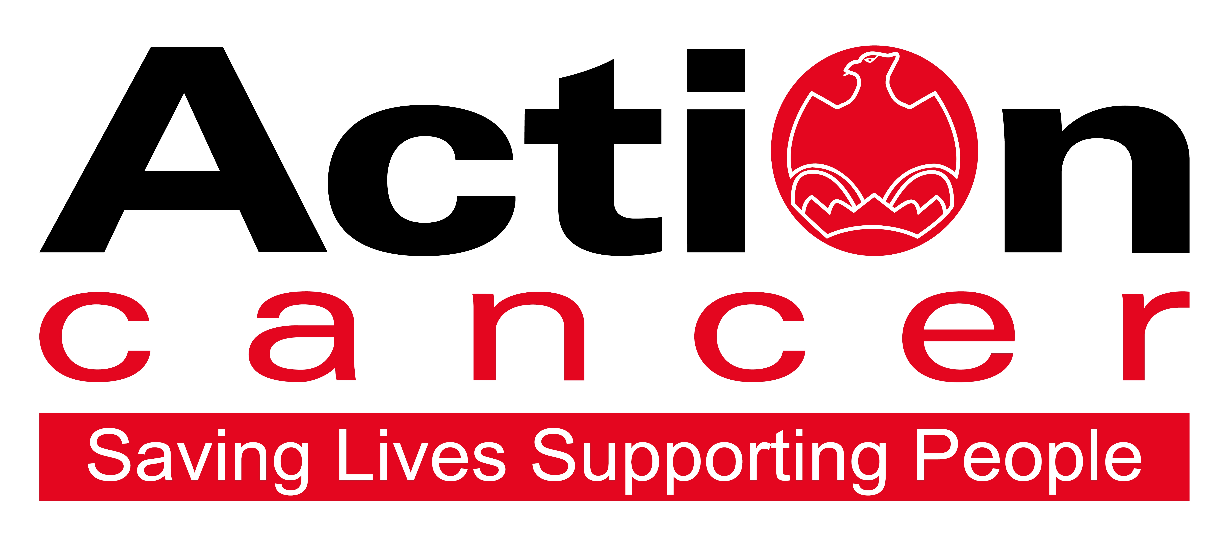

Title of Post: Fundraising Events Officer

Hours: 35 per week

Reports to: Head of Fundraising and Communications

Location: Action Cancer House

Salary: NJC point 33 – 37: £29,033 - £32,164

In addition to a competitive salary, Action Cancer offer the Total Reward Package (enclosed), which focuses on what our staff value, and includes a flexible mix of rewards designed to meet staff needs, their lifestyle, and their stage in life, including a time-off-in-lieu accrual system, training, flexible family-friendly working arrangements, pension contributions, and excellent professional development opportunities.



Action Cancer is a local Northern Ireland charity - all our money is raised to provide services for local communities. Our dedicated team of staff and volunteers work across the whole of Northern Ireland helping to save lives and support people affected by cancer. To operate our services we must raise over £3.4 million every year.

We provide early detection and health promotion services, and counselling and support services for cancer patients and their families, thereby making a real difference to people who are affected by or living with cancer.

Action Cancer staff - a mix of highly skilled professionals - are the most valuable asset to our charity. We offer a wide variety of training and development opportunities, and family friendly initiatives to enhance work-life balance, and to value and support individuals and family life. In recognition of this we were awarded Best Learning and Development Organisation in Ireland - Not for Profit Sector, and were winners of The Irish News ‘Best Place to Work’ Award, Employers For Childcare “Childcare Works Award” , Employers For Childcare Family Friendly Employer Award - Social Enterprise/Charity of the Year, and Employer of the Year Award by UTV Business Eye Awards.

We are also very proud to have achieved Investors in People Gold Champion status, Investors in People Health & Wellbeing Good Practice accreditation, and Investors in Volunteers accreditation. These awards are testament to our continued commitment to “have highly valued, trained, enthusiastic, focused and committed people who work together and engage with others to make a positive impact on our community”. 

Employees of Action Cancer must support its Mission, Values and Behaviours:



Values and Behaviours:

Our strengths are that we are a Values driven charity with people being at the very centre of everything we do. Our services are proven to make a difference, we are a Northern Ireland charity run and controlled by local people, raising money, spending money, and supporting people only here in Northern Ireland.
We have three stated Values which are supported by seven expected behaviours.

Value 1: Putting People First - People are at the centre of everything we do.

Value 2: Making a Difference - Having a positive impact on everything we do.

Value 3: Being Accountable - Clear, open and honest about everything we do.

Our Values are supported by seven Behaviours. We Will…
1. Treat people with respect, care, dignity and consideration.
2. Listen, hear and respond positively to what people say.
3. Support, develop and equip our people to reach their full potential.
4. Gain from our experience and celebrate success.
5. Work together, supporting, adding value, learning from and sharing with others.
6. Embrace and develop new ideas, ways of working and technologies.
7. Welcome scrutiny, taking ownership and responsibility collectively and individually for our actions.

Fundraising Events Officer – Job Description

Overall Responsibility

In accordance with Action Cancer’s strategic plan and in consultation with the Head of Fundraising and Communications, develop a strategy to generate income from events in line with the principles and objectives of Action Cancer.

Duties

Special Events

- Develop and meet agreed targets by building on the charity’s existing events programme and by introducing new events with the aim of generating funds for the charity.
- Develop meaningful and effective relationships with individuals, partners and cycling and running events and associations with the aim of encouraging them to run events on behalf of the charity.
- Provide support and resources to external parties who offer to run events for Action Cancer via public run events.
- Supervise volunteers and placements with the aim of maximizing events income.

Promotion of Events

- Contribute to the overall marketing and development and implementation of the charity’s promotion of events strategy and activity.
- Assist with the production of the publications and promotional materials relating to events.
- Explore innovative and creative ways to maintain the charity’s public profile and to educate and increase awareness of Action Cancer services and campaigns.
- Contribute to income growth through the expansion and development of the events portfolio and revenue generated
- Promote the New York Marathon and a select number of Half Marathons as Action Cancer Team events with agreed numbers of sign-ups
- Actively market participation by individuals and teams for established cycling and running events

Hair and Beauty Businesses

- To develop and co-ordinate the charity’s income by working closely with this business market throughout the year and during BCAM each October

Management and Development of Staff

- Line Manage the Events Assistant

Budget Control

- to undertake the budget build as part of the annual income and expenditure process
- to manage and achieve income (circa £300,000 per annum from existing and new events) and expenditure strictly in line with the agreed signed off annual budget
- to report monthly on actual, budgeted, and explanation of any variances

Health and Safety

- Ensure that all Health and Safety requirements are met.
- Ensure Action Cancer Health and Safety Policy is adhered to.

Other Duties

A team approach is central to the success of Action Cancer’s fundraising department and the post holder will be required to assist with:

- Direct Mail Campaigns
- PR
- Cheque presentations
- Implementation of awareness campaigns
- Corporate fundraising

This job description will be subject to review in the light of changing circumstances and is not intended to be rigid and definitive, but should be regarded as providing guidelines within which the individual works. Other duties of a similar nature and appropriate to the grade may be assigned from time to time. It is important to note that the responsibilities of the post may change to meet the evolving needs of the services that the charity provides.

General Responsibilities

All staff must comply with Action Cancer’s No Smoking Policy on Action Cancer Premises and also while on duty for the charity.

All duties are carried out in compliance with Action Cancer’s Health and Safety Policy and Statutory requirements.

Action Cancer is an Equal Opportunities Employer. You are required to adhere to Action Cancer’s Equal Opportunities Policy throughout the course of employment.

To ensure the ongoing confidence of the public in the staff of Action Cancer, staff must ensure they maintain the high standards of personal accountability.

Action Cancer is an Equal Opportunities employer, and an
Investors in People Gold Champion Organisation.

PERSONNEL SPECIFICATION

Essential Criterion

- A minimum of 24 months working experience in Event Management or Fundraising.

- Relevant Degree level qualification or equivalent OR a minimum of 4 years’ experience working in Event Management or Fundraising.

- Proven experience of achieving financial targets and competent budget management

- A minimum of one year’s experience supervising or managing staff.

- Proven team player

- Excellent communication skills

- Excellent organisational skills

- Ability to work on own initiative

- Ability to multi-task, prioritize and work to deadlines

- High level of experience and competence with IT including all Microsoft packages and social media

- Flexible and available to work hours to meet the needs of the role – including evenings and weekends.

- Hold a full, current driving license with business insurance and have access to the use of a car or some other appropriate form of transport to carry out the duties of the post in full.

Desirable Criterion

- Two year’s experience in a similar role

- Previous experience of public speaking

- Experience of Raisers Edge software

Terms and Conditions of Employment

- 2 satisfactory references are required one which must be from a current / previous employer
- Successful applicants must evidence their right to work in the UK (under the Asylum and Immigration Act).This will be evidenced in the first instance by a passport or other forms of ID that will be outlined if no passport is available.
- 6 months probationary period
- Evidence of relevant academic and professional qualifications
- Evidence of appropriate vehicle documentation
- All potential employees may be asked to attend a pre-employment medical

Financial & Pay In Kind | Action Cancer Total Reward
Salary | Health & Wellbeing
Pension contributions | Flexible Work options
Annual Increments to top of scale | NHS Cash Benefits Top-Up Scheme
Pay increases linked to NJC & AFC | Staff Care Services
Mileage Allowance | Access to Therapies
Travel Expenses | Access to Independent Counselling 24/7
Enhanced Paid Annual Leave | Health Screenings
Incremental Increases in Annual Leave | Return to Work Interviews
Additional Annual Leave at 10, 15, and 20 years service | Return to Work Programs
Paid Bank and Public Holidays | Occupational Health Service
Additional Day Paid Leave at Christmas | Time off work to Volunteer
Additional Celebration Days eg Royal Wedding, Jubilee | Kitchen Facilities
TOIL | Free Coffee / Tea/water fountains
Free Parking | Shower Facilities
Enhanced Sick Pay | Personal and Family Related
Enhanced Paternity Pay | Salary Sacrifice for Pension
Enhanced Maternity and Adoption Pay | Salary Sacrifice to Support Childcare Costs
Bicycles for Work Scheme | Fixed Closure at Christmas
Uniforms | Compassionate/Bereavement Leave
Memberships of Professional Bodies | Part Time Work
Memberships of Professional Organisations | Compressed Working
Organisation Wide Training Budget | Remote/Home Working
Attendance at External Seminars & Conferences | Family Friendly Policies
Subsistence Payments | People Friendly policies
Laptop Provision | Career Break
Mobile Phone Provision | Parental Leave
£10 Christmas Celebration Gift | Dependency Leave
Investment in People | Special Leave
Comprehensive Induction Training | Santa Party for Staff and Children
3 & 6 Month Review of Probation Period | Early Closure at Christmas, Easter and July
Coaching & Mentoring | Unpaid Sabbaticals
Four Performance Reviews per annum | Internet Purchases can be delivered to Work
Review of Annual Performance | Comprehensive development programme
121 Meetings with Line Manager | Recognition
On the job learning | Staff Empowerment - involvement in decisions
Training & Development linked to Strategic Plan | Personal Thank You's
Training & Development linked to Competencies | Celebrate Individual & Team Success
Continuing Professional Development | Equality of Opportunity
Training & Development linked to Individual Requests | Policies and Procedures
Educational Training Grants | Framework to Raise Matters of Concern
Study Leave | Open culture of communication
Overseas Challenge opportunities | Recognition in Chief Executive Newsletter
Staff Away Days | Flowers
Strategy Away Days | Contribution to Christmas Celebrations

