

Job Description & Personnel Specification

Shop Manager, Belmont Road
and
Shop Manager, Ormeau Road

2 Full Time, Permanent roles

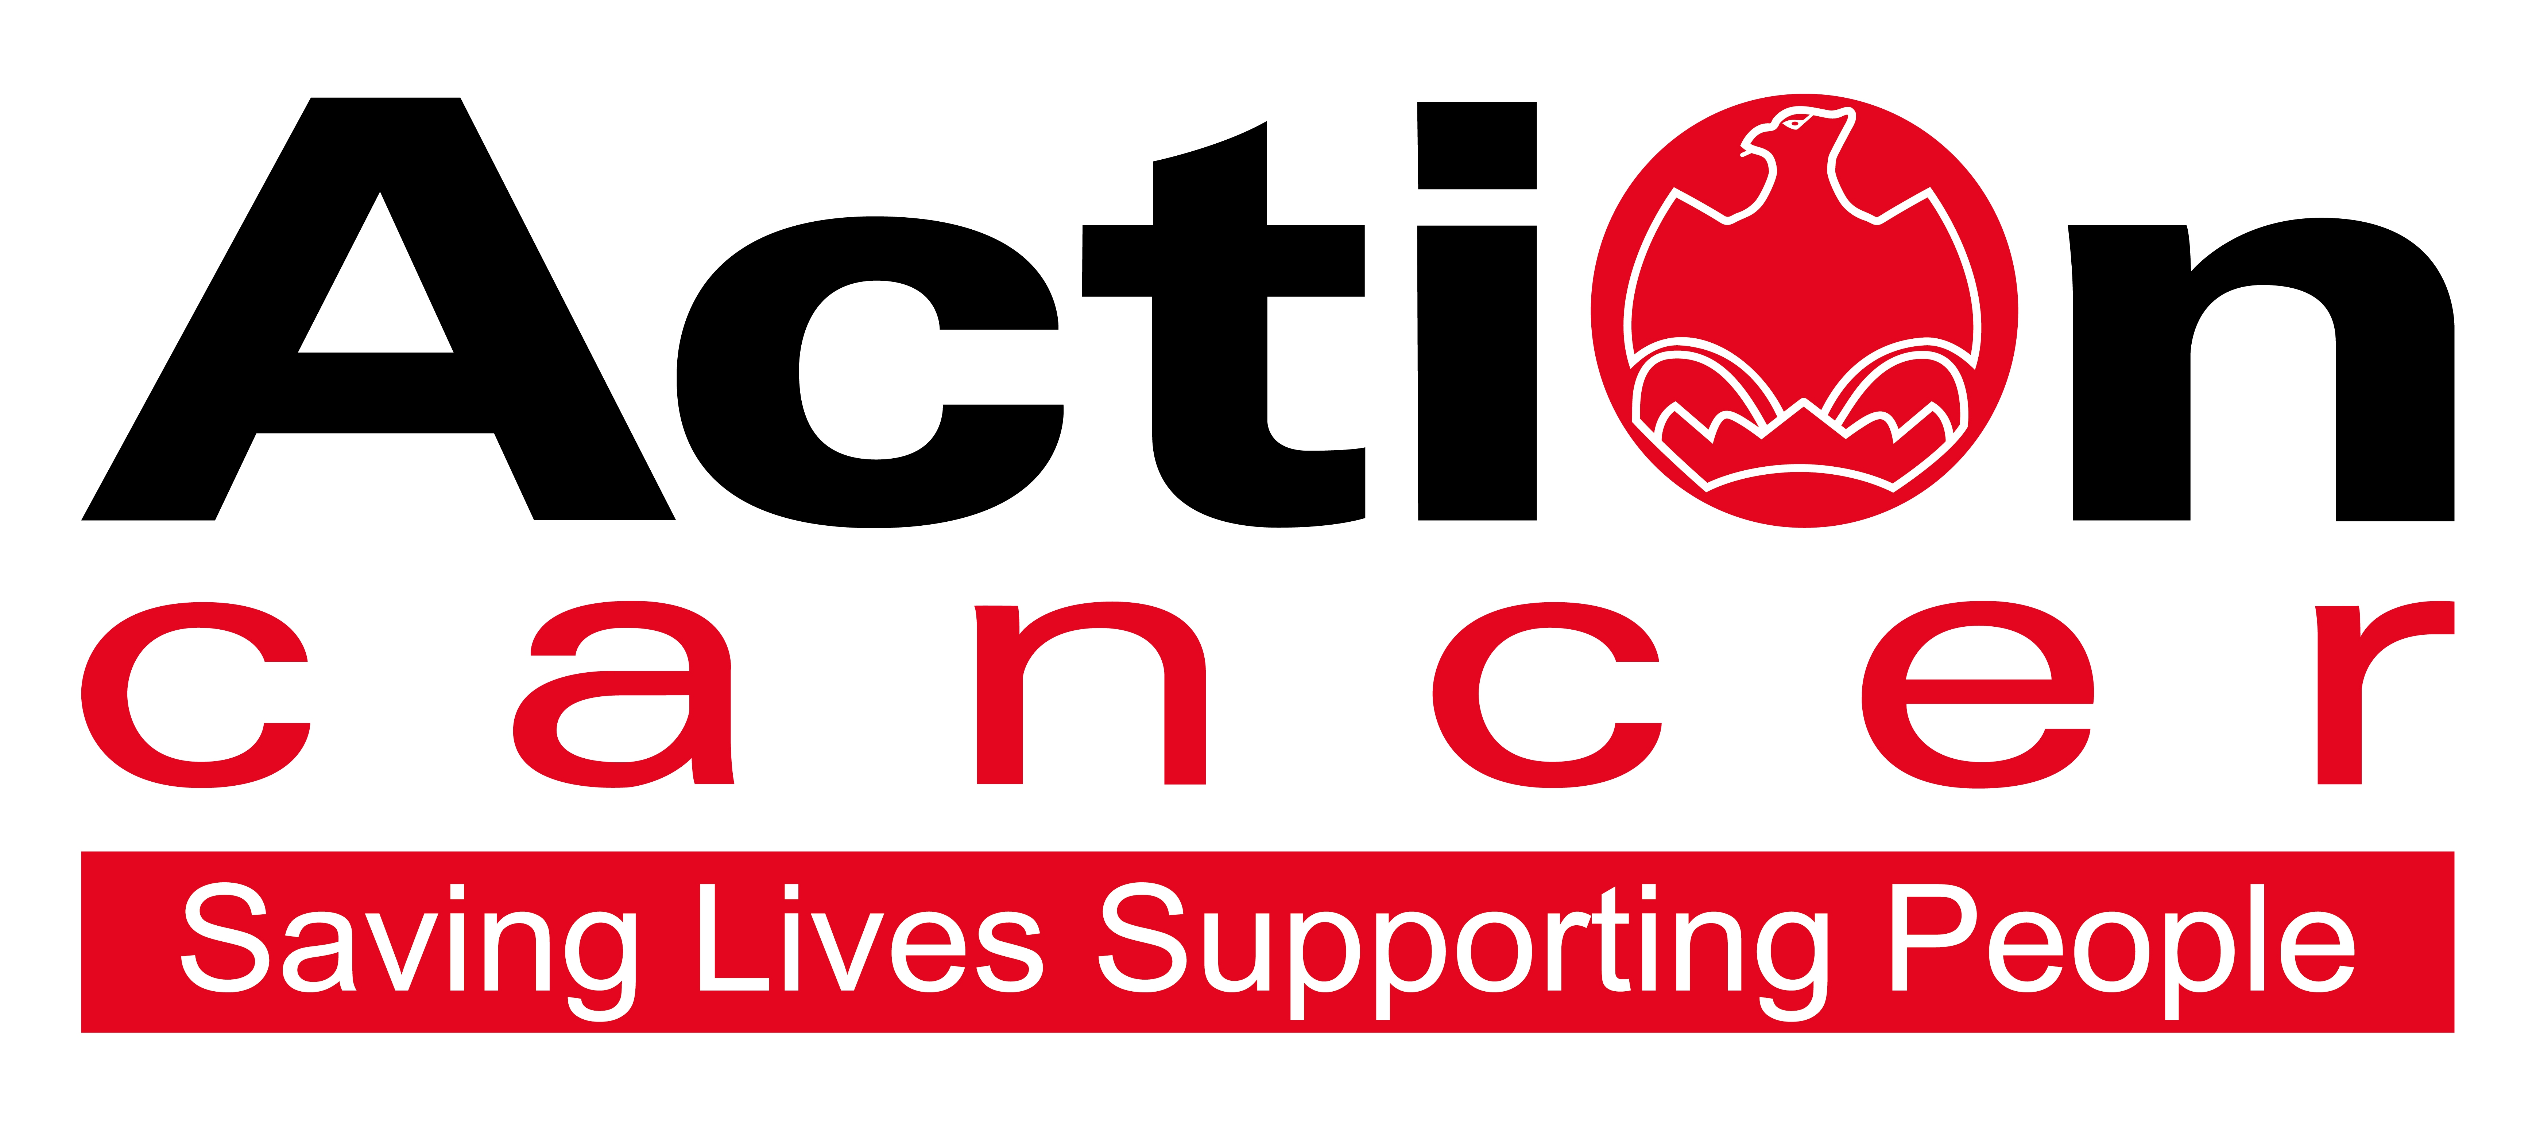

Title of Post: Shop Manager

Location: 18 Belmont Road, Belfast AND 181 Ormeau Road, Belfast

Hours: 35 hours per week

Reports to: Retail Operations Manager

Salary: NJC Points 12 – 16 : £15,823 - £17,169

In addition to a competitive salary, Action Cancer offer the Total Reward Package (enclosed), which focuses on what our staff value, and includes a flexible mix of rewards designed to meet staff needs, their lifestyle, and their stage in life, including a time-off-in-lieu accrual system, training, personal development opportunities, flexible family-friendly working arrangements, pension contributions, and excellent professional development opportunities.



Action Cancer is a local Northern Ireland charity - all our money is raised to provide services for local communities. Our dedicated team of staff and volunteers work across the whole of Northern Ireland helping to save lives and support people affected by cancer. To operate our services we must raise circa £4 million every year.

We provide early detection and health promotion services, and counselling and support services for cancer patients and their families, thereby making a real difference to people who are affected by or living with cancer.

Action Cancer staff - a mix of highly skilled professionals - are the most valuable asset to our charity. We offer a wide variety of training and development opportunities, and family friendly initiatives to enhance work-life balance, and to value and support individuals and family life. In recognition of this we have been awarded Best Learning and Development Organisation in Ireland - Not for Profit Sector, and were winners of The Irish News ‘Best Place to Work’ Award, Employers For Childcare “Childcare Works Award”, Employers For Childcare Family Friendly Employer Award - Social Enterprise/Charity of the Year, and Employer of the Year Award by UTV Business Eye Awards.

We are also very proud to have achieved Investors in People Gold Champion status, Investors in People Health & Wellbeing Good Practice accreditation, and Investors in Volunteers accreditation. These awards are testament to our continued commitment to developing and supporting our staff to “be a people centred charity where everyone is valued, empowered, highly motivated, developed and equipped to deliver their best”.


Employees of Action Cancer must support its Mission, Values and Behaviours:



Values and Behaviours:

Our strengths are that we are a Values driven charity with people being at the very centre of everything we do. Our services are proven to make a difference, we are a Northern Ireland charity run and controlled by local people, raising money, spending money, and supporting people only here in Northern Ireland.
We have three stated Values which are supported by seven expected behaviours.

Value 1: Putting People First - People are at the centre of everything we do.

Value 2: Making a Difference - Having a positive impact on everything we do.

Value 3: Being Accountable - Clear, open and honest about everything we do.

Our Values are supported by seven Behaviours. We Will…
1. Treat people with respect, care, dignity and consideration.
2. Listen, hear and respond positively to what people say.
3. Support, develop and equip our people to reach their full potential.
4. Gain from our experience and celebrate success.
5. Work together, supporting, adding value, learning from and sharing with others.
6. Embrace and develop new ideas, ways of working and technologies.
7. Welcome scrutiny, taking ownership and responsibility collectively and individually for our actions.

Shop Manager – Job Description

Overall Responsibility

To take responsibility for the effective management of the shop under standards set by the Retail Operations Manager.

Main Areas of Responsibility:

Sales

- To meet set shop targets by increasing shop sales.

- To sort and select appropriate items for sale from donated goods and maintain correct level, quality and rotation of stock.

- To ensure a high standard of presentation, display and pricing of stock according to Action Cancer’s retail standards.

- To monitor and check the security of stock on the shop floor and stock room, and to report any irregularities to the Retail Operations Manager.

- To ensure adequate stock levels by proactively sourcing stock in local area.

- To ensure that the shop, stock room, and other facilities are clean, tidy and safe at all times.

Financial Administration

- To implement and maintain financial procedures as set by the Retail Operations Manager.

- To take full responsibility for the shops administration and accounting procedure, including till operations, daily banking and weekly accounts.

3. To address and report any financial irregularities that may arise in the shop.

Staff

- To take full responsibility for the recruitment, management, and training of sufficient volunteers to enable the shop to run efficiently.

- To implement an effective rota system to ensure that the shop is covered and trading in the manager’s absence.

- To arrange regular meetings with volunteers to pass on information.

Information Service

- To provide, maintain and update the information service, as established by Action
Cancer.

- To instruct staff and volunteers in the provision and maintenance of the information service.

Health and Safety

- To ensure that the workplace for which the post-holder is responsible is maintained appropriately and in accordance with Action Cancer’s Health and Safety Policy and relevant Health and Safety Legislation.

- To ensure that all volunteers and staff are trained in all aspects of Health and Safety.

- To complete relevant Health and Safety checklists as instructed by the Retail Operations Manager.

Other Requirements

- To observe equality of opportunity in all areas of the day-to-day work for which the post-holder has responsibility.

- To compulsorily attend monthly shop management meetings and to undertake training as agreed with the Retail Operations Manager.

- To actively participate in the implementation of the Annual Performance Review System and any assessments.

- To provide cover for other Action Cancer shops as requested by the Retail Operations Manager.

- To undertake any other duties which may from time to time be requested by the Retail Operations Manager, which are commensurate with the duties and responsibilities of the post.

This job description will be subject to review in the light of changing circumstances and is not intended to be rigid and definitive, but should be regarded as providing guidelines within which the individual works. Other duties of a similar nature and appropriate to the grade may be assigned from time to time. It is important to note that the responsibilities of the post may change to meet the evolving needs of the services that the charity provides.

General Responsibilities

Members of staff are expected at all times to provide the appropriate service and to treat those with whom they come into contact with in a courteous and respectful manner

All staff must comply with Action Cancer’s No Smoking Policy on Action Cancer Premises and also while on duty for the charity.

All duties are carried out in compliance with Action Cancer’s Health and Safety Policy and Statutory requirements.

Action Cancer is an Equal Opportunities Employer. You are required to adhere to Action Cancer’s Equal Opportunities Policy throughout the course of employment.

All staff must comply with Action Cancer Data Protection Policy and Procedures.

To ensure the ongoing confidence of the public in the staff of Action Cancer, staff must ensure they maintain the high standards of personal accountability.

PERSONNEL SPECIFICATION

Essential Requirements

- Minimum of one year’s retail experience at management level with the ability to demonstrate experience of planning, monitoring and reporting at this level

- Experience of working within and achieving income and expenditure budgets.

- Strong and positive leadership skills including the ability to motivate and to delegate.

- Excellent organisational skills including the ability to prioritise and manage workload, multi-task and work to deadlines.

- Excellent communication and interpersonal skills

- Ability to work under pressure using own initiative as required

- Positive and flexible approach.

- Be able to undertake manual lifting and handling duties.

- Have access to the use of a car or some other appropriate form of transport to carry out the duties of the post including travelling for training purposes and meetings when required - a full, current driving licence with business insurance is required when using own car for business purposes.

- Must be prepared to work 5 out of 6 days including Saturday (excluding Sunday).

Desirable Requirements

- One year’s fashion retail experience.

- Experience of working with volunteers in a retail environment.

- Computer literate with a working knowledge of MS Office (Word, Excel, Outlook, Internet)

- Gift Aid experience

Terms and Conditions of Employment

- 2 satisfactory references are required one which must be from a current / previous employer
- Successful applicants must evidence their right to work in the UK (under the Asylum and Immigration Act).This will be evidenced in the first instance by a passport or other forms of ID that will be outlined if no passport is available.
- 6 months probationary period
- Evidence of appropriate vehicle documentation
- All potential employees may be asked to attend a pre employment medical

Action Cancer is an Equal Opportunities employer, and an
Investors in People Gold Champion Organisation.

Financial & Pay In Kind | Action Cancer Total Reward
Salary | Health & Wellbeing
Pension contributions | Flexible Work options
Annual Increments to top of scale | NHS Cash Benefits Top-Up Scheme
Pay increases linked to NJC & AFC | Staff Care Services
Mileage Allowance | Access to Therapies
Travel Expenses | Access to Independent Counselling 24/7
Enhanced Paid Annual Leave | Health Screenings
Incremental Increases in Annual Leave | Return to Work Interviews
Additional Annual Leave at 10, 15, and 20 years service | Return to Work Programs
Paid Bank and Public Holidays | Occupational Health Service
Additional Day Paid Leave at Christmas | Time off work to Volunteer
Additional Celebration Days eg Royal Wedding, Jubilee | Kitchen Facilities
TOIL | Free Coffee / Tea/water fountains
Free Parking | Shower Facilities
Enhanced Sick Pay | Personal and Family Related
Enhanced Paternity Pay | Salary Sacrifice for Pension
Enhanced Maternity and Adoption Pay | Salary Sacrifice to Support Childcare Costs
Bicycles for Work Scheme | Fixed Closure at Christmas
Uniforms | Compassionate/Bereavement Leave
Memberships of Professional Bodies | Part Time Work
Memberships of Professional Organisations | Compressed Working
Organisation Wide Training Budget | Remote/Home Working
Attendance at External Seminars & Conferences | Family Friendly Policies
Subsistence Payments | People Friendly policies
Laptop Provision | Career Break
Mobile Phone Provision | Parental Leave
£10 Christmas Celebration Gift | Dependency Leave
Investment in People | Special Leave
Comprehensive Induction Training | Santa Party for Staff and Children
3 & 6 Month Review of Probation Period | Early Closure at Christmas, Easter and July
Coaching & Mentoring | Unpaid Sabbaticals
Three Performance Reviews per annum | Internet Purchases can be delivered to Work
Review of Annual Performance | Comprehensive development programme
121 Meetings with Line Manager | Recognition
On the job learning | Staff Empowerment - involvement in decisions
Training & Development linked to Strategic Plan | Personal Thank You's
Training & Development linked to Competencies | Celebrate Individual & Team Success
Continuing Professional Development | Equality of Opportunity
Training & Development linked to Individual Requests | Policies and Procedures
Educational Training Grants | Framework to Raise Matters of Concern
Study Leave | Open culture of communication
Overseas Challenge opportunities | Recognition in Chief Executive Newsletter
Staff Away Days | Flowers
Strategy Away Days | Contribution to Christmas Celebrations

