

Job Description & Personnel Specification

Counsellor

14 hours per week

Permanent

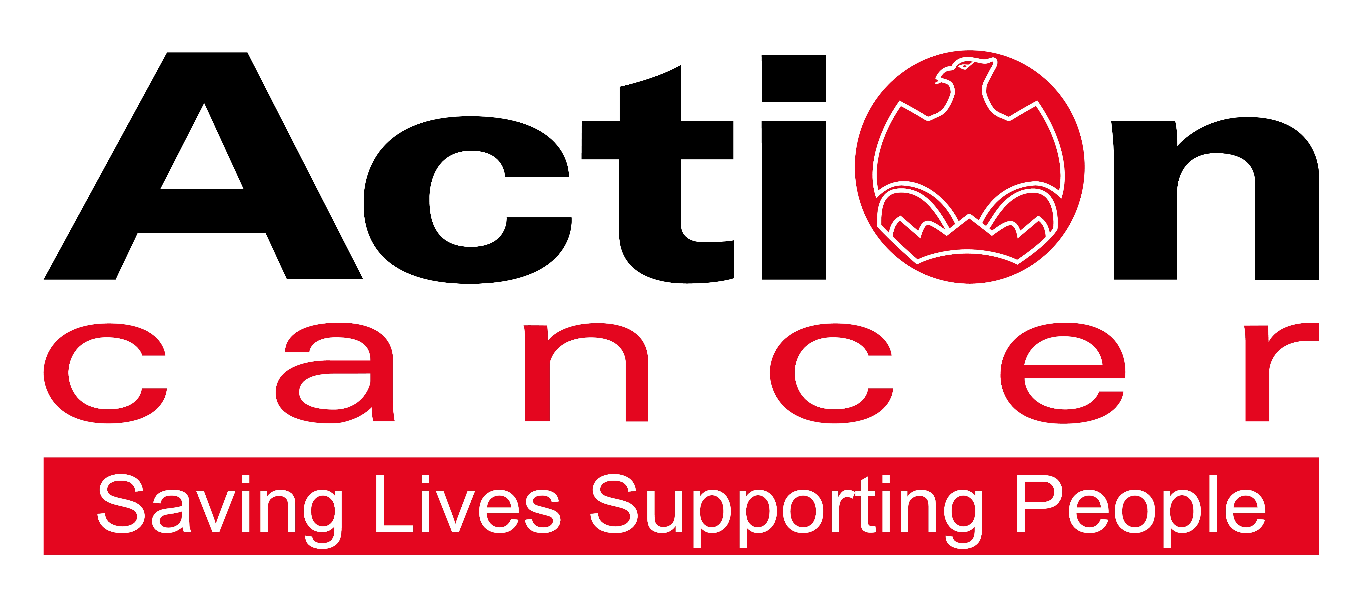

Title of Post: Counsellor

Hours: 14 hours per week (Monday 8.00 – 3.00pm, Wednesday 8.00 – 5.00pm)

Reports to: Service Development Manager

Location: Based at Action Cancer House, Belfast

Salary: NJC Scale Pts 29-33: £25,694 - £29,033
Pro rata: £10,278 - £11,613

In addition to a competitive salary, Action Cancer offer the Total Reward Package (enclosed), which focuses on what our staff value, and includes a flexible mix of rewards designed to meet staff needs, their lifestyle, and their stage in life, including a time-off-in-lieu accrual system, training, flexible family-friendly working arrangements, pension contributions, and excellent professional development opportunities.



Action Cancer is a local Northern Ireland charity - all our money is raised to provide services for local communities. Our dedicated team of staff and volunteers work across the whole of Northern Ireland helping to save lives and support people affected by cancer. To operate our services we must raise circa £4 million every year.

We provide early detection and health promotion services, and counselling and support services for cancer patients and their families, thereby making a real difference to people who are affected by or living with cancer.

Action Cancer staff - a mix of highly skilled professionals - are the most valuable asset to our charity. We offer a wide variety of training and development opportunities, and family friendly initiatives to enhance work-life balance, and to value and support individuals and family life. In recognition of this we were awarded Best Learning and Development Organisation in Ireland - Not for Profit Sector, and were winners of The Irish News ‘Best Place to Work’ Award 2015, Employers For Childcare “Childcare Works Award” 2014, Employers For Childcare Family Friendly Employer Award 2015 - Social Enterprise/Charity of the Year, Employer of the Year Award by UTV Business Eye Awards for 2015.

We are also very proud to have achieved Investors in People Gold Champion status, Investors in People Health & Wellbeing Good Practice accreditation, and Investors in Volunteers accreditation. These awards are testament to our continued commitment to developing and supporting our staff to “be a people centred charity where everyone is valued, empowered, highly motivated, developed and equipped to deliver their best”.


Employees of Action Cancer must support its Mission, Values and Behaviours:



Values and Behaviours:

Our strengths are that we are a Values driven charity with people being at the very centre of everything we do. Our services are proven to make a difference, we are a Northern Ireland charity run and controlled by local people, raising money, spending money, and supporting people only here in Northern Ireland.
We have three stated Values which are supported by seven expected behaviours.

Value 1: Putting People First - People are at the centre of everything we do.

Value 2: Making a Difference - Having a positive impact on everything we do.

Value 3: Being Accountable - Clear, open and honest about everything we do.

Our Values are supported by seven Behaviours. We Will…
1. Treat people with respect, care, dignity and consideration.
2. Listen, hear and respond positively to what people say.
3. Support, develop and equip our people to reach their full potential.
4. Gain from our experience and celebrate success.
5. Work together, supporting, adding value, learning from and sharing with others.
6. Embrace and develop new ideas, ways of working and technologies.
7. Welcome scrutiny, taking ownership and responsibility collectively and individually for our actions.

Counsellor – Job Description

Overall Responsibility

The post holder will contribute to the overall development of the counselling service within the charity and will participate as a member of the Action Cancer therapeutic team, comprising counsellors, complementary therapists, life coaches and the Peer Mentoring Service. Professional supervision will be provided together with access to continuing professional development. The post holder will work mainly from Action Cancer House and occasionally provide home visits for counselling clients and other venues.

Duties:

Counselling:
  - Provide face-to-face counselling sessions to cancer patients.
  - Provide face-to-face counselling sessions to individual family members affected by another person’s cancer (eg: spouses, partners etc.)
  - Provide telephone counselling and support, as necessary.
  - Maintain up-to-date knowledge and awareness of referral options to which clients can be referred, as appropriate.

Group based support
- Assist in the development and delivery of group-based support to cancer patients and their families.
- Assist with the provision of information sessions and awareness raising in relation to Action Cancer’s therapeutic activity.
- To liaise, communicate and attend meetings with Support and Therapeutic Services Team, and other agencies as required.

Quality standards
- Ensure that all work operates within the BACP Ethical Standards Framework for Good Practice in Counselling and Psychotherapy or equivalent IACP.
- Attend regular counselling supervision sessions.
- Ensure that own knowledge and skills are kept up-to-date regarding counselling theory and practice by means of continuing professional development.
- To undertake specific cancer awareness training regarding understanding the impact of cancer diagnosis.
- To participate in staff induction, appraisal and other training events as required.

Administration
- Keep accurate and up-to-date records (electronic and hard copy) of sessions provided, in accordance with Action Cancer’s and BACP requirements.
- Prepare reports, briefing papers and statistics as necessary for the monitoring and evaluation of the counselling service.
- Ensure timely access of emails and telephone communication.

Evaluation
- To participate in the evaluation of Support and Therapeutic Services on an ongoing basis.
- Ensure that all records are maintained and up to date.

Health and Safety

- Ensure that all Health and Safety requirements are met.
- Ensure Action Cancer Health and Safety Policy is adhered to.

Corporate responsibilities
- Ensure that Action Cancer’s policies, procedures and corporate high standards are adhered to at all times.
- Contribute to the ongoing promotion of Action Cancer’s positive profile and image, especially in relation to the therapeutic service.
- Support the overall work of the charity by attending/participating in activities and events as required.
- Represent the charity on outside bodies, including attendance at meetings, seminars and conferences, as required.
- Liaise with other partnership organisations re service requirements as required.

Additional duties
- Keep Line Manager and the Head of Professional Services fully apprised of all relevant matters.
- Ensure the confidentiality of all information received as a result of the post holder’s duties in
accordance with the charity’s expectations.
- Undertake any other duties that might be reasonably be required by the Service Development
Manager.

This job description will be subject to review in the light of changing circumstances and is not intended to be rigid and definitive, but should be regarded as providing guidelines within which the individual works. Other duties of a similar nature and appropriate to the grade may be assigned from time to time. It is important to note that the responsibilities of the post may change to meet the evolving needs of the services that the charity provides.

General Responsibilities

Members of staff are expected at all times to provide the appropriate service and to treat those with whom they come into contact with in a courteous and respectful manner

All staff must comply with Action Cancer’s No Smoking Policy on Action Cancer Premises and also while on duty for the charity.

All duties are carried out in compliance with Action Cancer’s Health and Safety Policy and Statutory requirements.

Action Cancer is an Equal Opportunities Employer. You are required to adhere to Action Cancer’s Equal Opportunities Policy throughout the course of employment.

All staff must comply with Action Cancer Data Protection Policy and Procedures.

To ensure the ongoing confidence of the public in the staff of Action Cancer, staff must ensure they maintain the high standards of personal accountability.

PERSONNEL SPECIFICATION

Essential Requirements

- Recognised Diploma in Counselling or equivalent.
- Hold professional accreditation as a counsellor through BACP or IACP, or a minimum of 250 hours post qualification working towards BACP or IACP accreditation.
- Minimum 2 years post qualifying counselling experience, working under professional supervision.
- Be able to demonstrate awareness of and adherence to a recognised professional code of ethics and standards (eg: BACP Ethical Framework or IACP). This includes working within the parameters of data protection.
- Hold a full, current driving license with business insurance and have access to the use of a car or some other appropriate form of transport to carry out the duties of the post in full.
- Flexibility to work early starts (8am) and evening work and occasional weekend work.
- Willingness to undertake the diploma in children and young people’s counselling if you do not already hold this qualification.

Desirable Requirements

- Previous experience of counselling work in the cancer field.
- Previous experience of group work.
- Experience in the design and/or delivery of counselling training courses/sessions.
- 3 years or more counselling experience, working under professional supervision.
- Diploma in children and young people’s counselling.
- Experience in managing referrals from health professionals.

Terms and Conditions of Employment

- 2 satisfactory references are required one which must be from a current / previous employer
- Successful applicants must evidence their right to work in the UK (under the Asylum and Immigration Act).This will be evidenced in the first instance by a passport or other forms of ID that will be outlined if no passport is available.
- 6 months probationary period
- Access NI Check
- Evidence of relevant academic and professional qualifications
- Evidence of appropriate vehicle documentation
- All potential employees may be asked to attend a pre-employment medical

Action Cancer is an Equal Opportunities employer, and an
Investors in People Gold Champion Organisation.

Financial & Pay In Kind | Action Cancer Total Reward
Salary | Health & Wellbeing
Pension contributions | Flexible Work options
Annual Increments to top of scale | NHS Cash Benefits Top-Up Scheme
Pay increases linked to NJC & AFC | Staff Care Services
Mileage Allowance | Access to Therapies
Travel Expenses | Access to Independent Counselling 24/7
Enhanced Paid Annual Leave | Health Screenings
Incremental Increases in Annual Leave | Return to Work Interviews
Additional Annual Leave at 10, 15, and 20 years service | Return to Work Programs
Paid Bank and Public Holidays | Occupational Health Service
Additional Day Paid Leave at Christmas | Time off work to Volunteer
Additional Celebration Days eg Royal Wedding, Jubilee | Kitchen Facilities
TOIL | Free Coffee / Tea/water fountains
Free Parking | Shower Facilities
Enhanced Sick Pay | Personal and Family Related
Enhanced Paternity Pay | Salary Sacrifice for Pension
Enhanced Maternity and Adoption Pay | Salary Sacrifice to Support Childcare Costs
Bicycles for Work Scheme | Fixed Closure at Christmas
Uniforms | Compassionate/Bereavement Leave
Memberships of Professional Bodies | Part Time Work
Memberships of Professional Organisations | Compressed Working
Organisation Wide Training Budget | Remote/Home Working
Attendance at External Seminars & Conferences | Family Friendly Policies
Subsistence Payments | People Friendly policies
Laptop Provision | Career Break
Mobile Phone Provision | Parental Leave
£10 Christmas Celebration Gift | Dependency Leave
Investment in People | Special Leave
Comprehensive Induction Training | Santa Party for Staff and Children
3 & 6 Month Review of Probation Period | Early Closure at Christmas, Easter and July
Coaching & Mentoring | Unpaid Sabbaticals
Three Performance Reviews per annum | Internet Purchases can be delivered to Work
Review of Annual Performance | Comprehensive development programme
121 Meetings with Line Manager | Recognition
On the job learning | Staff Empowerment - involvement in decisions
Training & Development linked to Strategic Plan | Personal Thank You's
Training & Development linked to Competencies | Celebrate Individual & Team Success
Continuing Professional Development | Equality of Opportunity
Training & Development linked to Individual Requests | Policies and Procedures
Educational Training Grants | Framework to Raise Matters of Concern
Study Leave | Open culture of communication
Overseas Challenge opportunities | Recognition in Chief Executive Newsletter
Staff Away Days | Flowers
Strategy Away Days | Contribution to Christmas Celebrations

