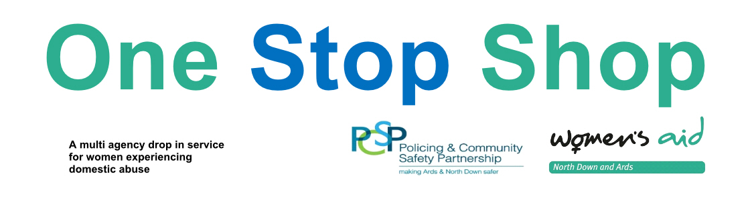
A multi-agency drop in service for women experiencing

- Physical abuse
- Emotional abuse
- Financial abuse
- Sexual abuse

The One Stop Shop provides FREE, immediate and confidential access to Women’s Aid, legal support, benefits advice,
housing support and safety advice.

Open on the 1st and 3rd Tuesday of each month 10am – 12pm.
Beginning on Tuesday 19th September 2017.
No appointment necessary – Crèche facilities available.

Location: Thriving Life Church
Crawfordsburn Road
Newtownards
BT23 4EA

For any further information about the One Stop Shop
or Women’s Aid support services
please call 028 91273196 or email onestopshop.ndawa@gmail.com

