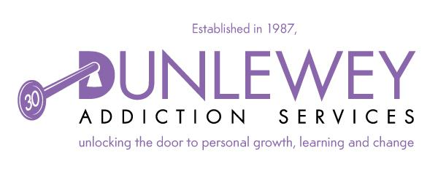
Title of Post: Facilitator
Reports to: Future ARCH Coordinator
Base/ Location: 16 Castle St Lisburn
Annual Leave: 25 Days pro rata.
Duration: 2 Years
Salary: £ 22,308 30 hours/week

PURPOSE OF THE JOB

To work with the Coordinator to facilitate, deliver and evaluate Future ARCH programmes to individuals who have completed a psychotherapy treatment programme for addiction issues

The post holder will have to ensure the effective facilitation of Future ARCH recovery programmes and Service user activities.

- Attend meetings with Coordinator, staff meetings and team meetings.

- To facilitate creative and innovative programmes, based on the needs of our Service Users and Service User groups.

- Facilitate Service User focus group meetings.

- Liaise with external facilitators, agencies and venues.

- With Coordinator, organise venues for facilitating programmes and the logistics required to achieve attendance by Service Users.

- Record information required to monitor and evaluate Future ARCH programme sessions to ensure quality standards are met, collecting relevant data including Service Users and stakeholders' feedback.

- Provide regular accurate reports and feedback to coordinator on agreed times.

- With coordinator manage resources to agreed budgets, targets and timescales.

- Work at all times within Dunlewey Addiction Services values, policies, procedures and guidelines.

- Undertake any other tasks as may be from time to time required.

- Always act in the best interest of Dunlewey Addiction Services.

This job description covers the current range of duties and will be reviewed from time to time. It is Dunlewey Addiction Services aim to reach agreement on changes, but if agreement is not possible, Dunlewey Addiction Service reserves the right to change this job description.

PERSONNEL SPECIFICATION FOR THE POST OF
Future ARCH FACILITATOR
 | ESSENTIAL CRITERIA | DESIRABLE CRITERIA
1. Circumstances | 1. A full current driving licence and access to a car is essential. Consideration will be given to alternative travelling proposals in respect of applicants with a disability who cannot hold a licence.  2. Willingness to work flexible hours required for the job which may include evening and weekend.
2. Qualifications | 1. Third level qualification in area of facilitating programs, or 2 years’ experience in facilitating programs in community and voluntary sector. | Programme development and facilitating experience in the voluntary and community sector
3. Experience | Working experience within the field of Addiction or Health & Social Care.  Experience in working in a Team environment.  Experience in producing reports.  Experience of Service User focused development and change through the provision of programmes.  Experience in using different mediums and resources to facilitate programmes and group work.  Experience in thinking creatively when facilitating programs  Experience of building good relationships with Service Users and stakeholders.  Experience of using Microsoft packages to include Microsoft outlook, Microsoft Word, Excel and PowerPoint. | Experience of working with Service Users to effect positive behavioural change through the delivery of recovery programmes

COMPETENCIES

Candidates who are shortlisted for interview will be required to demonstrate how, and to what extent, they meet some or all of the competencies listed below during their interview.
Service User Focus
Strives to exceed the expectations and requirements of service users, acts with service users in mind and values the importance of providing high-quality services.
Communicating Effectively
Keeps service users well informed and communicates messages clearly and concisely. Listens carefully, evaluates other opinions and is able to influence successfully. Actively promotes the exchange of ideas and information.

Team & Partnership Working
Encourages open communication and collaboration through the sharing of knowledge and best practices. Develops and encourages effective partnerships internally and externally to improve the efficiency and effectiveness of service delivery based on shared outcomes.

Personal Development, Performance & Professionalism
Demonstrates required job knowledge and understanding to successfully and competently fulfil or exceed the requirements of their post. Proactively demonstrates a desire to enhance and develop their job knowledge.

Continuous Improvement & Reports Delivery
Delivers reports on time, within constraints and in line with organisational policy, procedure and strategy.

Motivational
Motivates people to work effectively and deliver measurable outcomes. Acts as a positive role model for service users and fosters a climate of continuous improvement and recovery. Support change and engages in a consultative manner taking the opportunity to challenge and compromising as appropriate.

SUPPLEMENTARY INFORMATION
This is a regulated post and will be subject to a satisfactory Access NI check.

Short listing will be based on the evidence that you supply on your application form to satisfactorily demonstrate how, and to what extent, you meet the above criteria. The Short listing Panel will not make assumptions as to your circumstances, qualifications, and experience.

