Youth Support Worker (P/T)
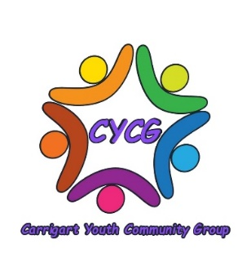
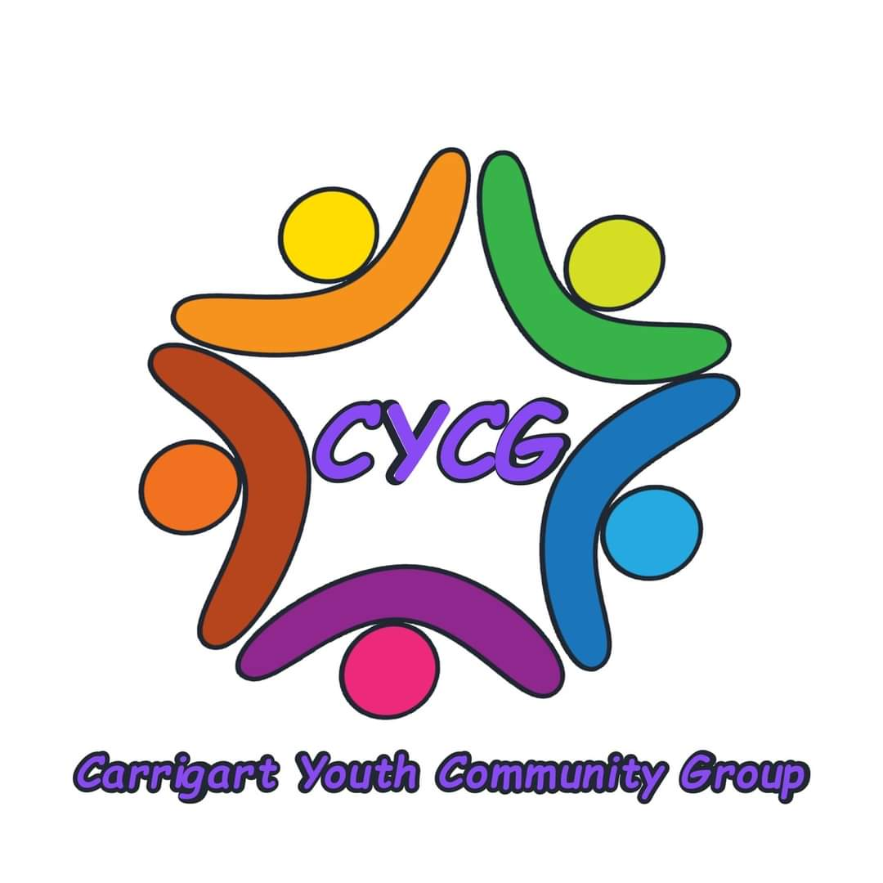

April 2024

The information within this application pack is designed to give applicants a fuller picture of the post and a brief introduction to Carrigart Youth and Community Group
After reading through the pack, we trust that you will be interested in applying for the post and ask that you please complete the Application Form online and return it too:

carrigartyouthcommunitygroup@gmail.com

Applicants will be informed by email if they have been shortlisted or not for interview.

It is anticipated that interviews will take place in May at the:
Glen Road Community Centre,
2 Carrigart Avenue
BT11 9HU

We would like you to note that closing date is: 3pm Wednesday 1st May 2024 no applications will be considered after this time.

Returned applications forms (as attachment in Word format) from a personal email address will be considered and treated as signed by the applicant.
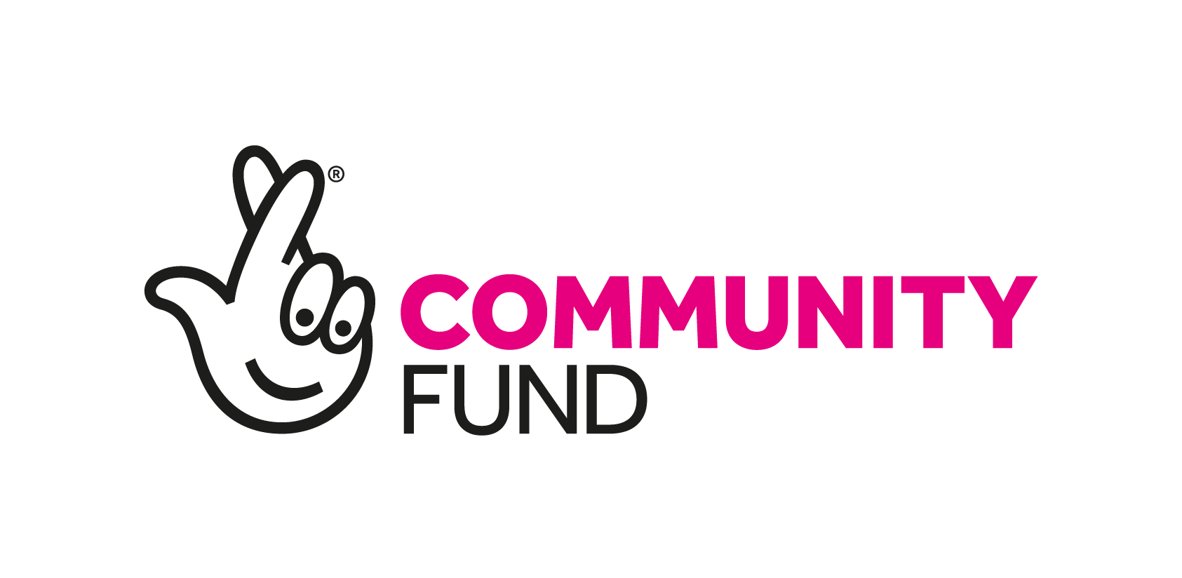

You will find the following enclosed within this pack:

- Introduction to CYCG

- General Information and Appointment Notes

- Pre-employment checks

- Job Description and Person Specification

- Application Form – includes Equality of Opportunity Monitoring Questionnaire &

Disclosure of Criminal Convictions Form (also available to download separately in Word format)

GENERAL INFORMATION AND APPOINTMENT NOTES: Project Worker - Do Something Active

The following outlines basic information about working terms and conditions. Full terms and conditions will be detailed in a Contract of Employment, which will be provided to the successful candidate.
 

  Location

Lenadoon, West Belfast but travel expected
 

- Hours of Work

This is a part-time post for 8 hours per week. The Youth Support Worker will be required to take a flexible approach to work and regularly work evenings and occasional weekends.
 
  Length of contract

This post is available on a fixed-term basis (to end of March 2027). The successful candidate will be issued with a detailed Contract of Employment within 4 weeks from the date of commencing work.
 

  Benefits

  - Salary: £11.44 per Hour

  - Annual Leave, Public & Privilege Holidays: The leave entitlement is 20 days Annual Leave and 10 days Public Holidays (calculated pro-rata for part-time employees). The leave-year runs from 1st March to end of February.

  - Pension: Not Applicable due to number of hours.

  - Probationary Period - There will be a probationary period of 6 months.

 
- Smoking Policy & Role Modelling

CYCG operates a strict non-smoking policy which also applies to the use of e-cigarettes. All personnel, staff, and volunteers, are prohibited from smoking in CYCG premises, when present at or leading on activities and events and at any time in the presence of children and young people. Staff and volunteers provide positive role modelling to the children and young people with whom we work and therefore any behaviour inconsistent with professional standards of best practice is not permitted.
 
- Equality of Opportunity

CYCG is committed to equality of opportunity in employment and welcomes applications from all suitably qualified persons, irrespective of religious belief, gender, physical ability, race, political opinion, age, marital status, sexual orientation or whether they have dependants. All applicants for employment will be considered based on merit.

To demonstrate our commitment to equality in employment we need to monitor the community background of all employees and job applicants as required by The Fair Employment and Treatment (NI) Order 1998. Therefore, we require all job applicants to complete and return a Monitoring Questionnaire. Personnel involved in either the short-listing or interview selection processes will not see its contents. However, if you do not complete this questionnaire, and return it with your completed and signed Application Form, we will not be able to process your application to the next stage of selection.

Child Protection (Safeguarding)

In compliance with Child Protection legislation and good governance the preferred candidate must agree to an Access NI managed Police check.

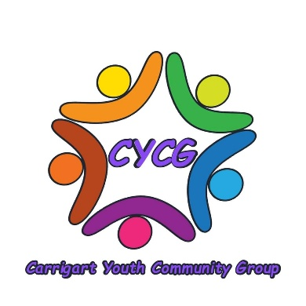
CYCG PROJECT INFORMATION

INTRODUCTION

Carrigart Youth and Community Group are a volunteer organisation based in Lenadoon, West Belfast. Our aim is to empower young people through their social development and by raising their critical consciousness.

This post is funded by the National Lottery Community Fund NI for our project “Building Together”. This will consist of running a drop-in project in the Lenadoon community for the young people. Over the next 3 years the project will take form through Summerscheme’s, Residentials, mental health groups and more.

4a. JOB DESCRIPTION & PERSON SPECIFICATION

JOB DESCRIPTION – Youth Support Worker

Job Title: Youth Support Worker (1 Post)
Salary: £11.44 per hour, 8 hours per week

Reports to: CYCG Committee

Job Purpose: The post holder will recruit and engage effectively in general youth work activities in the Lenadoon area.

The Youth Support Worker will proactively support and contribute to the development of youth participation, empowerment, and health & well-being through CYCG activities. They will support CYCG youth members and committee through health promotion and active engagement in sports, recreation training and direct contact with young people.

Main Duties & Key Responsibilities

- Provide a presence and raise the profile of the CYCG project throughout the designated target areas.

- Promote youth engagement with the CYCG project by providing support and supervision to the young people and volunteers and actively seek to involve young people in project activities and project management.

- As part of a youth work team, to support and quality assure the design, delivery, co-ordination and evaluation of the CYCG events. The post holder must also ensure that all activities are compliant with current legislation; that policy and best practice is maintained at the optimum level in relation to all work with young people.

- Design and participate in local Mental Health initiatives to shape and develop partnership working with targeted youth groups and organisations.

- Ensure that the project activities consistently promote a message of positive community relations, health, and well-being, and contribute to the shaping of strategies, interventions and practice models to help young people to build resilience to negative competing influences, lifestyle attitudes and risky, damaging and dangerous behaviours.

- To facilitate and develop youth participation in decision-making, through building positive relationships with young people, and those who work on their behalf.

- To create awareness of and signpost for services for young people on a range of youth issues including employability, drugs and alcohol abuse, mental health etc.

- To maximise and enhance youth participation and empowerment by utilising and developing electronic communications, social media platforms, networks and other appropriate forums of benefit to the project, its profile and beneficiaries.

To ensure that regular meetings (weekly or as appropriate) with project participants, and organisation staff are properly co-ordinated, scheduled and reported, so that relationships are built, and impact is maximised.

- Ensure Project Action Plans, budgets and all administrative procedures are implemented fully and that further opportunities are identified to optimise project and programme outcomes.

- To ensure that all project reviews, monitoring, and evaluation processes are fully implemented on behalf of project participants, CYCG, its sponsors and partner organisations.

PERSON SPECIFICATION

Key Skills & Experience:

- Relevant paid or voluntary experience in youth work.

- Excellent organisational skills, including the ability to assess, achieve and develop aims.

- Experience of delivering and managing youth projects or activities.

- Experience of first aid with a preferable qualification.

- Keen interest and ability to deliver Mental Health training to young people and demonstrable experience and interest in providing/sharing with others general youth activities.

- Ability to develop and implement innovative concepts and plans to meet set targets and to work to deadlines, using own initiative and within budget.

- Good computer skills and experience of using social media & networking with young people and those who support them.

- Professional communications skills with the ability to build rapport with members via a range of appropriate communication methods including effective report writing.

- A good understanding of the needs and interests of young people and young work sector.

- Knowledge of youth and community issues and a commitment to work with young people and those who work on their behalf in Lenadoon and surrounding areas.

CYCG APPLICATION FORM

Youth Support Worker

All questions must be answered, and the Application Form MUST be signed before it can be considered.

Completed applications must arrive no later than
3pm on Wednesday 1st May

LATE APPLICATIONS WILL NOT BE ACCEPTED

IN CONFIDENCE

For office use only:

Applicant's Name: _________________________ Applicant No _____________

NOTES:

Personal Details
Forename (s): | _______________________________________________________
Family Name: | _______________________________________________________
Address: | _______________________________________________________
 | _______________________________________________________

Postcode: ___________________________

Home Tel No: _______________________

Mobile No. ________________________

Email Address: _________________________________________________________

National Insurance Number: ______________

Do you hold a current full UK driving licence? Yes / No (underline)

Qualifications and Courses

Type of Exam | Subject | Grade
(GCSE, NVQ, A Level, BTEC, OCN, Degree, Post-Graduate etc)

Are you currently employed?

Yes / No (please underline your response).

______________________

Notice Required (if applicable):

Previous Work (Start with present or most recent job)

Name & Address of | Salary & | Type of Job (give brief | Reason for Leaving
Employer | Dates | description of duties)
 | Employed

Short- listing Criteria

CYCG may decide to shortlist applicants who appear from the available information to be the most suitable candidates for the post in terms of relevant skills, experience, and ability. It is therefore essential that applicants fully describe how they meet each requirement, including relevant timescale/duration (e.g., provide dates), of the ‘Eligibility Criteria’ and possible ‘Short-listing Criteria’ as indicated in the Person Specification.

Answer all questions in the spaces provided; additional sheets will not be included.
Give examples off:

- Your experience in programme management and delivery within a community youth work, sport or educational setting

(Max. 300 words).

- Your experience promoting, organising and co-ordinating youth & mental health activities & events (Max. 300 words).

- Your experience of facilitating youth participation and the establishment and maintenance of professional relationships with young people- Max. 300 words).

- The use and the potential use of IT and social media and electronic networks with young people (Max. 300 words

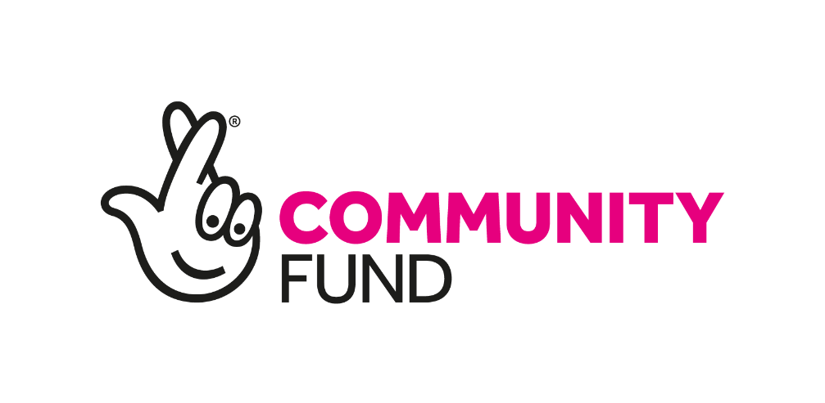

Declaration of Criminal Convictions and Monitoring Questionnaire

Is there any reason why you cannot work with children or young people? Yes / No (please underline your response).

In compliance with our policy and current legislation, applicants must fully complete the attached forms and return in a separate sealed envelope:

- Declaration of Criminal Convictions

- Monitoring Questionnaire - Equality of Opportunity

References

We reserve the right to take up references for candidates.

Declaration

I declare that the information provided in this Application Form is, to the best of my knowledge, True and complete.

Signed: ________________________________ Date: _ _ / _ _ / _ _ _ _

4b. DISCLOSURE OF CRIMINAL CONVICTION

Please read this information carefully.

Name of Applicant: ___________________________ Job Title: ___________________________

STATEMENT OF NON-DISCRIMINATION

CYCG is committed to equal opportunity for all job applicants, including those with criminal convictions. Information about criminal convictions is requested to assist the selection process and will be taken into account only when the conviction is considered relevant to the role. Any disclosure will be seen in the context of the criteria of the role, the nature of the offence and the responsibility for the care of children and young people, volunteers and employees. Applicants are required to declare any convictions, cautions, reprimands and final warnings not protected by legislation.

ADVICE TO APPLICANTS

The disclosure of a criminal record or other information will not debar you from registration or appointment unless CYCG considers that the conviction renders you unsuitable. In making this decision CYCG will consider the nature of the offence, how long ago it was committed, your age at that time and other factors which may be relevant. This information will be verified through an appropriate Access NI Enhanced Disclosure check. If you have received a formal caution or are currently facing prosecution for a criminal offence you should also bring this to our attention given the “exempted” nature of the role.

Please complete and sign this Declaration Form (below) accurately and return this with your application form. An arrangement may be made with you to discuss any convictions if clarification is required.

Thanking you in advance for your co-operation.

DECLARATION

Do you have any convictions that are not “protected” as defined by the Rehabilitation of Offenders (Exceptions) (Northern Ireland) Order 1979, as amended in 2014?

Yes | No
If ‘Yes’, please state the nature, date(s) and sentence of the offence(s) and provide any other information you feel may be of relevance, such as: the circumstances of the offence/incident; any relevant developments in your situation since; and whether or not you feel the conviction has relevance to this post. (Please continue on an additional separate page if required.) _____________________________________________________________________________________

_____________________________________________________________________________________
_____________________________________________________________________________________
_____________________________________________________________________________________
_____________________________________________________________________________________

I declare that any and all answers provided herein are complete and correct to the best of my knowledge and I have informed CYCG Monitoring Officer in writing of any pending future convictions. I understand that I have applied for a role which is a Regulated Activity Position as defined by the Safeguarding Vulnerable Groups (NI) Order 2007 (as amended by the Protection of Freedom Act 2012) and which also falls within the definition of an “exempted” position as provided for by the Rehabilitation of Offenders (Exceptions) Order (NI) 1979 (as amended in 2014).

I give my consent for an Access NI* check to take place and for this information to be shared only with relevant persons nominated as part of CYCG risk assessment and appointment procedures.

(Signature) ___________________________________ Date _ _ / _ _ / _ _ _ _

- CYCG complies with the Access NI Code of Practice. Further information is available at www.accessni.gov.uk

4c. MONITORING QUESTIONNAIRE - EQUALITY OF OPPORTUNITY

Job Title _____________________________ Job Ref: ____________ Date: _ _ / _ _ / _ _ _ _

CYCG is committed to equality of opportunity in employment and aims to select and employ the best person for each post. All job applicants and employees shall receive equal treatment regardless of gender, marital status, age, disability, socio-economic circumstances, health, sexuality, religious or political belief, colour, race and ethnic or national origin.

We will encourage positive attitudes and behaviour towards groups and individuals and will strive to eradicate prejudice and discrimination by promoting equality of opportunity in all areas of our work and organisational structure.

To demonstrate our commitment to equality in employment we need to monitor the community background of all employees and job applicants as required by the Fair Employment and Treatment (Northern Ireland) Order 1998.

Regardless of whether we practice religion, most of us in Northern Ireland are perceived as either Catholic or Protestant. We are therefore required to ask you to indicate your community background by ticking the appropriate box below.

DECLARATION

I am a member of the Catholic community

I am a member of the Protestant community

I am a member of neither the Protestant nor

the Catholic community

Please indicate what gender you identify as:

________________________

Date of Birth: __ /__ / ____

ETHNIC ORIGIN (please tick appropriate box.)

Bangladeshi | Black African | Black Caribbean
Black/Other | Chinese | Indian
Pakistani | White | Other (Please specify):
N.B. If you do not complete this questionnaire and return it with your completed Application Form, we will be unable to process your application to the next stage of the selection process.

- This form will be separated from your Application Form and will not be seen by the selection panel.
Thanking you in advance for your completed and signed Application Form.

