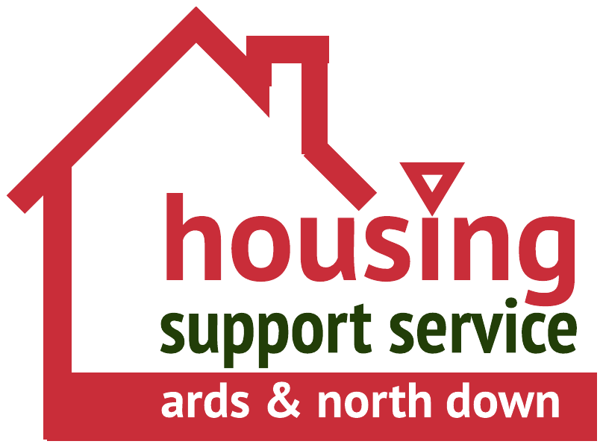
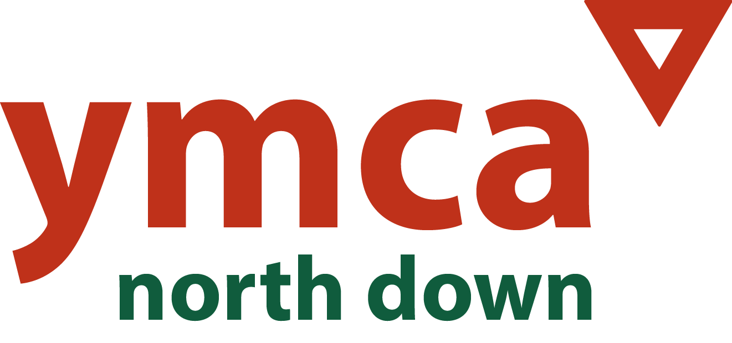
APPLICANT REF. NO: /HSW/0/2024 Equal Opportunities Monitoring

Please return this form in the envelope provided. This section will be detached from your application and will be used solely for monitoring purposes. Your answers will be treated in strict confidence and will not be made known to those involved in short listing or interviewing.

North Down YMCA recognises and actively promotes the benefits of a diverse workforce and is committed to treating all applicants and employees with dignity and respect regardless of race, gender disability, age, sexual orientation, religion or belief. We therefore welcome applications from all sections of the community.

COMMUNITY

Please indicate the community to which you belong by ticking the appropriate boxes below.
Religion:

🗆 Roman Catholic 🗆 Protestant 🗆 No religious background 🗆 Other religious background

White:

🗆 British 🗆 Irish 🗆 Any other white background

Mixed:

🗆 White & Black Caribbean 🗆 White & Black African 🗆 White & Asian 🗆 Any other mixed background

Black:

🗆 Caribbean 🗆 African 🗆 Any other Black background

Asian:

🗆 Indian 🗆 Pakistani 🗆 Bangladeshi 🗆 Any other Asian background

Chinese or Other Ethnic Group:

🗆 Chinese 🗆 Other Ethnic Group* please specify

GENDER :
DATE OF BIRTH :

DO YOU CONSIDER YOURSELF TO HAVE A DISABILITY? 🗆 Yes 🗆 No
The Disability Discrimination Act defines disability as “A physical or mental impairment which has a substantial and long-term effect on the person’s ability to carry out normal day-to-day activities”.
If yes, please state the nature of disability.

If you wish you may provide information about your sexual orientation here:
How did you become aware of this vacancy?
Date:

