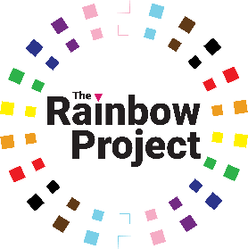
Diversity Monitoring Form – Application
Confidential

We are an Equal Opportunities Employer. We do not discriminate against our job
applicants or employees and we aim to select the best person for the job. We monitor the diversity job applicants and employees in order to demonstrate our commitment to promoting equality of opportunity in employment and to comply with our duties under the Fair Employment & Treatment (NI) Order 1998.

The information you provide about yourself on this form is voluntary, anonymous and confidential. It will be used only for statistical monitoring and will not be seen by the panel shortlisting or interviewing for the post.
Which post(s) did you apply for?

16 to 24 |  | 25 to 34 |  | 35 to 44 |  | 45 to 54
55 to 64 |  | 65 to 74 |  | 75+
Age
Gender

Yes |  | No
Do you consider yourself to be a trans person, or
to have a trans history?

Yes |  | No
Intersex / VSC
Do you have a variation in sex characteristics /
intersex variation?

Bisexual |  | Lesbian or gay
Heterosexual / straight |  | Other:
Sexual orientation

Community Background
Regardless of whether they actually practice a religion, most people in Northern
Ireland are perceived to be members of either the Protestant or Roman Catholic
communities.

I am a member of the Protestant community

I am a member of the Roman Catholic community

I am not a member of either the Protestant or the Roman Catholic communities
Other Religion or belief (if any)

Nationality

Ethnic identity

Yes |  | No
Disability
Do you consider yourself to be disabled?
If you answered “yes”, please indicate the nature of your impairment by ticking the appropriate box or boxes below.
Physical impairment, such as difficulty using your arms, or mobility issues requiring you to use a wheelchair or crutches
Sensory impairment, such as being blind or having a serious visual impairment, or being deaf or having a serious hearing impairment
Mental health condition, such as depression or schizophrenia

Learning disability or difficulty, such as Down’s Syndrome or dyslexia, or cognitive impairment, such as Autistic spectrum disorder
Long-standing or progressive illness or health condition, such as cancer, HIV infection, diabetes, epilepsy or chronic heart disease
Other (please specify):

Please edit or write on this form and return it to: diversity@rainbow-project.org

