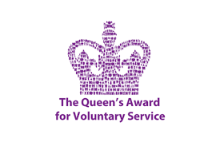

VOLUNTEERS NEEDED

Our volunteers are at the heart of everything we do. We couldn’t support so many people without their help.

We are proud of our small, dedicated team of volunteers. They help us keep our vital services going to support families who are bereaved by suicide and by raising awareness.

If you enjoy being part of a team, are compassionate and like meeting people then this could be the role for you. Thanks to volunteers like you we can provide people in our local community with help and support.

Why should I volunteer?

Everyone’s reasons for volunteering may be different and we are grateful that you may be interested in giving us your time.

Whether you have a skill to share, feel like trying something new, or want to meet new people we have a volunteering role for everyone.
In return, we want
to make sure that your experience with us is rewarding and enjoyable!
By volunteering for us, you can expect to:
- Be part of a well-loved charity supporting the local community
- Join an open and friendly volunteering environment which values and supports you
- A massive confidence boost
- Gain new skills that will enhance your CV
- Receive full training
- Meet new people from all paths of life
- Make a difference and experience something new
- Share your knowledge and skills

Volunteer Roles include but are not exhaustive

- Assisting at Suicide Prevention information stands
- Helping at Group meetings
- Helping to plan events
- Helping to volunteer at events

If you are interested in helping those who have been bereaved by suicide, raising awareness and promoting suicide prevention we would love to hear from you. For an application or more information please contact Claire on 90460201 or email eastbelfastsos@gmail.com

