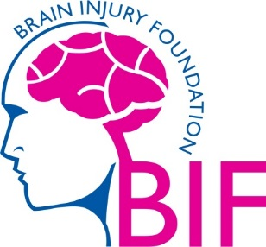

**IMPORTANT INFORMATION FOR APPLICANTS**

Dear Applicant

Thank you for your interest in the post of **Project Administrator.** Please read all the information you find in this pack as follows:

* + BIFs Equal Opportunities Policy Statement
  + Job Application Form, Equal Opportunities Monitoring form
  + A Job Description and Personnel Specification

**Job Application Form**

BIF requires that **all** sections of the Job Application Form are completed in full. This includes the completion of the Monitoring questionnaire.

If you write in any section of the Job Application Form “*see attached sheet or CV”,* or if you send a CV in place of a Job Application Form, we shall, with regret, be unable to consider these as valid applications.

We request the monitoring information to help NICVA promote equality of opportunity in employment. Our recruitment policy operates on the merit principle, i.e. we select the best person for the job regardless of religious or other beliefs.

We would like you to know that:

* only the Job Application Form is considered by the Recruitment Panel, who short-list and interview for vacancies;

**DISABILITY** If your disability precludes you from completing this form or from any part of the selection process contact the office for alternative arrangements and/or reasonable adjustments to be made.

The successful candidate will be required to provide documentation to support his/her claim that they are entitled to work in the UK. This is required under Section 8 of the Asylum & Immigration Act 1996, the law for all UK employers on preventing the employment of illegal workers.

Thank you